Project SHINE / SPIRIT2.0 Lesson:
What’s Your Shoe Size? Linear Regression with MS Excel
==========================Lesson Header ==========================
Lesson Title: What’s Your Shoe Size? Linear Regression with MS Excel
This Teacher was mentored by:


www.bd.com

In partnership with Project SHINE grant funded through the

National Science Foundation

Draft Date: July 10, 2010
1st Author (Writer): Merlin Lahm
Business Sector Partner: BD Pharmaceutical
Instructional Component Used: Data Analysis/Modeling Data by Best Fit Curves
Grade Level: 9-12

Content (what is taught):
- Data collection
- Data analysis
- Creation of a linear model

Context (how it is taught):
- Collect height and shoe size of males and females from all class sections
- Create a scatterplot by hand on graph paper
- Store the male and female data sets in a Microsoft Excel file or other spreadsheet software
- Perform linear regression for each set

Activity Description:
In this lesson, all students in a particular class will record their height as the independent variable and shoe size as the dependent variable. Data from all sections of the class will be pooled and divided into two distinct sets, one for males and one for females. Each student will create a scatterplot of data for their particular gender. Graphs will be compared and, it is hoped, it will be concluded that a linear model may be appropriate for each data set. In the computer lab with one student per machine, students will store the data sets in columns of an Excel spreadsheet. If needed, students will add the Data Analysis Tool Pack. This will only need to be performed once per machine. Students will choose Tools -> Data Analysis -> Regression to perform a linear regression and plot the points along with the graph of the line of best fit. After examining the correlation coefficient, the linear regression equation, and a plot of the data in comparison to the line of best fit, students will use their model to estimate the shoe size of the tallest and shortest NBA and WNBA player.

Standards:

Science: SE2 Math: MA3, MB1, MB2, MB3, MC2, ME1, ME2, ME3

Engineering: EA1, EA2, EB1, EB5, EC1 Technology: TA3, TB4, TC2, TC4, TF1, TF2, TF4

Materials List:
Computer lab Calculator Graph paper
Asking Questions:
(What’s Your Shoe Size? Linear Regression with MS Excel)

Summary: Students will determine under what conditions a linear model may be appropriate.
Students will discuss techniques to create a linear model.

Outline:
- Examine the shape of various scatterplots and choose those for which a linear model may be appropriate
- Review the technique used previously whereby students plot data points and fit a model to data “by sight”

Activity: The teacher will present several scatterplots of ordered pairs. For an image of various data sets, see attached file: M077-SHINE-Excel_Regression-A-Data.doc Ask the following questions:

Questions | Answers
What types of equations have you seen used to model data? | Answers may vary. Linear, exponential, quadratic, logarithmic, polynomial, etc.
For each scatterplot shown, would a linear model seem appropriate? If not, what type of model (what kind of equation) would be more appropriate? | Answers vary. See scatterplots below.
Have you used methods to create linear equations for data? If so, what? | Draw a line by sight, choose two points, determine slope, and create a linear equation.  Students may also have performed regression on a calculator.

Attachment:
Regression Data: M077-SHINE-Excel_Regression-A-Data.doc
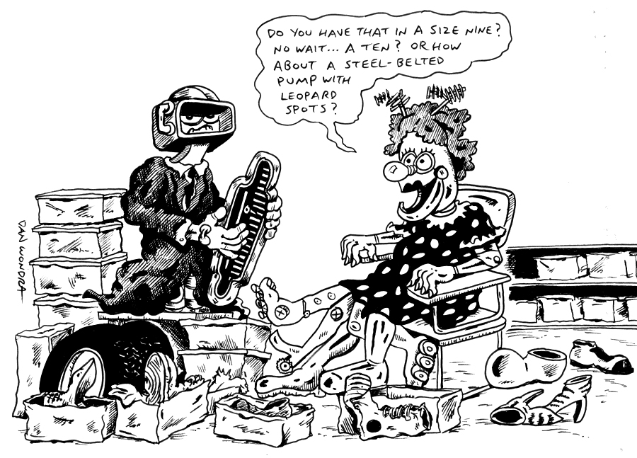
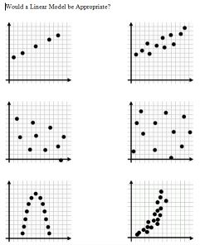
Exploring Concepts:
(What’s Your Shoe Size? Linear Regression with MS Excel)

Summary: Students in a particular class will record their height and shoe size. Each student will create a scatterplot of data for their particular gender. Graphs will be compared and a linear regression line will be drawn. Finally, a linear model will be calculated by hand.

Outline:
- Collect and pool data from class members relating height in inches to shoe size
- Create a scatterplot for each gender with height as the independent variable and shoe size as the dependent variable
- Students will create a linear model by hand

Activity: During one class period, students will record their height and shoe size. The data from all sections of the class will be pooled and divided into two distinct sets, one for males and one for females. The following day, students will create an x-y table of height and shoe size, recording height as the independent variable and shoe size as the dependent variable. The data will be graphed such that girls make a scatter plot of girl data and boys make a scatterplot of boy data. The graphs will be compared and a linear regression line drawn. Finally, a linear model will be calculated by hand for the data. After everyone is done the graphs, regression lines and linear models will be compared and discussed.
Height (in) | Male Shoe Size

Height (in) | Female Shoe Size
height
shoe
size
Instructing Concepts:
(What’s Your Shoe Size? Linear Regression with MS Excel)

Data Analysis/Modeling Data by Best-Fit Curves

The process of modeling data is essential for any field of study where data has been collected over time and predictions are desired about future behavior. The process involves identifying a trend that is present and making a prediction based on that trend. This process consists of four parts: 1) graphing a scatterplot of the data, 2) analyzing the data for a trend, 3) creating a function model that fits the trend, and 4) making credible predictions based on the model, assuming the trend continues.

Scatterplots
The first step is to graph a scatterplot of the data. This can be done by hand or by using a graphing utility. If you are doing it by hand, scales for the x (independent) variable and the y (dependent) variable will need to be chosen so that the data is spread out enough to make the trend recognizable.

Analyzing the data for a trend
After creating the scatterplot it is necessary to analyze the data for trends that are present. These trends can be as simple as a line (linear regression) or more complex such as a polynomial (quadratic, cubic, etc.), sinusoidal, power or any other function that looks like the trend present. The closer the data resembles the function you want to use to model it the better your predictions should be. The measure of how closely the function will model the data is called the correlation coefficient (r). Correlation is a number that ranges between – 1 and + 1. The closer r is to +1 or – 1, the more closely the variables are related. If r = 0 then there is no relation present between the variables. If r is positive, it means that as one variable increases the other increases. If r is negative, it means that as one variable increases the other decreases. Correlation is very hard to calculate by hand and is usually found using the aide of a graphing utility.

Creating a function model
After deciding on a function that models the trend present it is necessary to create an equation that can be used to make future predictions. The easiest model to create is a linear regression if the trend present is linear. To do this you first draw a line that comes as close to splitting the data while at the same time having all the data points are as close to the line you are drawing as possible. There will be a kind of balance to the line within that data plot that should split the data evenly and follow the same linear trend. If the trend that is present in the data is stronger, then it will be easier to draw your line. After drawing the line, you can calculate the equation by estimating two points on the line. Using these two points, calculate slope and the y-intercept and write the equation. Regression models can be found more precisely using graphing utilities. Anything other than a linear regression is very difficult to find by hand.

Making predictions using the model
After the model is found it is easy to use it to make predictions about future events assuming the trend continues. You can simply plug in for either the x or y variable and solve for the other. This will create a predicted data point that can be used to base future decisions on. If the correlation is high, meaning the trend is strong; the predictions should be fairly accurate.
Organizing Learning:
(What’s Your Shoe Size? Linear Regression with MS Excel)

Summary: Students have used calculators to store and analyze data, but spreadsheets are used often in business. For this reason, this activity will be used to introduce students to the data capabilities of spreadsheets.
Students will record in an x-y table the height (x) of each student and the student’s shoe size (y). Data from all sections of the class will be pooled and divided into two distinct sets, one for males and one for females. In the computer lab with one student per machine, students will store the data sets in columns of an Excel spreadsheet and perform a linear regression.

Outline:
- Record the data points in a table with height in inches as the independent variable and the student’s shoe size as the dependent variable.
- Store the data points as columns in an Excel spreadsheet.
- Add the Data Analysis Tool Pack. This will only need to be performed once per machine.
- Students will choose Tools -> Data Analysis -> Regression to perform a linear regression and plot the points along with the graph of the line of best fit.
- Record the resulting linear model and correlation coefficient.
- Compare the plot created by the spreadsheet to the ones the students drew by hand.

Activity: In this lesson, students in a particular class have recorded their height as the independent variable and shoe size as the dependent variable. Data from all sections of the class was pooled and divided into two distinct sets, one for males and one for females. Each student created a scatterplot of data for their particular gender by hand and graphs were compared. In the computer lab with one student per machine, students will store the data sets in columns of an Excel spreadsheet. If needed, students will add the Data Analysis Tool Pack and choose Tools -> Data Analysis -> Regression to perform a linear regression and plot the points along with the graph of the line of best fit. The graphs will be printed and compared to the regressions that students created by hand previously.
Understanding Learning:
(What’s Your Shoe Size? Linear Regression with MS Excel)

Summary: Students will store data in an Excel spreadsheet and perform a linear regression. Students will analyze the corresponding graph and apply the model to make a prediction.

Outline:
- Formative assessment of data analysis/modeling data by best-fit curves
- Summative assessment of data analysis/modeling data by best-fit curves

Activity: Students will complete written and performance assessment about data analysis.

Formative Assessment
As students are engaged in the lesson ask these or similar questions:
- How do you store data in the spreadsheet?
- What series of selections will produce a regression?
- How do you input the Y Range and the X Range on the spreadsheet?
- Where in the summary output do you find the coefficients for the regression equation?
- What selection under “Residuals” will produce a scatterplot of data and the line of best fit?

Summative Assessment
Students can answer the following writing prompts:
- Describe the process of data analysis. Explain the important steps of this process and what each entails.
- Students will write a short summary of the lab and what they have learned. Be sure to cite the steps of data analysis in your write-up.

Performance Assessment
- Students will find height and shoe size data for the NBA, WNBA or similar. Store the data in a spreadsheet, produce a scatterplot on the computer, and perform a regression to create a linear model.
  - Use the linear regression equation to predict the shoe size of the tallest and shortest player in the NBA or WNBA.
  - What does the correlation tell us about the relationship between the independent and dependent variable?

