SPIRIT 2.0 Lesson:
What’s Its Slope?
==========================Lesson Header ==========================
Lesson Title: What’s Its Slope?
This Teacher was mentored by:


www.duolift.com

and

www.loup.com

In partnership with Project SHINE grant funded through the

National Science Foundation

Draft Date: July 30, 2010
1st Author (Writer): Joan Lahm
2nd Author (Editor/Resource Finder):
Instructional Component Used: Slope (gradient)
Grade Level: Middle School Science (Earth Science – cartography)

Content (what is taught):
- The definition and formula for “slope” (rise over run)
- How to calculate the slope and percent grade of an inclined plane
- How to calculate the slope and percent grade of specific features represented on a topographic map

Context (how it is taught):
- Students will be given the definition and formula for “slope” and percent grade
- Students will calculate the slope of an inclined plane created with a ruler and their textbook
- Students will be given a topographic map and determine the slope and percent grade of a given feature on the map (example – river, road, hill, railroad, etc.)
- Prerequisite – students will need to know how to read a topographic map using contour lines, contour interval, and map scales

Activity Description:
After students have learned the definition and formula for slope and percent grade, they will calculate the slope of an inclined plane created by leaning a ruler against the edge of a textbook. English units will be used because most topographic maps printed in the United States are measured in feet. Example: elevation of textbook (1.5 inches), length (distance) of ruler (1 foot). Slope = 1.5 inches/foot. Or 1.5/12 x 100 = 12.5% grade. Students will examine a topographic map of their area and choose a feature (road, river, railroad track, hill, etc.) in which they will determine slope and percent grade. Using the map scale and a flexible ruler, students will calculate the distance of the feature in feet or miles. Using the contour interval and contour lines, students will determine the change in elevation from point A to point B in feet. From this data, students will determine the slope and percent grade of the feature.

Standards:

Science: SF2 Technology: TC4

Engineering: EB5 Math: MC2, MD1, MD2

Materials List:
- Flexible ruler
- Textbook to create an inclined plane
- Topographic map – preferably a local map with features familiar to students
Asking Questions: (What’s Its Slope?)

Summary: Some students will be able to relate to road signs showing percent grade in mountainous areas. An example of a percent grade sign will be shown in class for those who have not seen it. Students will be asked to predict the slope and percent grade of local features, such as a road, river, or hillside. Prior to using a local topographic map, students will be asked to explain how they can use the map to calculate slope and percent grade of a local feature. Knowledge of contour lines, contour intervals, and the use of map scales will be a prerequisite.

Outline:
- Students will share their prior experiences with slope and percent grade
- Students who have no prior experiences with slope and percent grade will be shown road signs and mountain slopes with percent grade illustrated
- Students will be asked to explain how they might use contour lines, contour interval, and map scales to determine slope and percent grade

Activity: The instructor will guide the class through a discussion of slope and percent grade. Definitions and formulas for slope and percent grade should be thought about. Different examples of grade will be cited and researched.

Questions | Answers
Have any of you seen a road sign in a mountainous region illustrating percent grade? Why is the sign there and what does it mean? | Varied responses. It informs the drivers of the slope of the area, how steep it is, caution for drivers - especially in large, heavy vehicles, it informs people of the change in elevation over distance
What are the percent grades along the route of the Tour de France? | Students can research the answer
How is slope and percent grade calculated? | Slope – the change in elevation over distance; percent grade – use the same units and multiply by 100
How can you use contour lines and the map scale to determine slope and percent grade? | Contour lines from point A to point B can be used to determine the change in elevation; the map scale is used to determine horizontal distance
What is the slope and percent grade of the (blank - feature)? The feature can be a road, hillside, river, railroad track, etc. | Varies
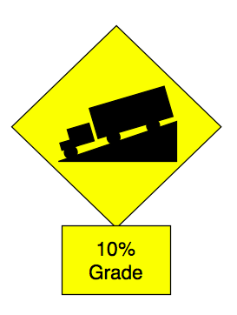
Resources:
USGS Topographic Maps: http://topomaps.usgs.gov
Other Topographic Maps: www.mytopo.com and www.topozone.com
Exploring Concepts: (What’s Its Slope?)

Summary: Students will use a ruler and book to illustrate what slope “looks” like. They will calculate the slope and percent grade of the inclined plane created by the ruler and book, as well as various ramps around the school.

Outline:
- Students will create an inclined plane with a ruler and textbook.
- Students will calculate the slope and percent grade of the inclined plane.
- Students will locate ramps in the school (handicap accessible ramps, etc) and calculate the percent grade.

Activity: To illustrate slope and percent grade, students will create an inclined plane with their textbook and ruler. Students will calculate the slope (change in elevation over distance). NOTE: The rise and run must be in the same units. To find the percent grade – multiply the slope by 100. Finally, students will search the school for ramps. These could be handicap accessible ramps, sidewalk ramps, etc. They should measure the slope and use it to calculate the percent grade.

Instructing Concepts: (What’s Its Slope?)

Slope

Putting Slope in Recognizable terms: Other words for slope are: steepness, pitch, grade, angle of elevation, angle of inclination/declination, and rise over run.

Putting Slope in Conceptual terms: Slope is a relationship between two rates (related rates) or a comparison of two distances.

Remember that rate is just a distance divided by a measure of time, r = d/t: the distance the bot travels in the y direction varies (or changes) as a factor (m) of the distance the bot travels in the x direction. So, some number (m) times x gives us y.

Therefore, m times (dist. of x) = (dist. of y). If we solve for the variable m by dividing both sides of the equation by (dist. of x), we get a related rate, or slope, also called rise over run.
Slope can be positive, negative, zero or undefined. Positive slope means that as one variable increases the other increases. Negative slope means that as one variable increases the other decreases. Zero slope means that there is no change in the y variable as the x variable changes. Undefined slope means that as the y variable changes there is no change in the x variable.

Putting Slope in Mathematical terms: We could also call the distance traveled in the y direction the change in distance of y or the difference in the y-coordinate values of two points. We could call the distance traveled in the x direction the change in distance of x or the difference in the x-coordinate values of the same two points. This gives us a formula: $m=\frac{Δy}{Δx}$ which shows the difference in y values over the difference in x values or, delta y divided by delta x. When we get to calculus, we define the slope at a point on a line or curve by making delta x very small. The slope at a point is given by the symbols: $m=\frac{\text{dy}}{\text{dx}}$.
Putting Slope in Process terms: Algebraic computation of slope is: $m=\frac{y_{2}−y_{1}}{x_{2}−x_{1}}$. Provide examples of calculating slope between points. Be sure to include examples and explanations of negative, zero, and undefined slope values.

Putting Slope in Applicable terms: Randomly angle the Bot, drive it for three seconds from a given point, measure the vertical and horizontal components, and define the slope. Another direct application for slope is percent grade or gradient. The formula for gradient is difference in elevation over distance multiplied by 100 equals percent grade. Percent grade is often found on road signs in hilly or mountainous areas. NOTE: the difference in elevation and distance must be in the same units.
Organizing Learning: (What’s Its Slope?)

Summary: Students will be given the definition and formula for slope and percent grade. Students will determine the slope and percent grade of an inclined plane. A topographic map will be used to determine the slope and percent grade of an assigned feature.

Outline:
- Students will use a topographic map to determine the slope and percent grade of an assigned feature on the map.
- Contour lines and a map scale will be used to calculate the change in elevation in feet over the distance in miles.
- After converting the miles to feet, students will determine the percent grade of the feature.

Activity: Students will learn the definition and formula for slope and percent grade. They will determine the slope and percent grade of a specific feature on a topographic map (ex. road, river, hill, railroad, etc.) by using the contour lines and map scales. Each pair will be assigned one of four features on the map. Students will compare their results and discuss any differences.
Resources:
USGS Topographic Maps  - http://topomaps.usgs.gov  - http://www.mytopo.com  - http://www.topozone.com  Ruler  Textbook | 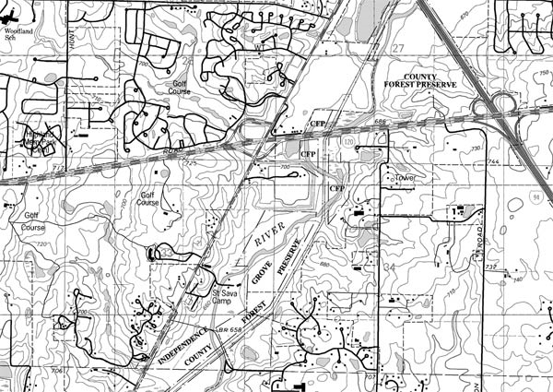

Example Data Table:

Group | Loup River  T17N, R1E, S32 | Loup Canal  T17N, R1E, S23 | UP Railroad  T17N, R1E, S24 | 18th Avenue  T17N, R1E,  Between S5 and S6
1
2
3
4
5
6
7

Understanding Learning: (What’s Its Slope?)

Summary: Students will be able to demonstrate their knowledge of slope and percent grade by answering questions on a quiz and calculating the slope and percent gradient of a feature on a topographic map.

Outline:
- Formative assessment of slope
- Summative assessment of slope

Activity: Students will be assessed over slope by completing a written and performance assessment.

Formative Assessment
As students are engaged in the sample inquiries ask these or similar questions:
- Are students able to measure and calculate the slope accurately?
- Do students understand how slope and gradient are related?
- Can student use the topographical map to find elevation change?

Summative Assessment
Students can answer the following writing prompt:
Explain the meaning of slope especially how it is related to gradient. Be sure to include any mathematical formulas and several examples where gradient is measured.

Performance Assessment
Students will be given a feature on a topographic map for which they will need to determine the slope and percent grade of the feature. Then, students will be given a board and other objects (for elevation) and will create an inclined plane with the same percent gradient as the feature on the map

Resources:
Local topographic map

