Project SHINE / SPIRIT2.0 Lesson:
This Teacher was mentored by:


www.behlenmfg.com

In partnership with Project SHINE grant funded through the

National Science Foundation

Who Let the Dogs Out?
==========================Lesson Header ==========================
Lesson Title: Who let the dogs out?
Draft Date: June 14, 2010
1st Author (Writer): Megan DeWispelare
Associated Business: Behlen Mfg. Co.
Instructional Component Used: Perimeter
Grade Level: Elementary

Content (what is taught):
- Application of a mathematical formula (perimeter)
- The perimeter of a polygon is the sum of the lengths of all its sides

Context (how it is taught):
- The associated business (Behlen Mfg.) makes fence panels, which goes hand in hand with perimeter.

Activity Description:
The student will find the perimeter of a location. After the perimeter is found, they will need to determine how many fence panels of a certain length are needed to enclose the area.

Standards:

Math: MD1, MD2, MA1

Materials List:
- Paper
- Pencil or pen
- Google SketchUp (http://sketchup.google.com)
Asking Questions: (Who let the dogs out?)

Summary: Show picture of a dog. Ask the kids how we could come up with a way to keep the dog inside the back yard. Naturally, they will say we need to create a fence.

Outline:
- Determine how to keep dog inside the given area
- Brainstorm different ways of creating a fence
- Ask students if size of dog matters for the area needing to be enclosed
- Brainstorm ways to work around a shed or tree in the way

Activity: The teacher will start a discussion about how his/her dog keeps running away. He/she will state that they need help so they do not lose their pet. Students can come up with ways to keep the pet at home. When the topic of fencing comes up, the discussion can be focused. Bring up different scenarios involving fencing that will need to be built/not built (shed, existing fence, etc.).

Questions | Answers
How can I keep my dog close to the house? | Use a chain or rope to hook to the collar.  The chain limits the area the dog can run in a circular perimeter or circumference.
What if the dog keeps getting the chain caught around a tree? | Put the dog in a kennel
What if the kennel doesn’t give the dog enough running room? | Build a fence
I have my shed for the mower in the back yard. | Build the fence around the shed.
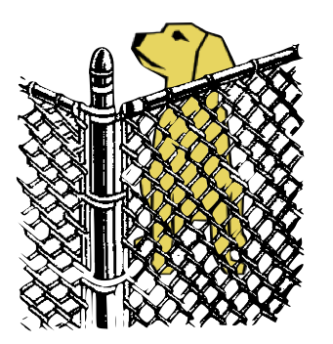
Exploring Concepts: (Who let the dogs out?)

Summary: Students will create a model fence panel out of classroom items or a computer application. After the panel is created, the students will estimate how many panels will be necessary to enclose a space that is defined by the teacher.

Outline:
- Students will create a model fence panel.
- Students will estimate how many model panels will be needed to enclose a space that the teacher defines.

Activity: The student will make a visual representation using building blocks, pencils, pens, crayons, etc. which will act like a fence panel. A computer application like Google SketchUp could be used. After students have determined the method of representation, they will estimate how many of each object they might need to create a fence around an area that the teacher will define. From this idea, we can teach how to find the perimeter of an area using the formula of perimeter of a polygon. A possible extension of the activity would be to talk about area that the fence encloses. If the perimeter changes, does that affect the area that is enclosed? This could be easily done on graph paper or the floor where enclosed squares can be counted to find the area.

Resources:
Behlen Mfg.: http://www.behlencountry.com/products/galvanized_fence_panels and
http://www.behlencountry.com/products/utility

Google SketchUp: http://www.google.com/sketchup/download/
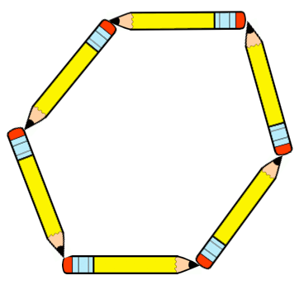
Instructing Concepts: (Who let the dogs out?)

Perimeter

Putting Perimeter in Recognizable Terms: Perimeter is the length of a shape that encloses an area. It can be thought of a path, border, or boundary.

Putting Perimeter in Conceptual Terms: The perimeter required to enclose an area is dependant on the area that it encloses. As the area to enclose gets larger, the perimeter must grow larger to accommodate the area.

Putting Perimeter in Mathematical Terms: Perimeter can be found mathematically using many different methods:
- The perimeter of a polygon can be found by summing the lengths of all the sides.
- The perimeter of a circle (circumference) can be found using the formula:, where C is the circumference, d is the diameter and r is the radius of the circle.
- If the perimeter to be found is enclosing a region that is curved, you can estimate the perimeter by measuring a group of short straight lines that approximate the perimeter. The exact perimeter (arc length) can be found in this case using an integral from calculus
Putting Perimeter in Process Terms: Computation of the perimeter for a defined area can be very easy or extremely difficult depending on the area. The process is different depending on the level of accuracy that is required. A single problem can be used by different levels of mathematics students. For instance the perimeter could be found by: 1) laying a string on the path and measuring the string, 2) the perimeter could be represented by short straight lines that are measured, or 3) the exact perimeter could be found using differential calculus.

Putting Perimeter in Applicable Terms: Perimeter is applicable anytime that a region of a defined area must be enclosed. It can be an application as simple as finding the perimeter of a triangle by measuring the sides or as complex as finding the length of a coastline of an island. Some of the most common applications for perimeter include fencing a space (your yard, etc.) and creating a frame for a picture or window. Perimeter is used in nearly every occupation and industry.
Organizing Learning: (Who let the dogs out?)

Summary: Students will calculate the perimeter of various shapes and figure out how many fence panels will be required to fence in the shape.

Outline:
- Determine the length of the fence or gate you want to use
- Calculate the perimeter of the figure
- Determine how many panels or pieces it is going to take

Activity: The teacher will provide the students several different areas that must be enclosed. Students will calculate the perimeter. The areas that are given to students can start relatively easy (triangle, rectangle, etc.) and progress to more difficult areas (trapezoid, pentagons, etc.). Students will be required to calculate/estimate the perimeter for each shape. Next, the teacher will provide a list of panel sizes and costs and students will calculate roughly how many fence panels it will take to “fence in” the given area. Finally, the cost associated with the fence will be computed. Does it make a difference which panel is used? Try to find the cheapest solution.

Example: The perimeter is 120 ft. using a 12 ft Corral Panel. How many panels am I going to need? Take 120 ft divided by the 12 ft length of the panel. You will need 10 panels.
1 panel costs $68.79 so 10 x $68.79 = $687.90. It would cost $687.90 for 10 panels.

Perimeter | Number of Panels | Cost | Total Price
120 ft | 10 panels of 12 ft | $2.99 each | $29.90
135 ft | 13-10 ft panels  1-5 ft panel | $2.99 each  $1.99 each | $40.86 total

Resources:
Behlen Mfg.: http://www.behlencountry.com/products/galvanized_fence_panels and
http://www.behlencountry.com/products/utility
Understanding Learning: (Who let the dogs out?)

Summary: The students will apply their knowledge of perimeter by calculating the perimeter of a given area.

Outline:
- Formative assessment of perimeter
- Summative assessment of perimeter

Activity:
Students will complete a written and performance assessment about perimeter.

Formative Assessment
As students are engaged in the lesson ask these or similar questions:
- Were the students able to find the length of each side?
- Were the students able to come up with a way to arrange the fence panels?
- Can students roughly predict how many panels are needed to enclose the area?
- Can students calculate the perimeter of the given shape?

Summative Assessment
Students can answer the following writing prompt:
Explain what the perimeter of a shape means and cite three places in the world where
finding the perimeter would be necessary.

Performance Assessment
- Below is a diagram consisting of three rectangles with the dimension of each stated. Your assignment is to calculate the perimeter of the diagram. After the students find the perimeter, see if they can find how many pieces of a certain type of fence they will need. They can use the links provided as long as they clarify what piece they are using.

Rectangle A Rectangle B Rectangle C
Length 96 ft. Length 24 ft Length 120ft.
Width 60 ft. Width 20 ft. Width 60 ft.

Answer: P=96+60+96+76+20+76+120+60+120+24=748 (total perimeter)

- The teacher can provide (or students can research) the cost of galvanized fence panels. Students should design a fence for a dog to run in under $500.00 with the LARGEST possible area to run in. They can use paper and pencil or use Google SketchUp (http://www.google.com) to complete this task.

