Project SHINE / SPIRIT2.0 Lesson:
This Teacher was mentored by:


www.nppd.com

In partnership with Project SHINE grant funded through the

National Science Foundation

Spin Your Turbines
==========================Lesson Header ==========================
Lesson Title: Spin Your Turbines
Draft Date: July 31, 2010
1st Author (Writer): Tom J. Price
Associated Business:
Instructional Component Used: Ratios and Proportions
Grade Level: 7th or 8th

Content (what is taught):
- The volume of water (acre/feet) that is needed to generate a particular load (megawatts) of power

Context (how it is taught):
- After a brief discussion of generating electrical power, the teacher will show the model of a penstock/intake pipes for a typical hydroelectric plant.
- After gaining some initial data (flow of water), groups of students will calculate the amount of electricity produced by the generators.
- Working backwards, these same groups of students will calculate the need (load) of a community and see how much water flow is needed to produce that load.
Activity Description:
The need for electrical power is ever increasing. Hydroelectric power is clean and renewable, if there is an available steady water source. The amount of electricity produced by a hydroelectric plant depends on the volume of water that is available to flow through the penstock.

Standards:

Science: SB2, SB3 Technology: TA4

Engineering: EB3, EC1 Math: MC1, MD1
Asking Questions: Spin Your Turbines

Summary: If your community has an ample supply of water, a hydroelectric power plant is a possibility to help meet the electrical needs of your community. Electricity can be generated in a variety of means, but each type of power has advantages and disadvantages.

Outline:
- Students will be engaged in a discussion about types of power generating scenarios, with the focus on hydroelectric power.

Activity: Interaction and discussion on different means of producing electricity will be covered. After different methods have been listed, the teacher should limit it to hydroelectric power. The questions below need to be covered. Note: The amount of water necessary for a dam probably will need to be researched on the Internet.

Questions | Answers
Why is hydroelectric power preferred than other types of power generation? | Clean, renewable, no pollution.
What are the drawbacks to hydroelectric power? | Need a constant supply of water.
How much water is necessary in order to contemplate building a hydroelectric dam? | A rate of at least 1,700 cubic feet per second (North Platte Hydro, Nebraska)

Resources:
Wikipedia shows a picture of several penstocks bringing water down to the turbines.
http://en.wikipedia.org/wiki/Penstock

US Department of Energy: http://www1.eere.energy.gov/windandhydro/hydro_plant_types.html

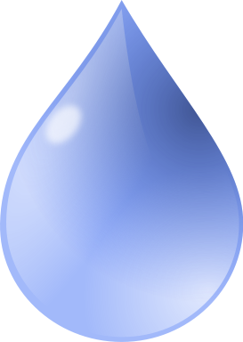
How Stuff Works: http://videos.howstuffworks.com/discovery/30198-really-big-things-hydroelectric-power-video.htm

Exploring Concepts: Spin Your Turbines

Summary: Since electricity can be produced by a variety of means, students will begin looking at the advantages and disadvantages of each method by researching the methods using the Internet. Data related to costs, raw materials, etc. should be written down. Discussion will be centered on hydroelectric, nuclear, wind, coal, and solar generating methods.

Outline:
- Students will discuss the advantages and disadvantages of various ways of producing electricity.
- Students will research hydroelectric, nuclear, wind, coal, and solar energy production and write down data relevant to each source.

Activity: In groups of 3 or 4 students, have the students go through the advantages and disadvantages of each type of power production. While conducting research about the types of power productions research should be located on each method. This data will be utilized later for a mathematical analysis of the methods.

Attachments:
M081-SHINE-Spin_Your_Turbines-E-Wrksht.doc
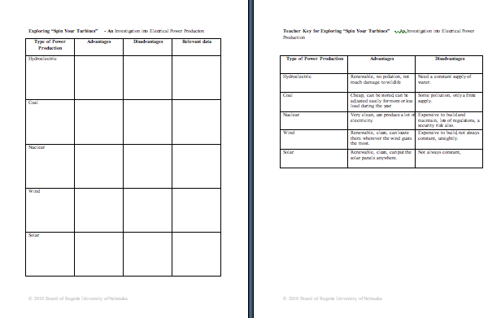

Instructing Concepts: Spin Your Turbines

Ratios and proportions

Putting “Ratios and Proportions” in Recognizable terms: Ratios are a way to compare two things. Ratios are often called rates when one of the quantities being compared is time. Proportions are two equal ratios.

Putting “Ratios and Proportions” in Conceptual terms: Ratios compare two different quantities. Those quantities can have the same units in which case the ratio has no units or the quantities can have different units in which case the ratio will have units. Proportions are two equivalent ratios and are found in many geometric and trigonometric applications.

Putting “Ratios and Proportions” in Mathematical terms: Ratios express the magnitudes of quantities relative to one another. They are a means of comparison and can be represented many different ways: Fractions, decimals, using a colon, and using the word to. For instance , , 4:5, and 4 to 5 all represent the same thing. Ratios should be given in lowest terms. If the ratio is 10 boys to 14 girls, the ratio should be given as 5 to 7. Proportions look like this and compare two equal ratios using four variables representing means and extremes. The means are b and c and the extremes are a and d. You can find any one of the variables given the other three using algebra.

Putting “Ratios and Proportions” in Process terms: Since the ratios can be represented in numerous ways the situation should dictate the form of the ratio. In sports like batting averages etc. ratios are given as decimals or percentages (.300), in recipes, ratios are given as fractions (3/4 cup), or on maps ratios are given as one scale to another scale 1 in : 100 miles. Proportions can be used to find one missing quantity from two equal ratios. They are solved using cross-multiplication (algebra) or the means-extremes product theorem (geometry).

Putting “Ratios and Proportions” in Applicable terms: Ratios can be used to compare different things. For instance you can use them to compare the size of one town to another (the first is twice the size of the second, 2:1). Ratios can be used to compare efficiency of a vehicle like 32 mpg for a car and 18 mpg for a pickup truck. Proportions can be used to find a missing quantity of two equal ratios. You can use proportions any time similar figures are present in geometry, drafting, cartography or architecture. The proportions will easily allow you to find an unknown measurement or length.

One application of ratios and proportions is finding percent change in the area of science or mathematics. A proportion can be set up , where original is what you started with and new is at the end. % change can increase or decrease. If new is larger than original it is increase and if new is smaller than original it is decrease.
Organizing Learning: Spin Your Turbines

Summary: When comparing certain efficiencies of hydroelectric power plants, a ratio might be helpful to sort through all the numbers. Every hydroelectric power plant in the world has a little bit different set of circumstances in producing their power. These variables have to be taken under consideration when evaluating current facilities or designing new hydroelectric facilities.

Outline:
- Finding the ratio of electrical production (megawatts) to the amount of flow of water (cubic feet per second) helps get a feel for the efficiency of a hydroelectric plant.
- These ratios (from 4 examples) will help in planning new hydroelectric plants.

Activity: In groups of 3 or 4, have the students work through the section “Organizing – Spin Your Turbines” to find the ratio of electrical production (megawatts) to water flow (cubic feet per second) of four known hydroelectric plants, some which should be quite famous. Using that ratio, the students are asked to do a calculation on finding the amount of power that could be produced from a given flow of water or finding the amount of water that would be needed to generate a certain amount of electrical load. Data and questions can be found in the attached file (M081-SHINE-Spin_Your_Turbines-O-Wrksht.doc).

Note: Other ratios could be found associated with costs, rainfall totals, river inflows, etc.

Attachments:
M081-SHINE-Spin_Your_Turbines-O-Wrksht.doc
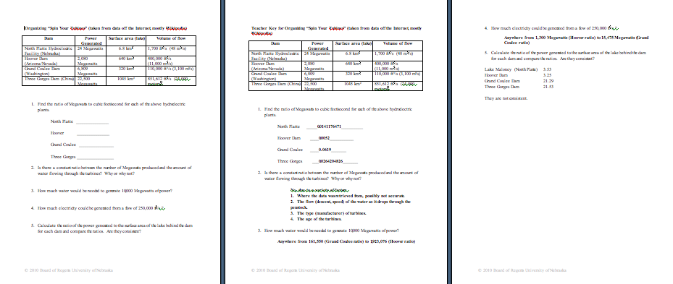

Understanding Learning: Spin Your Turbines

Summary: Students will be assessed on their understanding of ratios.

Outline:
- Formative assessment of ratios and proportions
- Summative assessment of ratios and proportions

Activity:
Students will complete written and quiz questions concerning ratios and proportions.

Formative Assessment
As students are engaged in the lesson ask these or similar questions:
- Why has water always been an important part of a nation’s needs?
- Do students understand how a ratio can be used to make comparisons?
- Were students able to calculate ratios?

Summative Assessment
Students can complete the following writing prompt:
Describe what a ratio is and how you utilized ratios in this lesson to learn something about hydroelectric power.

Students can answer the following quiz questions:
- A hydroelectric plant has a generating capacity of 50 Megawatts on a flow of water of 2,500 cubic feet/second. Calculate the ratio of the generating capacity to flow of water.

- A hydroelectric plant has a generating capacity of 100 Megawatts and has a capacity/flow ratio of 0.043. What is the amount of water that must be flowing through the penstocks?

- A hydroelectric plant has a flow of water of 700,000 cubic feet of water/second and has a capacity/flow ratio of 0.0315. What amount of electricity must this plant be producing?

