SPIRIT 2.0 Lesson:
Map Making 1
==========================Lesson Header ==========================
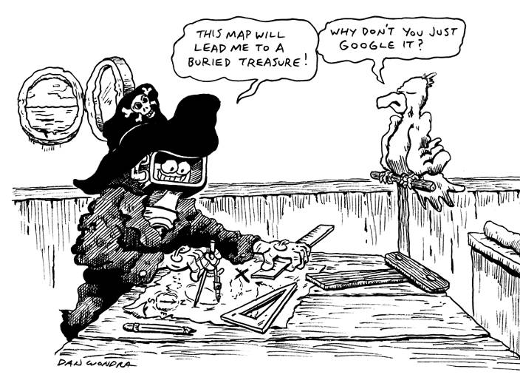
Lesson Title: Map Making 1-Coordinate Systems
Draft Date: July 3, 2010
1st Author (Writer): David Porter
Instructional Component Used: Cartography
Grade Level: 3rd-8th

Content:
- Maps use coordinate systems to ease their use in identifying locations
- Syntax of coordinate systems

Context:
- Maps are more useful when paired with an index which utilizes a coordinate system
- Coordinate systems have uses beyond cartography
Activity Description:
Activities focus on using coordinate systems. The activities include use of maps, creation of coordinate system grids on the floor, and games using coordinate systems and classroom robots.

Standards:

Technology: TA3, TB1, TC1, TC4, TD2, TF1 Engineering: EA1

Math: MD1, MD2, ME1

Materials List:
TI Calculator-controlled robot for the concluding assessment

- Classroom robots
- Graph paper
- Maps
- Tape
- Paper
- Index cards
- Markers
- Empty cereal boxes
- Milk bottle lids

A B C D E F

1
2
3
4
Asking Questions: (Map Making 1)

Summary: Students learn how coordinate systems are used to make maps more useful. They also explore other applications of coordinate systems.

Outline:
- Locate features on maps without the use of a coordinate-based index
- Coordinate systems are similar to coordinate/Cartesian planes
- Coordinate systems can be used in other settings

Activity: Provide maps to students (individually, in small groups, or projected on a screen). Have the index to the coordinates covered/hidden/removed. Ask them to find an unfamiliar small town or feature on the map. Once the first four questions, below, are discussed, reveal/hand-out the coordinate indices for the maps.

Questions | Answers
Do you feel as if you’re looking for Waldo? Why? | It’s difficult to find one little town among all of the others on a big map.
Cities usually have a system to help find addresses. How do addresses work? | Numbered streets go in one direction and numbered blocks go in the other direction. Even though the other streets usually have names, 310 Walnut Avenue means 3 blocks from the town’s central street.
Cartographers and mapmakers have a system to help locate features on maps, called a coordinate system. Do you know how it works? | Refer to the letters and numbers along the edges of the maps. Point out how the intersections of letters and numbers are unique locations.
Older Students: In what ways are maps with a coordinate system similar to and different from a coordinate/Cartesian plane? Younger students: How is this similar to the game of Battleship? | Coordinate planes use “ordered pairs” which are both numbers. A map is similar to the upper right quadrant of a coordinate plane (no negative numbers or letters are used).
Look at the index and find any town and its coordinates. Use the coordinates to locate the town on the map. | Teacher walks around to assist/formatively assess.
Locate a town/village and determine its coordinates. Locate the index and see if it agrees with you. | Teacher walks around to assist/formatively assess.
Why do the coordinates sometimes seem to be a little bit off? | The feature on the map may not line up directly with the letter and/or number on the edge of the map.
Coordinate grids such as these can also be used in other types of maps such as in search and rescue operations or minefields. How might a coordinate system be used with a robot to clear a minefield? | The grid could be used to systematically move a robot through a minefield so that there would be certainty that every square meter of ground would be swept clear of mines.

Resources: Maps (with removed/covered indices) for individual or student groups.
Exploring Concepts: (Map Making 1)

Summary: Students will create a coordinate grid system and then use a robot and pairs of coordinates to explore the system.

Outline:
- Students lay out a grid system on the floor
- Students place objects on the coordinate system
- Students challenge each other to direct a robot to specific coordinates

Activity: Students will create a coordinate grid system on the floor using folded index cards labeled with numbers on opposite sides (perhaps the north and south sides of the grid) and letters on the other set of opposite sides (east and west sides). Consider the speed of your classroom robots while determining the size of the grid so that it doesn’t take too long for the robot to travel from one coordinate pair to another. Students will each place a couple of objects within the grid and label them as items, which might be found on a map (i.e. parks, lakes, historical features, or government buildings). The coordinate pair of the objects will be placed on one side of index cards and the name of the features written on the other. Students will then take turns challenging their group members to first choose a card and then direct their robot to a particular pair of coordinates. Once the robot is at the coordinates, students will look at the back of the card to see if they have driven to the correct location.
An extension might be to provide graph paper and direct students to recreate the grid system on the floor onto the graph paper.

Resources:
- Index cards
- Markers
- Open floor area (approximately 12’ x 12’)
- Any type of classroom robots for small group use



Lake
Maverick
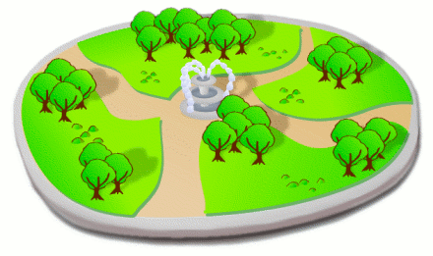
Instructing Concepts: (Map Making 1)

Mathematics of Cartography

Cartography: Cartography is the science of map making. A map is a scale drawing containing a set of points, lines, and areas that define their positions relative to a coordinate system. When making maps cartographers must use many different mathematics topics simultaneously. Some of these topics include: 1) Geometry (points, lines, areas, coordinates, etc.), 2) Scale (scale drawings), 3) Coordinate systems, and 4) Ratio and proportion. This instructional component will briefly highlight how these mathematical topics are applied in cartography.

Geometry: Maps are applied coordinate geometry. You can represent points, lines, curves, and areas that are in the real world on paper using a dilation (shrink). It is critical that the map be similar to the thing it is representing for it to be an accurate representation.

Scale: The scale on a map is the relationship between the distance on the map and the actual distance on the earth as a relative fraction (RF) or ratio. It will look something like 1:25000. This means that one unit of measurement on the map will equal 25000 of the same units in the real world. It doesn’t really matter what the unit is as long as you realize that it has to be the same for the map and in the world.
There are large scale and small scale maps. Large/small scale refers to the size of the relative fraction of the scale. Large scale maps have a scale of 1:24000 and larger fractions (smaller 2nd denominator). Small scale maps have a scale of 1:250000 and smaller (larger 2nd denominator). A good way to think about scale is if the fraction is closer to 1 then the map is more detailed.

Coordinate Systems: Coordinate systems on a map are how you are able to find a specific location. Map coordinate systems are not all that different from the Cartesian coordinate system. In fact on flat maps the Cartesian coordinate system is widely used. On the earth, locations are stated by using latitude and longitude in terms of an angle measure expressed in degrees, minutes, and seconds. Latitudes or parallels run east to west and begin with 0 degrees at the equator and increase to 90 degrees at the poles. The angles of latitude increase to the north and south on opposite sides of the equator. Longitudes or meridians run north to south and begin at the prime meridian with the angles of longitude increasing to 180 degrees east or west (half way around the globe). On the earth one degree of latitude is approximately 70 miles. One minute of latitude is a little bigger than a mile and a second is approximately 100 feet. Since latitudes are parallel a degree is always constant. The length of a degree of longitude varies from about 70 miles at the equator to zero miles at the poles because meridians are not parallel, but all intersect at the poles.

Ratio and Proportions: The map is a proportional representation of the real world. The scale on the map will be in the form or a ratio that is the scale factor between the world and the map representation. Every distance will correlate to that scale factor. This means that given the scale factor (ratio), you can measure a distance on the map and set up a proportion to find the actual distance in the world
Organizing Learning: (Map Making 1)

Summary: Students complete search and rescue missions in order to gain working knowledge of a coordinate system.

Outline:
- Students work together with a partner or small group of students to create a search area. The number of groups will depend on the number of classroom robots available.
- Each partner/small group creates a paper representation of the area and a “lost” location
- Each partner/small group then completes a search for the other’s lost child. The search process is recorded on the searcher’s graph paper map.

Activity: Pairs or small groups of students will create a representation of a wooded area on the floor using a coordinate system. The space between the letters or numbers should approximately correspond to the size of the classroom robot being used (so that the robot may occupy one of the coordinate locations). There should be approximately 10 letters and numbers (though students may choose to make it of a somewhat irregular shape). The area should be large enough to create a challenge, but not so large as to invoke frustration/use too much time. The wooded area representation may contain features such as mountains or streams (which may only able to be climbed/crossed in certain areas). The features may be placed on the floor using roll/sheets of paper, via objects such as boxes or books, put down with tape, or drawn using appropriate markers/chalk (if the floor is smooth or outdoors). For ease of use, the letters and numbers should be added on both opposing sides of the grid: for example, the numerals are placed on both the west and east sides while the letters are on the north and south sides. Folded index cards are one simple method for labeling the grid. The area must be large enough to permit movement of classroom robots through the map. Each student/small group will then create a paper version of the map, using graph paper, and secretly select a coordinate at which a child is lost and mark that location on the map. One student/small group will then use a robot to search for the lost child. The search party will begin at a coordinate of its choice. The hiding team will then tell the search party whether it has 1) found the child, 2) can hear the child (within two squares of the child), or 3) has not found the child. The searcher will then select a new coordinate to which to move, and the process is repeated until the child is found. The other search team then gets a chance to “find the child.” Each team will keep track of the path of the searcher as well as the number of searches which were made before the correct coordinate with the lost child was found. Multiple search attempts will be useful (using new graph paper each time) in order to compare search patterns. Students should conclude the activity by examining the patterns in order to discover if certain search strategies were more effective than others. Search and rescue parties typically use one of several proven patterns depending upon the terrain and number of searchers. The patterns include a spiral, sector search, or parallel movement search. Each relies on accurate use of maps and coordinate system in order to insure that every possible location has been searched.

Resources:
- Classroom robots
- Graph paper
- Tape
- Large sheets/rolls of paper
Understanding Learning: (Map Making 1)

Summary: A game (ShuffleBot) is played in order to assess students’ understanding of a coordinate system.

Outline:
- Formative assessment of cartography
- Summative assessment of cartography

Activity: Students will complete a performance assessment of cartography by competing against each other in a game.

Formative Assessment: As students are preparing for the summative assessment, ask these or similar questions:
- Were students able to understand and use the coordinates on a map?
- Do students understand the importance of coordinates as they relate to maps?
- Were students able to use coordinates to successfully move the robot?

Summative Assessment: Students can complete the following performance assessment:
- Students will compete in a game using the TI-Bot to place and remove objects from a coordinate grid. Students will program the robot to place their object on the grid and try to remove someone else’s. Points are based on the number and location of where the markers end up. For complete instructions, set-up information, and sample grid layouts, see the attached file: M082-Map_Making1-U-game.doc. Students will be assessed on the accuracy of their point totals at the end of the game.

Resources:
- TI Calculator-controlled classroom robot
- Empty cereal boxes
- Milk bottle tops
- Tape
- Graph paper

Attachments: M082_Map_Making1_U_game.doc
