SPIRIT 2.0 Lesson:
Map Making 2
==========================Lesson Header ==========================
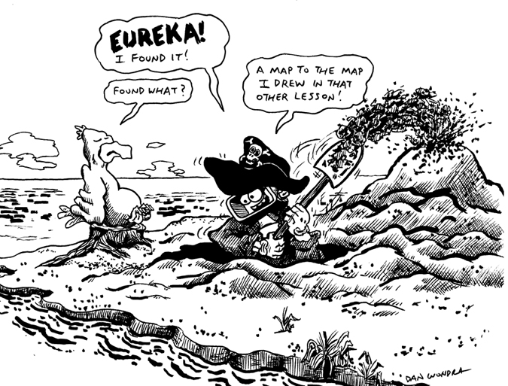
Lesson Title: Map Making 2-Scale
Draft Date: July 14, 2010
1st Author (Writer): David Porter
Instructional Component Used: Cartography
Grade Level: 6th-8th

Content:
- All maps use the concept of scale to accurately represent reality in a reduced size
- Practice determining scale

Context:
- Commercially created maps are examined
- Scale sizes are investigated and determined
- A neighborhood is created and then mapped
Activity Description:
Students use maps to learn about map scales and ratios. Students will practice determining ratios and scales of life-like objects. Students then calculate the scale of a classroom robot (comparing it to a larger object such as a type of car). They use this scale to create a simple network of roads and buildings for the robot to traverse. The students then take careful measurements of the robot’s neighborhood. The measurements are used to scale-accurate maps of the neighborhood.

Standards:

Technology: TA3, TD2 Math: MA3, MB2, MD1, MD2

Materials List:
Maps (in varied scales) of the area including the school

- Classroom robots
- Calculators
- Measuring tapes
- Rulers
- Paper
- Pencils
- Toy car and doll
- Optional: sidewalk chalk

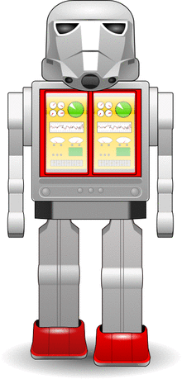
Asking Questions: (Map Making 2)

Summary: Students work with maps learning about their scales and ratios.

Outline:
- Differences in scales between maps are discovered
- Ratios are calculated and discussed

Activity: Students will use maps to learn about the scale and the ratios that can be used to find the “real” or “scaled” distance. Guiding questions are below.
Questions | Answers
What similarities and differences are there between these maps? | Many answers. If anyone mentions size of area shown remember to refer to that later.
Get out a ruler. Measure the size of the city in which the school is located (or a city which is near to the school). How large is the city? | Varied answers.
Why are there so many different answers? Are these maps inaccurate? What’s going on? | The maps show different amounts of the real world. The scale of the maps are different.
Find the scale on the map. What are they? | Teacher writes the scales on the board.
This scale compares inches to miles or cm to km. Every inch on the map is equal to that amount in the real city. How many miles/km does your map represent from side to side? | Students will need to measure the maps from side to side and then multiply that amount times the amount in the scale. Varied answers.
How could we compare inches to inches—that is if one inch equals 3 miles, how many inches does one inch equal? How many inches in a mile? In three miles? | How many feet in one mile (5,280)? How many inches in one mile (5,280 x 12)? How many inches in three miles (63,360 x 3)? The answer is 190,080 inches.
We can create a ratio with this answer. The ratio is 1:190,080. This could mean 1” = 190,080”. But it could also mean that 1 cm on the map = 190,080 cm in reality. That’s a big number. Are the ratios the same for all of our maps? If not, which of our maps would have a smaller number? | Not expecting agreement on an accurate answer. Lead students through the next questions.
Let’s each calculate the ratio of our map. Find the scale. Convert miles to inches or kilometers to centimeters. You may need to measure the scale with your ruler to find out what one inch or one centimeter equals on the map. | Each student will have a ratio for his/her map. Write the ratios on the board.
We can see that the ratio with the smallest number is _________and the ratio with the largest number is___________. What have we learned about the relationship between ratios and maps? | The larger the second number is in the ratio, the less detailed is the map. The smaller the second number is in the ratio, the more detailed—the smaller the area shown on the map.
Challenge : if you were to create a road map of the solar system, how large would the sun be? | If a normal sized road map is used and Pluto’s orbit used. The sun would be only .0085” (1/10 the size of a head of a pin.
Resources:
- Regional map
- USA map
- Globe
- Maps for individuals/small groups of varying scales, which
include the city/neighboring city of the students’ school district
- City map
- County and/or state map
Exploring Concepts: (Map Making 2)

Summary: Students will imagine a classroom robot as life size or as large as a car. They will determine its scale size. Finally, they will calculate how large a person and other objects would be if they were in the same scale.

Outline:
- The teacher leads students through the process of determining the scale size of an object
- Students then determine the scale sizes of a classroom robot and themselves

Activity: The teacher will ask the students to consider the classroom robot as a miniature. How large would it be if it were as big as a car (or as large as a dinosaur/human being—depending upon the type of robot being used)? What scale is it? That is, what is the ratio, which describes its proportion to a full size car? The teacher will demonstrate with objects such as a toy car and doll. First s/he asks a student to measure the object. We’ll start with the car (inches or centimeters). Then a measurement (actually measuring a car or use of a website) of a car is obtained. If the car is 3” long (rounding to the nearest inch or half inch) and the real car is 190”, then the ratio is 3:190. Divide both sides by 3 and the ratio is 1:63 or a 1/63 scale. Repeat with the doll, this time using a measurement of an appropriate human. Tell students that the resulting ratio works with any unit of measurement—inches or centimeters (kind of like recipes which call for 1 part of one ingredient and 3 parts of another).

Students will then determine the scale of the robot. The TI Calculator controlled robot is approximately 9” long. It’s a sleek little bot, so we’ll compare it to a Ford Mustang which is 188” long. The ratio is 9:188 or 1:21. The students’ results will differ according to the robot being used.

Students will then determine how large they would be reduced to the same scale (divide an adult’s height by 21—72”/21=3.4”). For this robot we’d need a 3.4” figure to accurately represent a 6’ person. Each student will determine this for themselves for their robot.

If time/interest permits, other objects could be reduced to the same scale: a school bus, the school itself…

Challenge: determine the scaled speed of the robot. See if students can figure out how to do it. (Time how long it takes for the robot to travel a measured distance, perhaps ten feet. Multiply this distance by the scale of the robot. Convert this distance to feet. This gives feet/some number of seconds. Divide by the number of seconds to get a feet/second result. Multiply by 3600 to get feet/hour, then divide by 5,280 to get miles/hour.)

Resources:
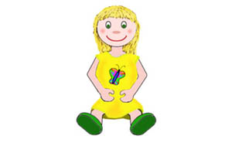
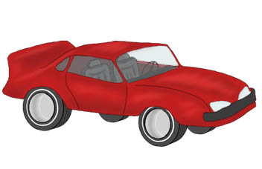
- Classroom robot
- Measuring devices: rulers and/or measuring tapes
- Toy car
- Doll
- Calculators
- Paper
- Pencils
Instructing Concepts: (Map Making 2)

Mathematics of Cartography

Cartography is the science of map making. A map is a scale drawing containing a set of points, lines, and areas that define their positions relative to a coordinate system. When making maps cartographers must use many different mathematics topics simultaneously. Some of these topics include: 1) Geometry (points, lines, areas, coordinates, etc.), 2) Scale (scale drawings), 3) Coordinate systems, and 4) Ratio and proportion. This instructional component will briefly highlight how these mathematical topics are applied in cartography.

Geometry: Maps are applied coordinate geometry. You can represent points, lines, curves, and areas that are in the real world on paper using a dilation (shrink). It is critical that the map be similar to the thing it is representing for it to be an accurate representation.

Scale: The scale on a map is the relationship between the distance on the map and the actual distance on the earth as a relative fraction (RF) or ratio. It will look something like 1:25000. This means that one unit of measurement on the map will equal 25000 of the same units in the real world. It doesn’t really matter what the unit is as long as you realize that it has to be the same for the map and in the world.
There are large scale and small scale maps. Large/small scale refers to the size of the relative fraction of the scale. Large scale maps have a scale of 1:24000 and larger fractions (smaller 2nd denominator). Small scale maps have a scale of 1:250000 and smaller (larger 2nd denominator). A good way to think about scale is if the fraction is closer to 1 then the map is more detailed.

Coordinate Systems: Coordinate systems on a map are how you are able to find a specific location. Map coordinate systems are not all that different from the Cartesian coordinate system. In fact on flat maps the Cartesian coordinate system is widely used. On the earth, locations are stated by using latitude and longitude in terms of an angle measure expressed in degrees, minutes, and seconds. Latitudes or parallels run east to west and begin with 0 degrees at the equator and increase to 90 degrees at the poles. The angles of latitude increase to the north and south on opposite sides of the equator. Longitudes or meridians run north to south and begin at the prime meridian with the angles of longitude increasing to 180 degrees east or west (half way around the globe). On the earth one degree of latitude is approximately 70 miles. One minute of latitude is a little bigger than a mile and a second is approximately 100 feet. Since latitudes are parallel a degree is always constant. The length of a degree of longitude varies from about 70 miles at the equator to zero miles at the poles because meridians are not parallel, but all intersect at the poles.

Ratio and Proportions: The map is a proportional representation of the real world. The scale on the map will be in the form or a ratio that is the scale factor between the world and the map representation. Every distance will correlate to that scale factor. This means that given the scale factor (ratio), you can measure a distance on the map and set up a proportion to find the actual distance in the world.
Organizing Learning: (Map Making 2)

Summary: Students determine the scale of a classroom robot in relationship to a motor vehicle. They then create a scale model neighborhood for the robot.

Outline:
- Students will imagine that the classroom robot is a particular object, such as a car or truck. They will then determine the scale of the robot.
- Students will create roads and buildings which are in scale with the robot.
- Measurements are carefully taken of the completed neighborhood, to be used for assessment purposes.

Activity: Select one type of available classroom robot (perhaps one for which more than one is available. This lesson will use a wheeled CEENBoT. If a different type is chosen such as a dinosaur style, the lesson could be adapted to represent a prehistoric scene. Students will determine the scale of the robot. They will then use this scale to create a neighborhood/network of roads and buildings through which to drive the robot. Roads, buildings, and other features should all be created according to the scale of the robot. For example, the CEENBoT is approximately 10” long. It is somewhat Jeep-like. A Jeep Wrangler is 164” long, resulting in a 1:16 scale. Therefore, a 28’ wide two lane road would be 21” wide (28’/16 x 12”). Given this scale, the resulting neighborhood will be quite large (a 30’ x 40’ house would be 22.5” x 30”). To reduce the time required for the project, have appropriately sized objects “stand-in” for buildings (boxes, chairs, desks, tables). Easily removable tape quickly provides roadway edges. Depending upon the time of year and climate, this activity could also be accomplished outside using sidewalk chalk and a paved play area.

Finally, students can enjoy taking turns driving their robots through their neighborhood while others take measurements. Each student will be responsible for recording measurements for the “U” (assessment) portion of the lesson. All measurements should be taken from an overhead point of view (as in a map). The overall size of the neighborhood, roads and buildings, and any other features should be recorded. The map-making will be greatly simplified if all measurements are recorded in metric units.

If more than one size of classroom robot is available/used, one should be used to determine the scale. The other(s) could be identified as different types of vehicles (tractor trailers or mini-Coopers).

A challenge option is to locate the neighborhood as it exists within the classroom. Measurements would then need to be taken of the overall classroom size, key features (such as the teacher’s desk), and the distances between the neighborhood and the classroom’s walls.

Resources:
- Boxes
- Paper and pencils
- Option of sidewalk chalk

- Classroom robots
- Calculators
- Easily-removable tape
- Measuring devices such as rulers,
yard/meter sticks, and measuring tapes
Understanding Learning: (Map Making 2)

Summary: Students will use the data obtained in the “O” portion of the Map Making 2 lesson (or record similar information from some portion of the school grounds) in order to create a map.

Outline:
- Formative assessment of cartography
- Summative assessment of cartography

Activity: Students will complete a performance assessment based on cartography.
Formative Assessment
- Can students apply the concept of scale when making maps?
- Do student understand that a map is useless without a proper scale?
- Were students able to use scale to “resize” their robots?

Summative Assessment: Students can complete the following performance assessment:
- Students will create a map of the robot’s neighborhood, to scale, according to the size of their paper. The map will include a key/legend which denotes the scale and any symbols used on the map. Below are detailed instructions:

Students will be given the choice of a variety of sizes of papers in order to create a map of the class-created neighborhood (see the “O” portion of “Map Making 2”). Their maps will need to include the entire neighborhood and fill the paper, thus each student or small group will need to create their own scale for the map they make. All features should be included on the map and in the appropriately scaled size for full credit. The teacher will likely need to model the process for the class, something like this:

My imaginary neighborhood was 95” wide and 124” long—not the same as yours so you can’t use my figures, sorry ☺. My paper is 10” square. I’ll use the longer dimension to figure out the scale so that the map will fit on the paper. 124”/10” = 12.4. I have a 1:12.4 ratio. Therefore, every inch in the robot’s neighborhood will need to be divided by 12.4 in order to get the correct size on my map. The road was 53 cm wide in the robot’s neighborhood. I’ll divide that by 12.4 and find that the road on my map should be 4.3 cm wide. The main road was 249 cm long. Dividing that by 12.4 tells me that the road on my map should be 20 cm long.

Maps should have a key, or legend, which includes the scale and explanation of any symbols used on the map. Maps may include a coordinate system along the edges with an index.

The challenge students’ maps will include the classroom area surrounding the robots’ neighborhood.

Resources:
- “Real-world” measurements from the robot’s neighborhood in the “O” portion of this lesson
- A variety of sizes of sheets of paper, ranging from legal size up to 24” x 36” NOTE: If the lesson is to be completed within the classroom, paper sizes may need to be towards the smaller end of the spectrum for practicality
- Calculators
- Rulers
- Pencils and erasers

