Project SHINE Lesson:
This Teacher was mentored by:


www.bd.com

In partnership with Project SHINE grant funded through the

National Science Foundation

Defining the Curve
==========================Lesson Header ==========================
Lesson Title: Defining the Curve
Draft Date: June 13, 2011
1st Author (Writer): Robert S. Rail
Associated Business: BD Pharmaceutical
Instructional Component Used: Central Tendency
Grade Level: 10 – 12 (Algebra II)

Content (what is taught):
- Measurement
- Mean = Sum of data values/ total number of data values
- Variance = Distance from the mean
- Application of Standard Deviation = Square root of mean of squares of variances

Context (how it is taught):
- Measurement of diameters of cylindrical objects
- Computation of mean, variance, and standard deviation
- Graphing of results
Activity Description:
In this lesson, students investigate normal data distribution as used by manufacturing quality control processes.

Standards:

Math: ME1, ME2, ME3 Science: SA1, SA2

Technology: TA3, TA4 Engineering: EA1, EB5

Materials List:
- Samples sets of cylindrical objects (ones with noticeable variation and one from a manufacturing process) NOTE: you will need sets for each group of students.
- Calipers (3 per group)
- Data charts and pencils (1 per student)
- Graphing calculator or access to Excel
Asking Questions: (Defining the Curve)

Summary: Students decide the level of quality achievable in a human-designed process.

Outline:
- Agree to an acceptable level of success or failure
- Determine a method of measuring and displaying success to failure ratios
- Discuss the standards used by manufacturing plants to control product quality

Activity: A classroom discussion will be conducted centered on success and failure. Students will be asked to consider what success and failure are and what are acceptable levels of success and failure. Does the situation matter? Are there degrees of success and failure? Consider terrorism. The terrorist only have to succeed 1 out of 1000 attempts for it to be considered success where the people trying to stop terrorism would see that as failure. Does success/failure have connections to business processes? Be sure to cover questions like the ones below.

Questions | Answers
What is an unacceptable level of success? | 95% to 100% depending on the process
How would you measure it? | Rulers, calipers, micrometers, cameras
Can you see an unacceptable level of success? If so, how would you display or graph it? | Yes – high volume of rejects, discards, customer complaints.  Recorded data and graphs
What would the control graph or success distribution look like? | Bell curve (histograph)
What would happen to your graph if your failure rate increased? | The bell curve would lengthen from end to end and flatten out at the mean
What would happen to your graph if your failure rate decreased? | The bell curve would shorten from end to end and spike at the mean

Resources:
- BD: Medical Supplies; Devices and Technology; Laboratory Products; Antibodies http://www.bd.com
Success
Failure
Exploring Concepts: (Defining the Curve)

Summary: Students will investigate normal data distribution as used by manufacturing quality control processes.

Outline:
- Break students into quality control teams.
- Give each team a box of cylindrical objects to be measured (choose items like to have a high variance level such as ink cartridges, pencils, pen barrels, etc). The diameter of each item will be measured three times using a ruler.
- Students will compute the mean of the diameter, the variances from the mean, and the standard deviations for the set.
- Students will chart and graph the diameter of each item, the mean, and the standard deviations of the set of measurements.

Activity: Have students get into pairs or groups. Give students sample product sets to evaluate. Note: these sample items should have a higher variance between the samples. Students should see that the objects have that variance when they graph the results. The sample set should contain 15 – 20 similarly-sized cylindrical items (These objects are just random cylindrical objects and should be close in size but have some noticeable differences), rulers, and measurement tables (see attached). Each item in the box should be measured for diameter by 3 different students in the groups with the average of the 3 measurements being recorded and used for further calculations and graphing. Students should then complete the worksheet which will allow them to find standard deviation and answer questions about standard deviation. The following calculations need to be completed:

- Sample Mean = Average of all the sample measurements.
- Variance = Absolute value of the Sample Mean minus the sample measurement.
- Variance² = Square the Variance of each sample measurement.
- Average Variance² = Average of the Variance² of all the samples.
- Standard Deviation = Square root of the Average Variance².

Finally, have the students graph the three standard deviations below and above the mean as shown on the bell curve below.

Attachments: M085_Defining_the_curve_E_Chart.doc
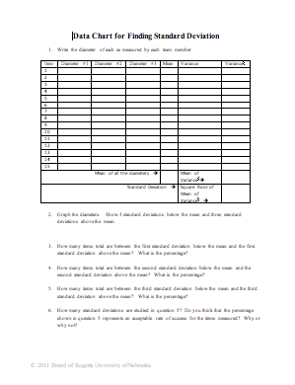
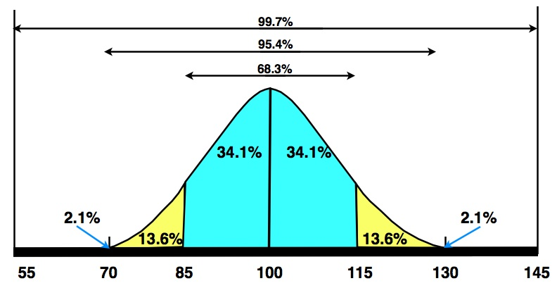

Instructing Concepts: (Defining the Curve)

Central Tendency

Putting “Central Tendency” in Recognizable Terms: Central tendency refers to the “middle” number of a set of data. There are three main measures of central tendency: mean, median, and mode. Which one is best depends on the data.

Putting “Central Tendency” in Conceptual Terms: The three measures of central tendency are all slightly different. The most common is the mean or average, the median is the center most value where ½ of the data lies above and ½ lies below, and the mode is the value with the most frequent occurrences in the data set.

Putting “Central Tendency” in Mathematical Terms: Each of the measures of central tendency can be found mathematically. By summing the data and dividing by the number of pieces of data in the set, you can calculate the mean or average. The formula for mean is $m=\frac{1}{n}\sum_{i=1}^{n}{x_{i}}$ where $m$ is mean, n is the number of elements of data in the set and $x_{i}$ is the elements of data. Median is found by placing the data in ascending order, and then locating the middle value. If there are an odd number of elements in the set, the median is the middle element and will be included in the data set. If there is an even number of elements in the set, the median is found by averaging the middle two elements and this median number will not occur in the original data set. Mode is found by simply counting the elements in the data set and is the most prevalent element.

Putting “Central Tendency” in Process Terms: Central tendency discusses the middle of a set of data. Mean is the most common measure of central tendency but it is affected by outliers or data that deviates radically from the rest of the data in the set. Median is better in situations where data is skewed. Take for instance home prices. If there are 20 houses and 19 of them are worth between $50,000 and $150,000 and the 20th house is worth $2,000,000, the average will be affected by the house with the large value but the median will be much more representative of the data. Mode is useful in situations where data is categorical like what is the most popular type of book in a store or most popular movie.

Putting “Central Tendency” in Applicable Terms: There are other ideas relating to central tendency that are important. Range is the space between the smallest and largest values in the data set. Standard deviation is a measure of how far elements will tend to differ from the mean. These ideas together with the measures of central tendency allow us to make comparisons between an element in the data set and the “middle” value. These comparisons allow us to understand trends that are present in the data set.

Standard Deviation is a mathematical concept that is closely related to the measures of central tendency. Standard deviation measures the dispersion or variation of the data from the sample mean. A high standard deviation is related to data which is very different from the mean. Where a low standard deviation indicates data that is very close to the mean. Standard deviation can be found using the formula:
where is standard deviation, n is the total number of data points in the population, x_{i} is each individual piece of data, and is the population mean.
Organizing Learning: (Defining the Curve)

Summary: Students will find the accuracy of a production process through the use of product measurement, computation of mean, determination of product variance, and computation of standard deviation. All measurements and calculations will be graphed using the bell curve form of histogram.

Outline:
- Give each group a box of cylindrical objects to be measured. The diameter of each item is to be measured three times using a caliper. NOTE: These objects should have a low variance like object from a machine process.
- Students will compute the mean of the diameter, the variances from the mean, and the standard deviations for the set
- Students will chart and graph the diameter of each item and the mean and the standard deviations of the set of measurements

Activity: NOTE: this activity is similar to another activity in the lesson. Here students should be working with samples with low variances like medical syringes or some other carefully manufactured object). Start by having students get into groups. Give each group a box of 15 – 20 similarly-sized cylindrical items (such as syringe barrels, pen barrels, ink cartridges, etc.), calipers, and measurement tables (see attached). Each item in the box should be measured for diameter by 3 different students in the groups with the average of the 3 measurements being recorded and used for further calculations and graphing. Students should then complete the worksheet which will allow them to find standard deviation and answer questions about standard deviation. The following calculations need to be completed:

- Sample Mean = Average of all the sample measurements.
- Variance = Absolute value of the Sample Mean minus the sample measurement.
- Variance² = Square the Variance of each sample measurement.
- Average Variance² = Average of the Variance² of all the samples.
- Standard Deviation = Square root of the Average Variance².

Finally, have the students graph the three standard deviations below and above the mean as shown on the measurements graph. Students should then discuss how a set of objects from a manufacturing process compare to random round objects using the mathematical concepts: mean, variance and standard deviation.

Attachments: M085_Defining_the_curve_O_Chart.doc

Understanding Learning: (Defining the Curve)

Summary: Students will write an explanation of how standard deviation can be used to control quality and reduce delivered defects in a manufacturing environment.

Outline:
- Formative assessment of central tendency (standard deviation)
- Summative assessment of central tendency (standard deviation)

Activity:
Formative Assessment: As students are engaged in the lesson, teacher walks around and asks these or similar questions to students to get idea of their understanding of average:
- What percentage of items measured will fall within one standard deviation of the mean (high or low)?
- What percentage of items measured will not fall within three standard deviations of the mean (high or low)?
- How do you think this principle can be applied outside of math class?

Summative Assessment: Students will complete the following writing prompts about standard deviation:
- Using the data that you have collected: what would happen to your mean and standard deviation if you drop the lowest two measurements? How would this impact your failure ratio and why?
- Write an explanation of why standard deviation is used in standardized testing, demographics, and quality control?

Students will complete the following quiz questions about standard deviation:
1) Which bell curve below has the highest standard deviation?
2) Which has the lowest standard deviation?
3) State what standard deviation means relative to each bell curve.

A  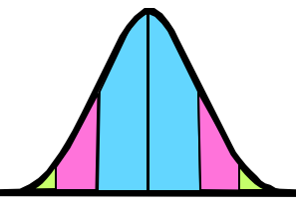 | B 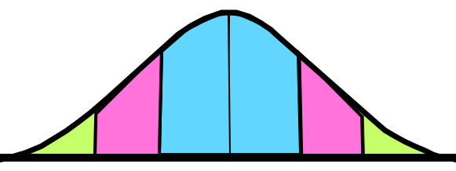 | C  