SHINE Lesson:
This Teacher was mentored by:


www.nppd.com

In partnership with Project SHINE grant funded through the

National Science Foundation

“Em-Brace It”
===============================THEATRE===========================
Lesson Title: Em-Brace It
Draft Date: June 9, 2011
1st Author (Writer): Amanda Berg
Associated Business: Nebraska Public Power District
Instructional Component Used: Pythagorean Theorem
Grade Level: Theater 9-12

Outline of Lesson
“To live a creative life, we must lose our fear of being wrong.”

Content (what is taught):
- Pythagorean Theorem
- Angles created by electrical poles
- Angles created by theatrical flats
- How to solve equations using the Pythagorean Theorem

Context (how it is taught):
- Small group discussion
- Class discussion
- Equation worksheet
- Group work to design/build a theatrical flat
Activity Description:
Class will begin with a discussion of electricity. Students will begin to think about the Pythagorean Theorem in relation to electrical poles. Then students will move on to find comparisons between angles created by electrical poles, and those created by theatrical flats. Students will work together in groups of 3-4 to solve a Pythagorean Theorem worksheet. Once this is mastered, students will move on to build a theatrical flat using the skills they learned in relation to the Pythagorean Theorem.

Standards:
Math: MD2 Science: SF5

Technology: TD2 Engineering: EB1

Materials List:
- Copies of Pythagorean Theorem worksheet (M086_SHINE_Em-Brace_It_E_Wrksht.doc)
- Graphing paper, rulers, and pencils
- Pictures of electrical poles/pictures of theatrical flats
- Pre-constructed flats, and pre-constructed pieces of wood to formulate the braces
- Nails, hammer, screws, drill, hinges, and safety goggles
Asking Questions: (Em-Brace It)

Summary: As a class, students will work together to answer questions about the source and path of electricity. They will begin to think about the process electricity takes from coal/water, to the light switch. They will also answer questions in relation to electricity, the Pythagorean Theorem, and theatre.

Outline:
- Ask questions about electricity, getting your students to think about the electrical poles
- Ask questions about the Pythagorean Theorem to ensure students have a basic understanding of how to use and apply it
- Ask students if they can see connections or parallels between the above mentioned concepts, and theatre (specifically when building a set)

Activity: The teacher will lead the class in a discussion about electricity. The teacher will ask questions that assist students in drawing connections between electrical poles and the Pythagorean Theorem. From there, the teacher will lead students to draw connections between angles created by electrical poles, and angles created by theatrical flats. They will see that the Pythagorean Theorem is necessary when constructing both.

Questions | Answers
What does NPPD do? | They harness, and maintain power in Nebraska
Flip on a light switch and ask where the electricity came from? | Discuss the path it takes from a coal plant, through the power lines, to the building.
What do you need to consider before putting up an electrical pole? | Is the ground level? Environmental issues? How to brace it? Length of wire? Etc?
How does this relate to theatre, when building a set? | The same concept is true when you attach a brace to the back of a flat.
a + b = c
2
2
2
Exploring Concepts: (Em-Brace It)

Summary: Before you begin, review how to use the Pythagorean Theorem. Students will work in groups of 3-4 to solve some basic Pythagorean Theorem problems that focus on the angles that electrical poles create with a brace wire, and the ground.

Outline:
- Students will look at images of electrical poles with a wire brace
- The concept of Pythagorean Theorem will be introduced/reviewed
- Students will complete a worksheet using the Pythagorean Theorem

Activity: The activity begins by looking at pictures of electrical poles that create angles with the ground, and a connected wire brace. Have students discuss how they could use the Pythagorean Theorem to solve for all sides of the created angle. After discussion, students will work on finishing a worksheet with related problems to solve using the Pythagorean Theorem. Do one problem with the class, and then allow them to work in groups of 3-4 to finish the worksheet. When completed, review the solutions with the class. Before moving on, make sure that students understand how to successfully use the Pythagorean Theorem to solve for all sides of the created angle.

Attachments: M086_SHINE_Em-Brace_It_E_Wrksht.doc
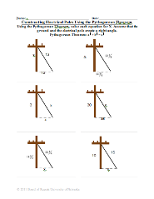

Resources: Images of electrical poles can be found by doing an image search on Google and/or you can take pictures of poles in your community.
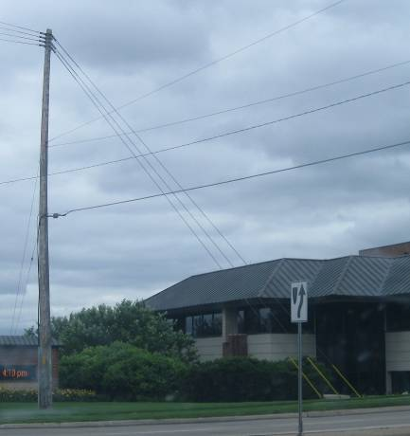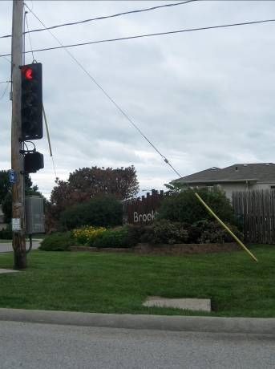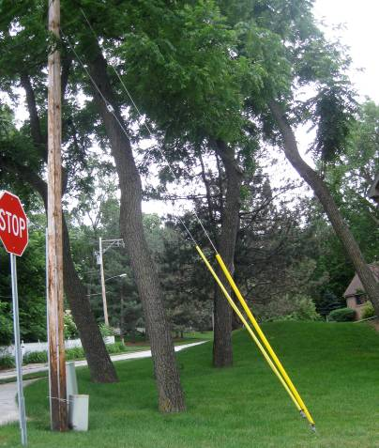
Instructing Concepts: (Em-Brace It)

Pythagorean Theorem

Putting “Pythagorean Theorem” in Recognizable Terms: The Pythagorean Theorem establishes the quantitative relationship between the three sides of any right triangle. It applies to all right triangles. A right triangle is any triangle that contains one right angle (90 degrees).

Putting “Pythagorean Theorem” in Conceptual Terms: The hypotenuse of a right triangle is the side across from the right angle. The hypotenuse does not touch the right angle. The other two sides, the sides that include the right angle, are called the “legs” of the right triangle. These legs may be called “a” and “b”. The hypotenuse is often called “c”. The sum of the squares of the lengths of the legs of a right triangle is equal to the square of the length of the hypotenuse of that right triangle.

Putting “Pythagorean Theorem” in Mathematical Terms: a ² + b ² = c ² . Then by algebraic rearrangement the following relationships are also true for all right triangles:
- c = SQRT(a ² + b ²)
- a ² = c ² – b ² and b ² = c ² – a ²
- a = SQRT(c ² – b ²) and b = SQRT(c ² – a ²)
Putting “Pythagorean Theorem” in Process Terms: Due to the Pythagorean Theorem, we can solve for any unknown side of a right triangle if we know the lengths of the other two sides (by simple substitution).

Putting “Pythagorean Theorem” in Applicable Terms: Drive the dot along a [straight] line from the origin. Stop it at irregular (random) time intervals and estimate its position by looking at the coordinates of its position at rest. Calculate the distance it has traveled by taking the square root of the sum of the squares of the legs of the right triangle formed by the x coordinate, the y coordinate, and the origin.
Organizing Learning: (Em-Brace It)

Summary: Electrical poles and theatrical flats have one major thing in common, and that is the Pythagorean Theorem. Students will use this formula to draw a sketch of a flat with two braces. The drawing must be labeled and to scale with a key in the lower left hand corner.

Outline:
- Students will relate electrical pole braces and braces on theatrical flats.
- Scale drawings of a flat will be completed.

Activity: The activity will begin with a discussion comparing the angles created by electrical poles, with the angles created by theatrical flats. Pass around a picture of an electrical pole, and one of a theatrical flat. Students should observe and write down the similarities and differences. Students then will work in groups of 3-4 to create a drawing of a theatrical flat. While they are working, they need to keep the following criteria in mind; the drawing must contain one flat with at least 2 braces connected to the back. In addition, it must be to scale, labeled, and have a key in the lower left hand corner. When students are finished, they must share and compare their drawing with one other group.

Materials:
- Graph paper

Resources: Images of theatrical flats and electrical poles can be found by doing an image search on Google.
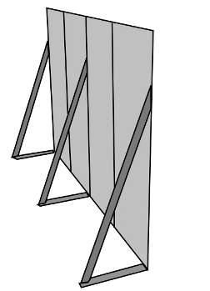
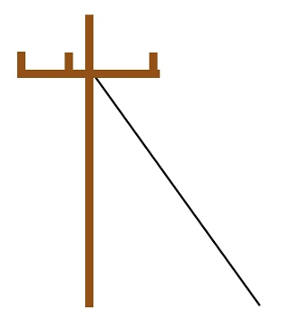
VS.

Understanding Learning: (Em-Brace It)

Summary: Students will demonstrate an ability to use the Pythagorean Theorem by solving math equations, as well as constructing their own theatrical flats.

Outline:
- Formative assessment of Pythagorean Theorem
- Summative assessment of Pythagorean Theorem

Activity: Students will complete written and performance assessments relating to the Pythagorean theorem.

Formative Assessment: As students are engaged in the lesson, ask these or similar questions:
1) Do students understand the general flow of electricity from its source, to a light switch?
2) Can students use the Pythagorean Theorem to solve for “x”?
3) Can students use the Pythagorean Theorem to create a scale drawing of a flat with 2 braces?
4) Can students see the correlation between constructing electrical poles and constructing theatrical flats?

Summative Assessment: Students can complete the following writing prompt:
What is the Pythagorean Theorem and cite 3 examples in the real world where it could be applied. Pick one of your examples and create a problem that you can solve using the Pythagorean Theorem.

Students can complete the following performance assessment:
Students will build a “flat” that can be use in a theater production. The construction of the flat will utilize the Pythagorean theorem for the bracing. Below is a set of steps for the project.

1) Students should work in groups of 3-4.
2) Each group will build a flat using the scale drawing their group created or was provided.
3) Brace pieces should be assembled. Be sure that the braces are appropriate size for the overall flat.
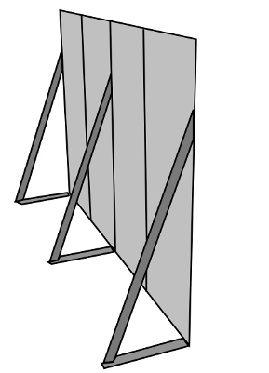
4) Hinges should be used to attach the braces to the flat.
5) The hinges need to be attached so that they fold into the flat.
6) When they are finished, insure that the flat can safely stand on its own.
7) At all times, ensure that the group members are being safe.

