Name:_________________________________________ Date:_________________________
Constructing Electrical Poles Using the Pythagorean Theorem
Using the Pythagorean Theorem, solve each equation for X. Assume that the ground and the electrical pole create a right angle.
Pythagorean Theorem: a ² + b ² = c ²
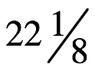
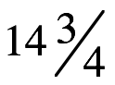
13
12
x
x



______________________________________ _____________________________________
x
38
30

3
x

4

______________________________________ _____________________________________

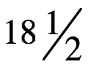
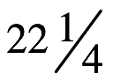
x
15
x
10

______________________________________ _____________________________________

