Extension Activity for Graphical Understanding of the Derivative

Below is the sketch of a function . Sketch the graph of the derivative of this function
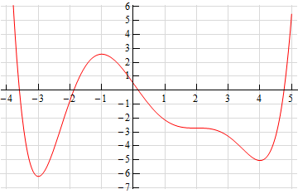
Solution to Extension Activity

- If you have some basic knowledge of the interpretations of the derivative you can get a sketch of the derivative. It will not be a perfect sketch for the most part, but you should be able to get most of the basic features of the derivative in the sketch.
- Let’s start off with the following sketch of the function with a couple of additions.
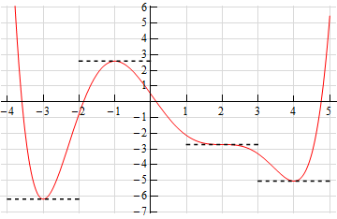

- Notice that at x = -3, x = -1, x = 2 and x = 4 the tangent line to the function is horizontal. This means that the slope of the tangent line must be zero. Now, we know that the slope of the tangent line at a particular point is also the value of the derivative of the function at that point. Therefore, we now know that, .

- This is a good starting point for us. It gives us a few points on the graph of the derivative. It also breaks the domain of the function up into regions where the function is increasing and decreasing. We know that if the function is increasing at a point then the derivative must be positive at that point. We also know that if the function is decreasing at a point then the derivative must be negative at that point.

- We can now give the following information about the derivative:

- Remember that we are giving the signs of the derivatives here and whether the function is increasing or decreasing. The sign of the function itself is completely immaterial here and will not in any way effect the sign of the derivative.

- This may still seem like we don’t have enough information to get a sketch, but we can get a little bit more information about the derivative from the graph of the function. In the range we know that the derivative must be negative, however we can also see that the derivative needs to be increasing in this range. It is negative here until we reach x = -3 and at this point the derivative must be zero. The only way for the derivative to be negative to the left of x = -3 and zero at x = -3 is for the derivative to increase as we increase x towards x = -3.

- Now, in the range -3 < x < -1 we know that the derivative must be zero at the endpoints and positive in between the two endpoints. Directly to the right of x = -3 the derivative must also be increasing (because it starts at zero and then goes positive - therefore it must be increasing). So, the derivative in this range must start out increasing and must eventually get back to zero at
x = - 1. So, at some point in this interval the derivative must start decreasing before it reaches
x = - 1, Now, we have to be careful here because this is just general behavior here at the two endpoints. We won’t know where the derivative goes from increasing to decreasing and it may well change between increasing and decreasing several times before we reach x = - 1. All we can really say is that immediately to the right of x = - 3 the derivative will be increasing and immediately to the left of x = - 1 the derivative will be decreasing.

- Next, for the ranges -1 < x < 2 and 2 < x < 4 we know the derivative will be zero at the endpoints and negative in between. Also, we can see in each of these ranges that the derivative will be decreasing just to the right of the left hand endpoint and increasing just to the left of the right hand endpoint.

- Finally, in the last region x > 4 we know that the derivative is zero at x = 4 and positive to the right of x = 4 Once again, following the reasoning above, the derivative must also be increasing in this range. Putting all of this material together (and always taking the simplest choices for increasing and/or decreasing information) gives us the following sketch for the derivative.

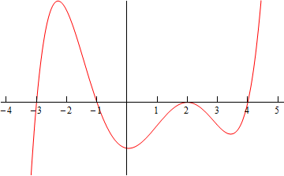
- Note that this was done with the actual derivative and so is in fact accurate. Any sketch you do will probably not look quite the same. The “humps” in each of the regions may be at different places and/or different heights for example. Also, note that we left off the vertical scale because given the information that we’ve got at this point there was no real way to know this information.

