SHINE Lesson:
Building Bridges Behlen Style!
========================== Lesson Header ==========================
Lesson Title: Building Bridges Behlen Style!
This Teacher was mentored by:


www.behlenmfg.com

In partnership with Project SHINE grant funded through the

National Science Foundation

Draft Date: 6/2011
1st Author (Writer): Jessica A Eckman
Associated Business: Behlen Manufacturing
Instructional Component Used: Data Analysis
Grade Level: Grades 6-8

Content (what is taught):
- Testing of bridges built with Behlen Corrugation Technology
- Charting of test results
- Analysis of graphed data

Context (how it is taught):
- Students will test bridges and chart results.
- Students will use charts of data to create graphs
- Students will analyze graph results
Activity Description:
Students make observations about an unstable structure and reflect on what makes structures strong and why we need strong structures. Students will use various materials and widths of corrugations to build S-beams while recording data in a chart. (Data Collection) Students will use line plots to display data collected in chart form. Next, students will analyze data to determine what material worked best overall, and what corrugation widths supported the most weight within each material tested. (Data Analysis) Students will determine the best Behlen Bridge based on graph results (material and corrugation width). Students will also present their data analysis findings to the class describing how they discovered the most effective material and corrugation widths.

Standards:

Math: ME1, ME2 Science: SE1, SE2

Technology: TA1, TA3, TB4, TC4 Engineering: EA1, EA2, EA3, EA4, EB1, ED1

Materials List:
- Card Stock
- Card Board
- Weights
- Graph Paper
- Chart Worksheet
- Ability to View Video Clip
Asking Questions: (Building Bridges Behlen Style!)

Summary: Students will make observations about an unstable structure and reflect on what makes structures strong and why we need strong structures.

Outline:
- Students will view the “Galloping Gertie” Bridge video
- Students will reflect on bridges and other strong structures
- Determine prior knowledge and necessary new vocabulary

Activity: Students will view a video of the Tacoma, WA “Galloping Gertie” bridge (link below) as a hook into the lesson. Following the video, ask these questions:

Questions | Answers
Why did this happen to the Tacoma, WA bridge? | The suspension bridge began to move vertically in the wind. Hurricane force winds finally caused the bridge collapsed.
What makes bridges fail? | The leading causes of bridge failures are flooding, collisions with boats or cars, or overloading.
Why do we need strong structures? | Bridges are a link between pieces of land. Bridge failure can cause loss of life and property, in addition to the inconvenience that follows while a new bridge is built.
What is corrugation? | Corrugation is a series of ridges and furrows. A corrugated surface creates more support points.
How can we test how strong a structure is? | By testing a model to see how much weight the structure will support until collapse! Also by knowing tensile strength of materials used.

Resource:
- Galloping Gertie Video: http://www.youtube.com/watch?v=3mclp9QmCGs
Exploring Concepts: (Building Bridges Behlen Style!)

Summary: Students will work in groups and experiment with ways to fold paper to be a stand-alone structure that will support a designated amount of weight. NOTE: The paper cannot just lay flat.

Outline:
- Rules will be explained
- Students will break into groups
- Groups will be given paper strips and test weight
- Students will attempt to fold paper successfully

Activity: Students will be given a strip of paper and asked to fold it into a shape that will stand-alone and support the weight of a stapler. Rules will be explained (no tape, no staples, and paper must be curved or folded). NOTE: The paper cannot just lay flat. As students experiment with the paper, they will engineer ways to fold or shape the paper “bridge” to support the designated weight. Examples of weights that could be used include: tape dispenser, stapler, brick, etc. (for Behlen examples of the S-Span, see website below).

Resources:
- Behlen S-Span Types: http://www.behlenbuildingsystems.com/sspantypes.htm
Instructing Concepts: (Building Bridges Behlen Style!)

Data Analysis

Data analysis is the process of collecting, analyzing, modeling data, and making predictions. The reasons for this process are many but typically the most important are: 1) to find useful information, 2) to make predictions about possible outcomes, and 3) to support and provide evidence for the decision making process.

Data Collection: The process can start with the collection of data using any number of strategies. The data collection might take the form of an experiment where you conduct trials in which you measure the effect of one variable on another by controlling all other possible variables. The collection might be a survey of something by sampling to gather information. It is important that the survey be unbiased, random, and representative of the group you are sampling. Data can be present without going out to collect something new. In the business world it could be historic sales, production, or costs. In academia it can be test scores. In engineering, data is collected on production processes, historical usage or environmental factors, and stress or strength measurements. Data is everywhere and often the problem is not finding data but limiting it to what you are looking to study.

Data Analysis: The analysis of the data that was collected is a critical step. Here you are carefully looking at the data that was collected. It could be in a spreadsheet or other computer application that can organize the data. You probably will want to graph the data because trends are easier to see from a picture. This step is really about identifying trends that might be present. It is possible that there isn’t a strong trend present in the data. If there is not a trend it is not necessarily bad. It just means that the variables are not related.

Mathematical Modeling: Modeling the data that was collected and analyzed is where the mathematics occurs in this process. You can use a graphing calculator, computer spreadsheet or other specialized computer application to generate an equation that represents the data. These uses of technology will also provide statistical measurements like variance and correlation that can help you understand the effectiveness of your equation (model).

Reporting: The final step in this process is to report the data and model that represent it and to make predictions using the model to support decisions. If you have a model that statistically represents the data accurately it should be possible to make fairly reliable predictions. You can present the results in printed form, graphically, or a combination of both. You can show your prediction by showing an extrapolation using your model and present that information as support for a decision. You need to be cautioned that any predictions that are made are only that, a prediction. If the trend changes, your prediction will not be correct. The process of data analysis is a tool to make an educated guess about the future not a guarantee that your prediction will come true.
Organizing Learning: (Building Bridges Behlen Style!)

Summary: Students will use various materials and widths of corrugations to build S-beams, while recording data in a chart (Data Collection). Students will use line plots to display data collected in chart form. Next, students will analyze data to determine what material worked best overall, and what corrugation widths supported the most weight within each material tested (Data Analysis).

Outline:
- Students will use various materials to construct S band “bridges”
- Students will test various widths of corrugations and record maximum weight held before collapse
- Students will record findings in a chart (below)
- Students will create line graphs from data recorded in chart form
- Students will compare data

Activity: Students will work in groups of two or three to build “S-Band Bridges” using corrugation technology developed by Behlen Mfg Co. Students will use a chart (below) to record findings. They will test using different materials (i.e. card stock, thin cardboard, thick cardboard, etc.). For each material tested, students will use varying widths of corrugations. After each construction of varying “S-Band Bridges”, students will add weight to the top of the S Band until the structure collapses. An example of a designated standard weight could be a textbook. Once one is weighed, students can stack multiple books to see how many total books the bridge will hold until the structure collapses. Students will then use the charted data to create line graphs displaying results. Students will compare the results from the graphs.

Material Used:________________________

S Band (Corrugation) Width: | Weight Bridge Held:

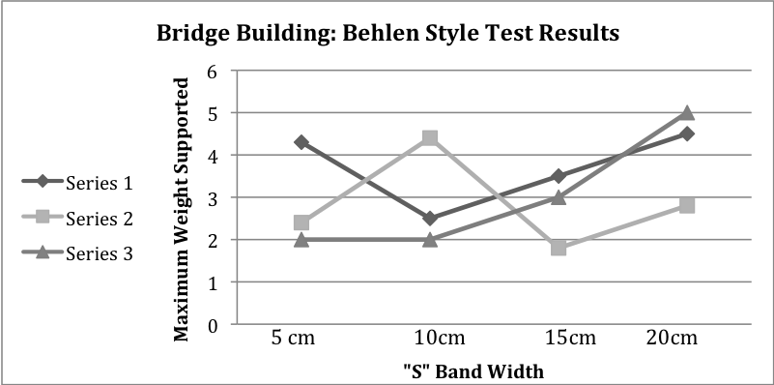
Understanding Learning: (Building Bridges Behlen Style!)

Summary: Students will determine the best Behlen Bridge based on graph results (material and corrugation width). Students will also present their data analysis findings to the class describing how they discovered the most effective material and corrugation widths.

Outline:
- Formative assessment of data analysis
- Summative assessment of data analysis

Activity: Students will complete written and performance assessments relating to data analysis.

Formative Assessment: As students are engaged in the lesson ask these or similar questions:
- Were students able to discover the corrugation strategy during exploration?
- Can students define corrugation?
- Can students determine trends in data and compare data sets?

Summative Assessment: Students can complete the following writing prompt:
- Explain the process of data analysis. Why is it important to study data?

Students can complete the following performance assessment: Students will use graphs (see image below) from Behlen bridge tests to determine which material and corrugation width supported the most weight. Students will back up findings while presenting to the class. Students could also compete to see which group can develop the bridge that will support the most weight.

