SHINE Lesson:
Gone With the Wind
==========================Lesson Header ==========================
Lesson Title: Gone With the Wind
Draft Date: June 10, 2011
1st Author (Writer): Bernie Fleischacker
Associated Business: Nebraska Public Power District
This Teacher was mentored by:


www.nppd.com

In partnership with Project SHINE grant funded through the

National Science Foundation

Instructional Component Used: Displays of Data
Grade Level: Middle School

Content (what is taught):
- The types of renewable energy now being developed
- The concept of a “megawatt”
- Constructing line graphs
- Calculating percentages
- Constructing circle graphs

Context (how it is taught)
- A teacher led discussion about renewable energy
- Analysis of data from a table on changes in wind energy generated
- Creating line graphs showing changes in wind energy produced over time
- Calculating how much total energy is produced from data that tells 10% of the total
- Calculating the % of total energy production that is provided by wind for each year
- Constructing circle graphs based upon the student’s calculations
Activity Description:
Students will be given data for five years of wind power generation for Nebraska Public Power District. They will use that data to construct line and circle graphs.

Standards:

Math: MA1, ME2 Science: SF2

Technology: TA4, TC4 Engineering: EB1

Materials List:
- Graph Paper
- Oak Tag or Copy Paper
- Markers
- Compasses and Protractors
- Calculators
Asking Questions: (Gone With the Wind)

Summary: Students will define renewable energy, give examples of them, and determine what “new” type is being developed by power companies to generate electricity in Nebraska.

Outline:
- Question students about what they think renewable energy is
- Ask students to give examples of renewable forms of energy
- Ask students which form of renewable energy they think is being developed the most in Nebraska and why

Activity: There will be a large group discussion to determine if students understand the concept of renewable energy. The teacher should be ready to provide input as needed. The overall purpose of the discussion is to help them understand that wind energy is the alternative being developed in Nebraska at this time and why it is important.

Questions | Answers
What does renewable energy mean? | Energy that can be replaced over time
What are examples of renewable forms of energy? | Biomass, hydro, nuclear, solar, thermal, tidal, wind
Which type is Nebraska starting to use a lot more of to generate electricity? | Wind
Why is wind the preferred choice at this time? | Non-polluting, abundant open areas of relatively steady, moderately strong wind, much cheaper than solar presently

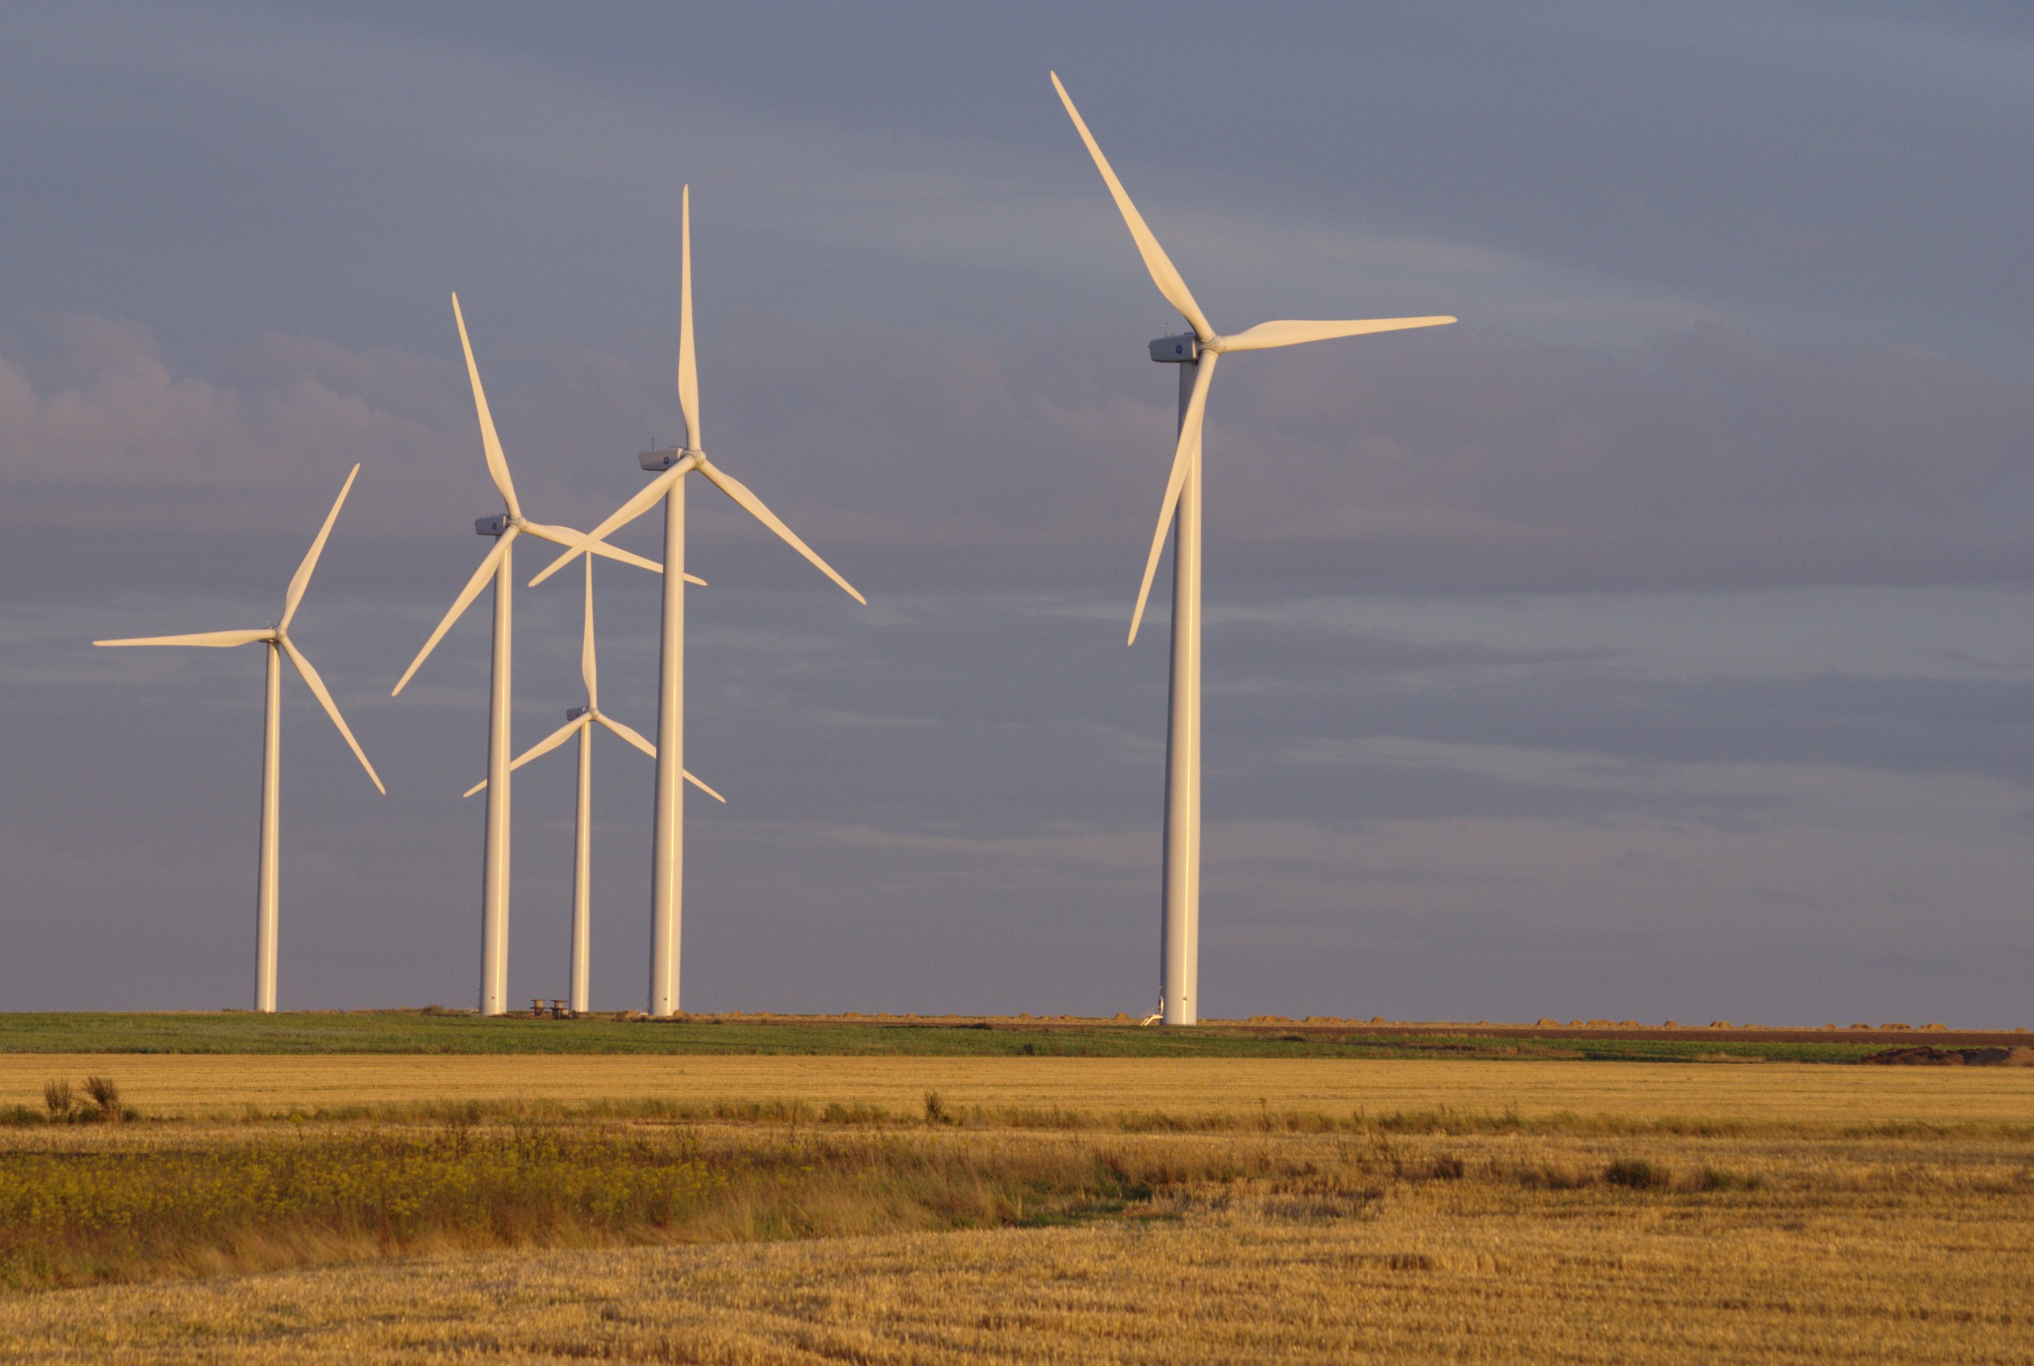
Image Source: Wikimedia Commons
http://commons.wikimedia.org/wiki/File:%C3%89oliennes_Caen.jpg

Exploring Concepts: (Gone With the Wind)

Summary: Students will research the total amount of electrical energy produced by a local power utility and the portion provided by wind energy.

Outline:
- Teach students the concept of a megawatt
- Students will research electricity generation by a local power utility
- Emphasis should be placed on wind energy produced

Activity: Ask students if they know how much energy light bulbs use in watts? Use the example of a 100-watt bulb to explain that one 100-watt light bulb burning in 10,000 homes would equal one megawatt, which is a million watts. This would be roughly enough to light a 100 watt bulb in every home in Columbus, Nebraska. Nebraska Public Power District (NPPD) is the nation’s largest public power district and that serves most of Nebraska outside of Lincoln and Omaha. Inform students that NPPD generates about 4,300 megawatts of power each year which would be enough to light a 100-watt bulb in all of the homes in Iowa, Kansas, Nebraska, North Dakota, and South Dakota.
After the megawatt activity, students will research electricity generation produced in their local area. Data should be located to show the different methods of generating electricity with a particular emphasis on renewable energy sources (particularly wind generation).

Resources:
- Internet access for research
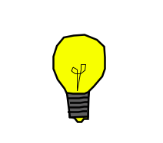
Instructing Concepts: (Gone With the Wind)

Displays of Data

Graphs are used to convey meaning from data. This data may be numerical in nature. It may also be almost any other item or concept which can be quantified. As a picture is worth many words, so then a graph can permit people to quickly and easily interpret data. It is worth noting at the outset that graphs do not always convey accurate meaning or precision. Graphs can be constructed so that meaning is obscured rather than revealed. This is most often accomplished by either omitting pertinent information or skewing the placement of variables by altering the scale along an axis. Thus, as with most ways of gaining information, it is critical to examine them for validity of construction. Numbers and graphs can lie.

Many types of graphs exist: leaf and stem plots, scatter plots, histograms, line graphs, bar graphs, and circle/pie graphs. Each type of graph has a specific purpose-a type of data/report for which it is best suited, although some overlap exists. The following are several common types of graphs, basic construction information, and common uses.

Name of Graph | How Constructed | Common Uses
Leaf and Stem Plot | Numerical data is arranged according to place value. | Helps to organize large amounts of information-shows the data’s distribution. Often used for test scores, weather data, and scores.
Pictograph | Simple pictures/icons are used to represent data. Each picture/icon represents a certain quantity. The number of pictures (whole or fraction thereof) indicates the quantity for a given time or place. | Provides an overview of a statistical relationship. Accuracy is limited due to the difficulty in evaluating fractions of the pictures/icons. Often used with maps to quantify production of goods in regions
Line Graph | Two variables and axes are used. The vertical, y axis is called the scale. The horizontal, x axis, often uses some measurement or concept related to time. | Effectively shows trends over time. Good with large amounts of data-even if it is closely spaced. Accurate. Helpful in the making of predictions. Used for quantitative data.
Bar Graph | Two axes are used. Rather than placing points at intersections of the x and y axis, rectangular bars are drawn-the height or length of which correspond to a variable’s value. | Comparisons between variables are more clearly seen than with line graphs. Shows trends. Bar graphs are best when the quantities measured are distinct—such as groups based on weight or age. Used for qualitative data.
Circle Graph/  Pie Charts | Circle/pie charts display data according to percentages. The total pie always represents 100%. The angle of each “slice” relates to a percentage of the whole for a particular group. | Use only when the entire group (100%) can be placed within the circle. These do not show trends/change over time. Useful if fewer than four or five groups exist within the whole.
Histograms | Histograms display the frequency or relative frequency (percentage or fraction) of an interval of a one-variable data set. | Use only with one-variable data to show the distribution of the data within the range of values. Useful for large data sets (generally 20 or more data points).
Organizing Learning: (Gone With the Wind)

Summary: Students will be given data (or can use data found during research relating to wind energy generation) to create different displays of data.

Outline:
- Students will create different data displays for data given to them concerning NPPD’s current and future use of wind power.

Activity: Students will be given the following data related to NPPD power generated from wind in megawatts:

ACTUAL & PROJECTED WIND ENERGY PRODUCTION FOR NPPD IN MEGAWATTS
2007 | 2009 | 2012 | 2013 | 2020
9 | 51 | 202 | 232 | 499

Working in pairs (or small groups), students should create a line graph to illustrate the increase in megawatts of electrical power provided by wind over time.
Understanding Learning: (Gone With the Wind)

Summary: Students will analyze the data given to create circle graphs that show the percentage of NPPD’s electrical power that is supplied by wind. The students will then write a paragraph to describe the steps they took to create the graphs.

Outline:
- Formative assessment of data displays
- Summative assessment of data displays

Activity: Students will complete written and performance assessments related to displays of data.

Formative Assessment: As students are engaged in the lesson ask these or similar questions:
- Do students understand the concept of a “megawatt”?
- Were the students able to accurately graph the changes in wind power generated over time?

Summative Assessment: Students can complete the following writing prompt: Select one display of data and state what the particular representation of data tells the viewer.

Students can complete the following performance assessment: Students will use the data that assumes NPPD will continue to increase electrical production by about 3.7% annually (which has been the average of recent years). Students should be told that although the amount produced can vary from year to year based on weather, population changes, energy conservation, and economic conditions, the following data will be used to calculate what percentage of the total energy produced each year comes from wind energy. Students will then calculate the percentage of electricity that was generated by wind power in each of the years data is given, and will then work in pairs (or small groups) to construct bar graphs that illustrate those percentages. It is suggested that they round the percentages to the nearest one-half percent.

Actual and Projected Wind and Total Energy Produced by NPPD in Megawatts
2007 | 2009 | 2012 | 2013 | 2020
9 | 51 | 202 | 232 | 499
3131 | 3370 | 3758 | 3897 | 4988

Students will write a paragraph describing the steps they had to follow to construct their graphs.

