Project SHINE Lesson:
Seisan Rain … “Production Line” ========================Lesson Header ==========================
Lesson Title: Seisan Rain … “Production Line”
Draft Date: 6/10/11
1st Author (Writer): Becky Schueth
Associated Business: Kawasaki
This Teacher was mentored by:

www.kawasakilincoln.com

In partnership with Project SHINE grant funded through the

National Science Foundation

Instructional Component Used: Geometry Vocabulary
Grade Level: 7-12

Content (what is taught):
- Determine and classify angle measurement
- Application of ruler and protractor performing constructions
- Analysis of production line

Context (how it is taught):
- Demonstration by the teacher to model angle measurement and construction
- Students create production line puzzles
- Students complete assessment on angle measurement and basics of the production line
Activity Description:
In this lesson, students will investigate angle and side length measurement by creating polygons in a production line. Students will compare their results with the Kawasaki video to understand the production line and the importance of accuracy.

Standards:

Math: MB3, MC3, MC4, MD1, MD2 Science: SA1, SA2

Technology: TA1, TB4, TD2, TF3 Engineering: EB6, EC5, ED2, ED3

Materials List:
- 50 sheets of pink and blue paper
- Rulers
- Protractors
- Scissors
- Tape or Glue
- 40 sheets of white paper
Asking Questions: (Seisan Rain … “Production Line”)

Summary: Students will view the Kawasaki video clip to introduce the production line. Students will then brainstorm ideas regarding the production line.

Outline:
- Discussion of Kawasaki Video
- Determine Vocabulary

Activity: Show the Kawasaki video clip (link below) to introduce the concept of the production line. Begin to prompt students to think about the production line and the affects their work may have on a coworker. Determine the necessary vocabulary for comprehension of the activity.

Questions | Answers
What ideas do you have when you think about a production line? | Factory work, automobiles, performing same task repeatedly, etc.
What are examples of products built on a production line? | Automobiles, railroad cars, sewing machines, bicycles, clocks, watches, etc.
What types of products do you think are made at Kawasaki? | Motorcycles, ATV’s, Watercraft, Utility Vehicles, RUV’s, etc.
How do you think math is used on a production line? | Basic math facts, Fractions, Measurement, Tolerances, etc.
What geometry concepts would be important to Kawasaki? | Angles (measuring and finding missing angles without protractor), volume, surface area, etc.

Resources:
- YouTube Video – Kawasaki: King of the Watercraft: http://www.youtube.com/watch?v=Vi4ejb1Y2BQ
Exploring Concepts: (Seisan Rain … “Production Line”)

Summary: Students will demonstrate their ability to measure angles from a protractor demonstration. Students will create their own angles and have partners measure and classify each angle. Students will also discuss how to create polygons from given side lengths and angles measurements.

Outline:
- Begin with a teacher demonstration of key ideas to utilize the protractor to measure angles
- Students will draw angles for their partner to measure and classify
- Students will brainstorm how to use this knowledge to create polygons.

Activity: Students will work in pairs after the teacher demonstration on tips for utilizing the protractor to measure angles. Each student will draw 3 angles for their partner to measure and classify and will check their partner’s accuracy. Next, students will randomly select two angle measurements for their partner to construct utilizing rulers and protractors. Each student will again check their partner’s work for accuracy. Students will give a score to their partner for the number of correct responses from above activity (5 points total). Students will brainstorm how to use this knowledge to create polygons from given side lengths and angle measures.

Image Source: Wikimedia Commons
http://commons.wikimedia.org/wiki
Instructing Concepts: (Seisan Rain … “Production Line”)

Geometry Vocabulary

Points and Lines
Point – A dimensionless figure that is an indivisible part of space.
Line – A straight figure of one dimension that is made up of an infinite number of points.
Parallel lines – Two lines that will never intersect.
Transversal line – A line, line segment, ray, etc. that intersects two parallel lines.
Perpendicular lines – Two lines, line segments, rays, etc. that intersect at a right angle.
Line segment - a portion of a line that has a starting and ending point.

Angles
Ray - Part of a line that begins at a point (terminal point) and extends endlessly in one direction.
Angle – Two rays whose terminal points coincide.
Angle Measure - In geometry, the measure of angles is between zero and 180 degrees inclusive.
Acute angle – An angle whose measure is less than 90 degrees.
Obtuse angle – An angle whose measure is more than 90 degrees and less than 180 degrees.
Straight angle – An angle that measures 180 degrees. A line is a straight angle.
Right angle – An angle that measures 90 degrees.
Complementary angles – Two angles whose measure adds to be 90 degrees.
Supplementary angles – Two angles whose measure adds to be 180 degrees.

Circles
Circle – The set of all points in a plane that are the same distance from a point called the center.
Radius – The distance from the center of a circle to the circle.
Chord – A line segment that begins and ends on the circle.
Diameter – A chord that contains the center of the circle.
Secant – A line segment that intersects the circle in exactly two different points.
Tangent – A line segment that touches the circle in exactly one point.
Semicircle – Half of a circle. Drawing a diameter forms it.

Polygons
Polygon – A closed plane figure formed by straight-line segments whose endpoints coincide.
Triangle – A polygon with three sides.
Quadrilateral – A polygon with four sides.

Three Dimensional
Plane – A flat surface that extends forever in all directions.
Organizing Learning: (Seisan Rain … “Production Line”)

Summary: Students will evaluate the effectiveness of their “Angles Production Line” to determine the accuracy of the puzzles created from each shape measured and constructed in specific parts of the assembly line. The team leader is responsible for trouble-shooting and keeping their workers on-task as well as constructing the final product (puzzle).

Outline:
- Students will complete a “Angles Production Line” puzzle
- Students will compare this activity to the Kawasaki video and discuss responsibility, accuracy and work ethic

Activity: The production line puzzles for this exercise are attached in file: M093_SHINE_Production_Line_O_Worksheet2.doc
The students will split into 3-5 production lines. There will be colored paper at each worker’s station. The worker will create their specific shape using the directions at each station. Each worker will need a ruler and protractor to measure and draw the shapes precisely. Then the worker will cut out the shape and pass it on to the next person. The team leader will be responsible for putting the pieces together to form the outlined shape on a piece of blank white paper. The team leader will also solve any issues that arise in the production line when hearing the prompt, “Stop.” An attachment is included for the teacher to see the end puzzle. (worksheet 1 attached below) Another attachment is included for the students to have in their station of the production line. Assign each student a number from 1-5 in the production line, with student # 6 as the team leader. The workers will be required to complete the specific number of puzzles of each color. Determine which production line completes the task first, then compare and contrast the accuracy of each puzzle. Make comparisons to the Kawasaki video and discuss the importance of responsibility, accuracy, and work ethic in the production line.

Attachments:
- M093_SHINE_Production_Line_O_Worksheet1.doc
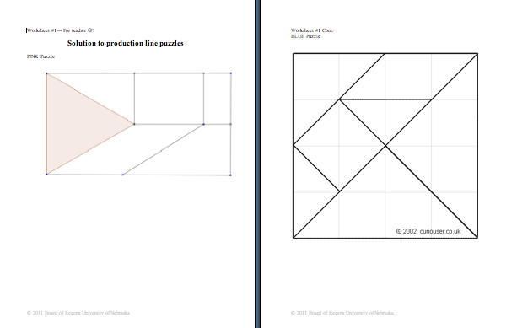

- M093_SHINE_Production_Line_O_Worksheet2.doc
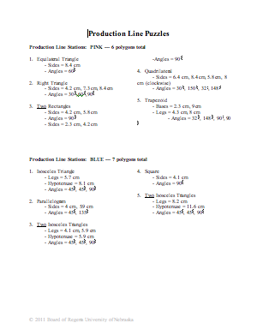

Understanding Learning: (Seisan Rain … “Production Line”)

Summary: Students will write a short summary describing the use of a protractor to measure angles. Students will also take the Quiz to assess their knowledge of constructing/measuring polygons and their insight regarding production lines in industry.

Outline:
- Formative assessment of geometry vocabulary (angles & measurement)
- Summative assessment of geometry vocabulary (angles & measurement)

Activity: Students will complete written and quiz questions about geometry vocabulary (angles & measurement).

Formative Assessment: As students are engaged in the lesson ask these or similar questions:
- Were the students able to construct and cut out the polygons to form the two different types of puzzles from each production line?
- Can students explain the difficulties of the production line?
- Can students develop attributes needed of workers in a production line?
- Are students able to effectively utilize the protractors and rulers for the lesson?

Summative Assessment: Students will complete the following writing prompts about angles and measurement:
- In your own words, write a story about how you could use a protractor in a real-life situation.
- Describe how to utilize the protractor and highlight a key point for a friend to know before using a protractor.

Students will complete the quiz (See attached file: M093_SHINE_Production_Line_U_Quiz.doc).

Attachments:
- Production Line Quiz: M093_SHINE_Production_Line_U_Quiz.doc
