Project SHINE Lesson:
ENERGY LABELS
==========================Lesson Header ==========================
Lesson Title: Energy Labels
Draft Date: July 14, 2011
1st Author (Writer): Deb Ohnoutka
Associated Business: NPPD
Instructional Component Used: Data Analysis
This Teacher was mentored by:


www.nppd.com

In partnership with Project SHINE grant funded through the

National Science Foundation

Grade Level: 7

Content (what is taught):
- Amount of electricity used by common items
- Cost of electricity according to local utility rates
- EnergyGuide labels which evaluate appliances according to their efficiency

Context (how it is taught):
- Rank household items according to how much electricity they use
- Evaluating EnergyGuide labels to select energy-efficient appliances

Activity Description:
The lesson will help students think about electricity use of household items. They will learn to use EnergyGuide labels to determine the efficiency of appliances.

Standards:

Math: MA3, ME2 Science: SF2

Technology: TD3

Materials List:
- Handouts and worksheets provided with lessons
- Internet access
Asking Questions: (Energy Labels)

Summary: Students will think about how much electricity household items use.

Outline:
- Students will understand that most of the things they rely on each day require power, specifically electricity
- Students will understand that consumers are charged for the electricity they use
- Students will begin to think about ways they can reduce the amount of electricity their homes require, helping them save money

Activity: The teacher will help students understand that our society relies on electricity a great deal and that it is important to be responsible with our energy use.

Questions | Answers
What items have you used so far today that require electricity? | Answers will vary, but may include: lights, toaster, refrigerator, hair dryer, computer, etc.
Which household appliances use the most energy? | Answers will vary.
Why is it important to know how much electricity your house uses? | So you understand how you will be charged on your electric bill; so you can determine ways to reduce your electrical costs; so you can conserve energy, which will ultimately benefit the environment.
How much does electricity cost? | Answers will vary; contact local power utility.
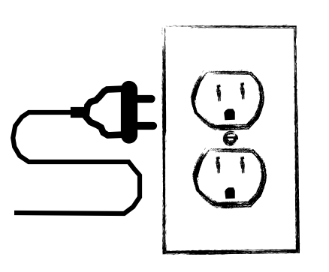
Exploring Concepts: (Energy Labels)

Summary: Students will explore the amounts of electricity used by common household appliances.

Outline:
- Students will work with a partner to rank common household appliances and items according to how much electricity they think they use
- Students will then use information from power companies to check their initial rankings

Activity: Divide students into pairs. Give each pair a copy of the “Rank Appliances” worksheet. Students will work with a partner to rank common household appliances and items according to how much electricity they think they use. Use large newsprint paper to hang around the room with results. Discuss the differences between students’ results.

Next, give each pair a copy of the “Actual Electrical Usage” worksheet. Students will then use information from power companies to check their initial rankings. Students can use the Internet if computers are available, or the teacher can supply information to students. Students will need to convert rates for each appliance or item so electricity use is per hour. As a class, students will rank appliances/items again, according to their actual electrical usage. Discuss any surprises students had related to how much energy these items use.

After ranking items again, discuss how long each item is used (refrigerator (24/7) compared to hair dryer (ten minutes). Ask students which item tends to cost the most to operate.

Resource:
- http://www.nppd.com/My_Home/Product_Brochures/Additional_Files/electric_usage.asp

Attachments:
- Rank Appliances: M095_SHINE_Energy_Labels_E_Appliances.doc
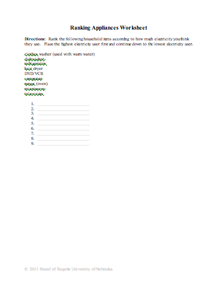

- Actual Electrical Usage: M095_SHINE_Energy_Labels_E_Actual_Usage.doc
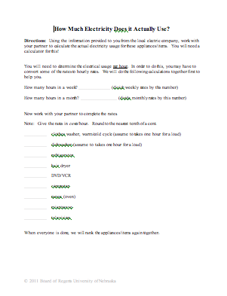
Instructing Concepts: (Energy Labels)

Data Analysis

Data analysis is the process of collecting, analyzing, modeling data, and making predictions. The reasons for this process are many but typically the most important are: 1) to find useful information, 2) to make predictions about possible outcomes, and 3) to support and provide evidence for the decision making process.

Data Collection: The process can start with the collection of data using any number of strategies. The data collection might take the form of an experiment where you conduct trials in which you measure the effect of one variable on another by controlling all other possible variables. The collection might be a survey of something by sampling to gather information. It is important that the survey be unbiased, random, and representative of the group you are sampling. Data can be present without going out to collect something new. In the business world it could be historic sales, production, or costs. In academia it can be test scores. In engineering, data is collected on production processes, historical usage or environmental factors, and stress or strength measurements. Data is everywhere and often the problem is not finding data but limiting it to what you are looking to study.

Data Analysis: The analysis of the data that was collected is a critical step. Here you are carefully looking at the data that was collected. It could be in a spreadsheet or other computer application that can organize the data. You probably will want to graph the data because trends are easier to see from a picture. This step is really about identifying trends that might be present. It is possible that there isn’t a strong trend present in the data. If there is not a trend it is not necessarily bad. It just means that the variables are not related.

Mathematical Modeling: Modeling the data that was collected and analyzed is where the mathematics occurs in this process. You can use a graphing calculator, computer spreadsheet or other specialized computer application to generate an equation that represents the data. These uses of technology will also provide statistical measurements like variance and correlation that can help you understand the effectiveness of your equation (model).

Reporting: The final step in this process is to report the data and model that represent it and to make predictions using the model to support decisions. If you have a model that statistically represents the data accurately it should be possible to make fairly reliable predictions. You can present the results in printed form, graphically, or a combination of both. You can show your prediction by showing an extrapolation using your model and present that information as support for a decision. You need to be cautioned that any predictions that are made are only that, a prediction. If the trend changes, your prediction will not be correct. The process of data analysis is a tool to make an educated guess about the future not a guarantee that your prediction will come true.
Organizing Learning: (Energy Labels)

Summary: Students will learn how to interpret EnergyGuide Labels found on common appliances.

Outline:
- Students will look at a sample EnergyGuide label
- Students will answer questions by interpreting information from the label

Activity: Give each student a copy of the “Energy Label” handout. Read the first page together. Look over the label on the second page together, pointing out different parts of the label. Give each student an “Energy label” worksheet to complete over the handout. Students will hand in worksheets when completed. Teacher could also show new television labels (May 2011) and light bulb energy labels (2012).

Resources:
- http://www.ftc.gov/bcp/edu/pubs/consumer/homes/rea14.shtm
- http://www.nppd.com/My_Account/Additional_Files/rates/standard_rates.pdf

Attachments:
- “Energy Label” Handout (from ftc.gov): M095_SHINE_Energy_Labels_O_Energy_Guide_Labels.pdf
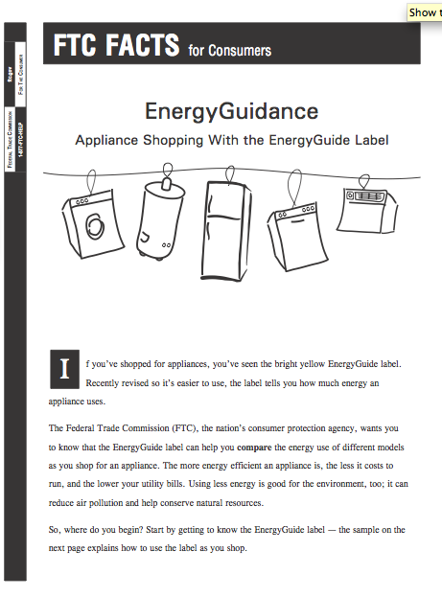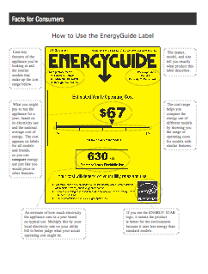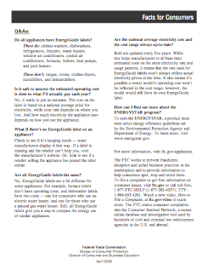

- TV and Light Bulb Labels (from ftc.gov): M095_SHINE_Energy_Labels_O_TV_Light.pdf
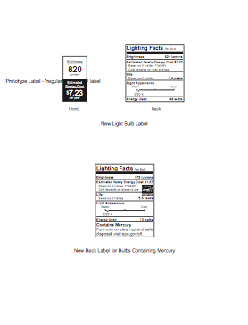

- Energy Label Worksheet: M095_SHINE_Energy_Labels_O_Energy_Guide_Labels_Wrksht.doc
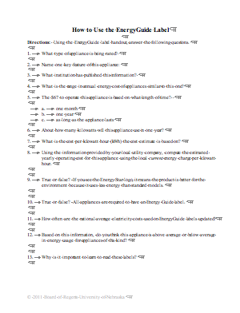
Understanding Learning: (Energy Labels)

Summary: Students will determine the most cost efficient appliance by comparing EnergyGuide labels.

Outline:
- Formative assessment of data analysis
- Summative assessment of data analysis

Activity: Students can complete written and performance assessment related to data analysis.

Formative Assessment: As students are engaged in the lesson ask these or similar questions:
- Are students able to find the relevant information on the label?
- Are students considering the given features for each appliance?

Summative Assessment: Students can answer the following writing prompt:
Explain how you used data analysis in this lesson. What did you learn using data analysis that was important or surprised you?

Students can complete the following performance assessment:
Students will use EnergyGuide labels to select the most energy efficient appliance by completing the Refrigerator Scenario” (attached). Students will respond to the writing prompt at the bottom of the assessment.

Attachment:
- “Refrigerator Scenario”: M095_SHINE_Energy_Labels_U_Refrigerator.doc
