Project SHINE Lesson:
Can You Trig It?
==========================Lesson Header ==========================
Lesson Title: Can You Trig It?
This Teacher was mentored by:


http://www.vishay.com/

In partnership with Project SHINE grant funded through the

National Science Foundation

Draft Date: 7/14/11
1st Author (Writer): Becky Schueth
Associated Business: Vishay
Instructional Component Used: Basic Trigonometric Functions
Grade Level: 9-12

Content (what is taught):
- Finding the height of unknown objects utilizing the tangent ratio
- Understanding sine, cosine, and tangent functions and their applications

Context (how it is taught):
- Complete the “How Tall Is It?” activity
- Utilize “trig tables” as an alternative method to solve right triangle and application problems
Activity Description:
In this lesson, students will investigate the trigonometric functions. Students will complete the “How Tall Is It?” activity. This will allow the students to determine the heights of unknown objects throughout the school. The tangent ratio will serve as the basis for solving for the missing heights. The students will utilize “trig tables,” also used at Vishay, as an alternative method of solving for missing sides or angles in right triangles. Students will utilize white boards for guided practice, and then will work in groups to determine the solutions to various trigonometric application problems.

Standards:

Math: MC4, MD2, ME1, ME3 Science: SA1, SA2

Technology: TC4, TA3 Engineering: ED1, ED2, ED3, ED6

Materials List:
- Scientific Calculator
- Protractors on Cardstock
- Drinking Straws
- String
- Tape
- Paper Clips
- Tape Measure
Asking Questions: (Can You Trig It?)

Summary: Students are asked to discuss previous knowledge of resistors and inductors that are created at Vishay. Students will examine the various methods to solve right triangles.

Outline:
- Discuss resistors/inductors manufactured at Vishay
- Examine methods utilized to solve for missing angles and sides on right triangles

Activity: Students will answer the following questions regarding their previous knowledge of Vishay. In addition, the concepts of resistors and inductors will be discussed. Students will brainstorm possible job opportunities that exist at Vishay and the mathematics needed to be successful. Students will then elaborate on the methods that they have previously utilized to solve right triangles.

Questions | Answers
What does the company Vishay manufacture? | Vishay manufactures resistors using wire wound, metal film, and power metal strip construction to provide high quality, precision, and high power resistors.
What is a resistor? | Passive components that restrict current flow
What is an inductor? | Passive electronic component that stores energy in magnetic field
What job opportunities exist at Vishay? | Engineering, Professional/Administration, Sales, Skilled Workers/Technicians, Production Workers
What types of mathematics would be important for a manufacturing company? | Geometry, Problem Solving, Measurement, Basic Math Calculations, Number Sense
What previous methods have been utilized to solve right triangles? | Pythagorean Theorem  Trigonometric Functions  Distance Formula
Exploring Concepts: (Can You Trig It?)

Summary: Students will explore the tangent ratio by completing the “How Tall Is It?” activity. Students will also complete the rubric to evaluate their group members and themselves.

Outline:
- Introduction of tangent activity for students (attachment included for the teacher to utilize)
- In groups, students will go around the school using their clinometers to measure the angle of elevation to the top of the object and measure the distance from the observer to the object, forming a right triangle. Utilizing the tangent ratio, students will determine the height in the triangle. Next, the observer will add in their eye height to get the total height of the object. (Attachment included for students to record the above data.)
- Students will evaluate group members and themselves with the attached rubric

Activity: Students will get introductory information regarding the tangent activity per their teacher. An attachment is included for the teacher giving preliminary concepts for the students to become familiar with for the activity. Students will then be put into groups of 3-4 students per group. The students will then go around the school in order to estimate the heights of objects chosen by the teacher to measure. Students will utilize their homemade clinometers to determine the angle of elevation to the top of the object. Then, students will measure the distance from the observer to the object, which forms a right triangle. By utilizing the tangent ratio, students can determine the height in the triangle (which is NOT the total height of the object yet!). Next, the observer will add in their own eye height to get the total height of the object. An attachment is included for the students to record their data for the specified objects. Lastly, the students will evaluate their group members and themselves with the attached rubric.
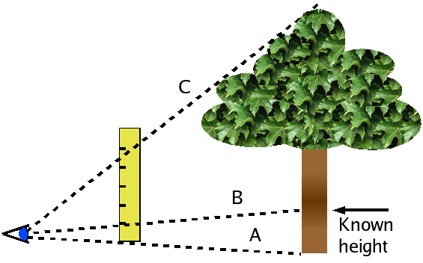

Image Source: Wikimedia Commons
http://commons.wikimedia.org

Attachments:
- Teacher Handout: M097_SHINE_Can_You_Trig_It_E_Teacher.doc
- Tangent Worksheet: M097_SHINE_Can_You_Trig_It_E_Worksheet1.doc
- Activity Rubric: M097_SHINE_Can_You_Trig_It_E_Rubric.doc
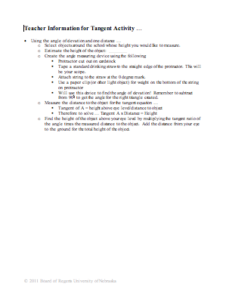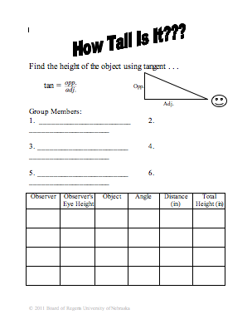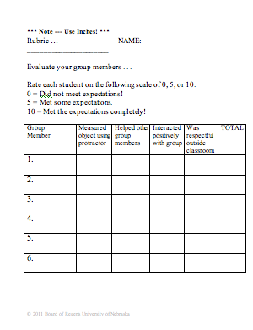
Instructing Concepts: (Can You Trig It?)

Basic Trigonometric Functions

Putting “Trig Functions” in Recognizable Terms: Trig functions are ratios of the legs and hypotenuse of the right triangles used in the Pythagorean Theorem. The basic trig functions are related to the reference angle (the given angle or its equivalent).

Putting “Trig Functions” in Conceptual Terms: If we look at a rectangular coordinate system and place an angle (θ) so that its vertex is located at the origin and the adjacent leg of the angle lies on the abscissa, the basic trigonometric functions of that angle are defined to be:
- Sine – the ratio of the length of the leg opposite the reference angle divided by the length of the hypotenuse.
- Cosine – the ratio of the length of the leg adjacent to the reference angle divided by the length of the hypotenuse.
- Tangent – the ratio of the length of the leg opposite the reference angle divided by the length of the leg adjacent to the reference angle.
Putting “Trig Functions” in Mathematical Terms: The basic trig functions for an angle θ positioned as above are defined, then, to be:
- sin θ = y/r
- cos θ = x/r
- tan θ = y/x
where x is the x coordinate of any point on the terminal side of the angle other than the origin, y is the y coordinate of that point, and r is the length of the line segment from the origin to that point. (Remember from the Pythagorean Theorem that x ² + y ² = r ² ).

Putting “Trig Functions” in Process Terms: Since the trig functions of an angle are defined to be the ratios above, and those ratios do not change based upon the position of the point (x,y) on the hypotenuse, the sine, cosine, and tangent are related to the angle θ and not the (x,y) point chosen to calculate the ratios.

Putting “Trig Functions” in Applicable Terms: Drive the bot along a [straight] line from the origin and stop it at irregular (random) time intervals. Determine the coordinates of the bot’s location and calculate the definition ratios for sine, cosine, and tangent at several different points along the line (the hypotenuse of the right triangle formed by connecting the (x,y) point to the abscissa with a vertical line).
Organizing Learning: (Can You Trig It?)

Summary: Students will utilize the “trig tables” provided to solve application problems using the trigonometric functions. The “trig tables” will provide an alternative method utilized at Vishay to calculate missing sides or angles of right triangles. The tables are utilized daily to be certain that the parts for the machines they build match up correctly, providing a low tolerance to ensure quality.

Outline:
- Discuss the information in the “trig table”
- Utilize the white boards to do guided practice problems in class
- Complete the trig applications worksheet in small groups
- Explain answers and discuss the benefits of utilizing the “trig tables” in small groups

Activity: Students will each receive a copy of the “trig table” to examine. Students will discuss the different format used in the tables and compare it to the traditional SOHCAHTOA method.
sine = opposite/hypotenuse
cosine = adjacent/hypotenuse
tangent = opposite/adjacent
Students will then utilize the white boards to complete practice problems in class with the attached worksheet to check for understanding of the “trig table.” Next, students will form small groups and work together to complete the attached trig applications worksheet. Students must explain and discuss their thought processes while utilizing the “trig table.” In addition, students will determine the benefits of utilizing the “trig table.”

Attachments:
- “Trig Table”: M097_SHINE_Can_You_Trig_It_O_Trig_Tables.doc
- Guided Practice: M097_SHINE_Can_You_Trig_It_O_Practice.doc
- Applications: M097_SHINE_Can_You_Trig_It_O_Applications.doc
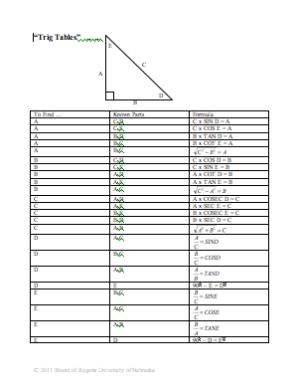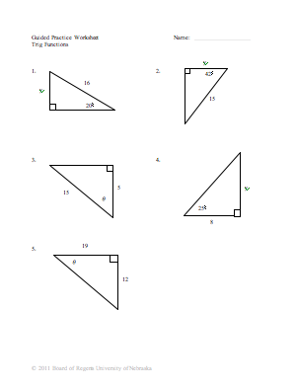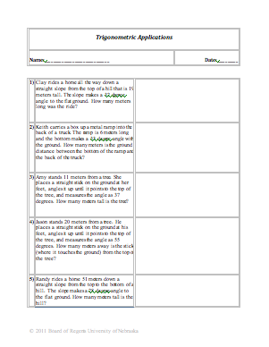
Understanding Learning: (Can You Trig It?)

Summary: Students will create their own application problems for a classmate to solve and then select one problem to create a poster on the computer illustrating the application problem and the solution.

Outline:
- Formative assessment of trigonometric ratios
- Summative assessment of trigonometric ratios

Activity: Students will complete performance assessments on trigonometric ratios.

Formative Assessment: As students are engaged in the lesson ask these or similar questions:
- Were the students able to create a connection between the trigonometric functions and applications from the activities?
- Are students able to set up a ratio to solve for a missing side or angle in application problems?
- Can students effectively use both methods throughout the lesson to solve trigonometric problems?
- Can students explain the benefits of utilizing the “trig table”?

Summative Assessment: Students can complete the following performance assessments:
- Students will create three of their own application problems to solve utilizing the trigonometric functions. Students will then exchange their papers and solve the application problems that a classmate created. The student will then check their original application problems they created.
- Students will then select one of their own application problems and create a poster on the computer utilizing graphics to illustrate the problem along with a solution key.

