SPIRIT 2.0 Lesson:
BoT Bowling
==========================Lesson Header ==========================
Lesson Title: BoT Bowling
Draft Date: 5-31-12
1st Author (Writer): Nancy L. Boyle
Instructional Component Used: Two-Step Equations
Grade Level: 7th - 8th Grade
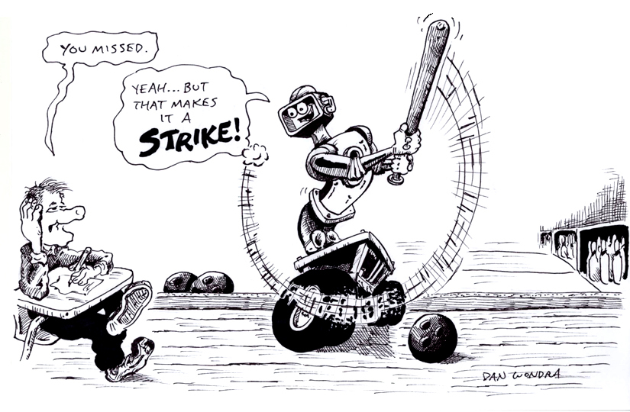
Content (what is taught):
- Teacher will discuss the pre-algebraic concept of x
- Students will demonstrate ability to solve for x
- Students will apply this new knowledge to a real life application ie bowling

Context (how it is taught):
- Students will be introduced to algebra (value of x).
- Students will learn to solve for the value of x.
- Students will connect solving for value of x with real-life applications.
Activity Description:
Students will discover uses of the pre-algebraic concept and SOLVE for an unknown value and use this during CEENBoT bowling games.

Standards:

Math: MB2, ME2 Science: SB1, SE1

Technology: TA3, TB4 Engineering: EB1, ED1, ED2, ED3

Materials List:
- CEENBoT
- Bowling Score Sheet
- Pens
- Masking Tape
- Bowling Pins
- Paper
Asking Questions: (BoT Bowling)

Summary: Students will brainstorm real-life examples in which a value will be unknown. This will introduce algebra concept of a variable and solving for a variable.

Outline:
- Students will discuss possible situations in which the value is uncertain
- Teacher will introduce the value of x and two-step equations as new mathematical concepts

Activity: Students will be asked to think about situations where a value is unknown and how mathematics could be utilized to find the unknown.

Questions | Answers
How do I calculate a math problem when I don’t know the value of every number? | By using algebra you can solve problems in which you do not know all numeric values. Giving the unknown a value of x.
When do I need to know the value of “x”? | When I do not know what the outcome will be
What are real life examples when this math concept is used? | Purchasing gas for a vehicle, playing a football game, or going bowling.
Exploring Concepts: (BoT Bowling)

Summary: Students will “discover” how to solve algebraic equations involving two steps.

Outline:
- Students will be guided in how to solve two-step algebraic equations
- Students will solve a few example problems on their own
  - x + 5 = 7
  - 10 + x = 15
  - 12-x = 6
  - 10 +x +x =25
  - 10 + 10 + x =29

Activity: The teacher will present an algebraic equation like and ask the class how to find “x”. The concept of an equation being a “balanced” scale should be introduced either as part of this lesson or be prior knowledge from solving simpler equations. The teacher should do exactly what students suggest. If they suggest dividing by 4, divide both sides of the equation creating fractions. The teacher can provide additional examples as needed. To conclude, students can complete the following practice problems.

Instructing Concepts: (BoT Bowling)

Value of x and Two-Step Equations

Putting “Two Step Equations” in Recognizable Terms: Two Step Equations are common in algebra. They involve two steps to get the variable by itself. This means that 1 or 2 numbers are “connected” to the x and have to be canceled out.

Putting “Two Step Equations” in Conceptual Terms: The idea of solving for x is an abstract algebra skill. Two-step equations are one of many types of equations that are solved using algebra. The process of solving algebraic equations is a very complex process but by learning to solve two-step equations you can begin to understand the process.

Putting “Two Step Equations” in Mathematical Terms: To solve two-step equation it is necessary to keep the equation balanced. What you do to one side of the equal sign you must do to the other. A two-step equation will fit one of the forms: 1) ax + b = c, 2) ax + bx = c, or 3) ax = bx + c where a, b, and c are constants. To solve an equation of the first form you must undo the number added or subtracted to the x first and then either multiply or divide to get the x alone. Combining like terms and then multiplying or dividing to get the x alone can solve equations of the second form. Equations of the third form can be solved by moving bx to the other side of the equal sign, combining terms, and then multiplying or dividing to get the x alone.

Putting “Two Step Equations” in Process Terms: Thus, the process for solving two-step equations is a basic algebra skill. It is used to solve problems that can be used to model the real world. The process for solving linear equations can be done in 5 steps: 1) distribute, 2) combine like terms, 3) move the variable to one side and combine, 4) undo addition and subtraction, and 5) undo multiplication and division. This process will always work to solve linear equations. It is worth noting that there is sometimes a more efficient process depending on the equation but it is specialized and won’t always work.

Putting “Two Step Equations” in Applicable Terms: Two-step equations can be used to model many real world situations. One case would be a trip of 500 miles and we have driven 100 miles already. We will drive the remaining distance at 60 miles per hour. How long will it take to make our destination? This can be modeled by 60x + 100 = 500. This is only one of many applications of two-step equations.
Organizing Learning: (BoT Bowling)

Summary: Students will bowl using the CEENBoT as a device to knock over the pins. Students will keep score for a mock bowling game and solve a two-step equation to find the average number of pins that they must knock down to achieve a certain score.

Outline:
- Students will CEENBoT bowl and keep score
- Students will solve two-step equations to determine the average number of pins per frame they must knock down

Activity: A game of bowling will be played by the students in pairs or small groups. The CEENBoT will be used in a bowling game to replace a bowling ball in which it will knock over the bowling pins. Students will score their bowling game. After each frame, the students will create a two-step equation to determine the average number of pins that they must knock down to achieve a score of 200 pins (or whatever number is chosen). The two-step equation will take the form of number of frames left * average number of pins in each frame + pins already knocked down = 200 (or score decided on at the beginning). This activity will allow the students to solve 10 different two-step equations as part of the activity. NOTE: It may be possible that students cannot possibly knock down enough pins to score reach the target score.

Resources:
- Bowling Rules http://slocums.homestead.com/gamescore.html
- Bowling Score sheets available on-line via the following websites:
http://www.derose.net/steve/resources/papers/bowlingScoreSheet.pdf
http://www.apollostemplates.com/templates-bowling/
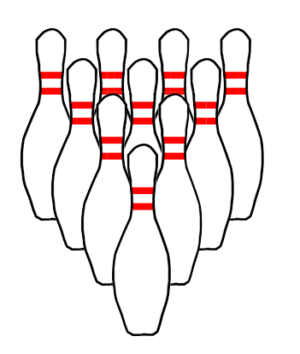
Understanding Learning: (BoT Bowling)

Summary: Students will understand the algebraic concept of the value of x and will solve two-step equations.

Outline:
- Formative Assessment of Two-Step Equations
- Summative Assessment of Two-Step Equations

Activity: Students will complete written and quiz questions related to solving two-step equations.

Formative Assessment: As students are engaged in the lesson ask these or similar questions:
- Did students correctly keep score?
- Did students compare the actual score to their estimation?
- Did students better understand solving for the value of x and the two step equation?
- Can students apply the concepts to real life problem solving situations?

Summative Assessment: Students can complete the following writing prompt:
Given the equation , solve the equation for “x” and explain the algebraic process and reasoning of your work.

Students can complete the following quiz questions.

