Project SHINE Lesson:
Zoildal Sand, Sand, Everywhere?
==========================Lesson Header ==========================
Lesson Title: Zoildal Sand, Sand, Everywhere?
Draft Date: 6/8/2012
1st Author (Writer): Deb Borgelt
Associated Business: Loup Power District
Instructional Component Used: Surface Area and Volume
Grade Level: Middle School
This Teacher was mentored by:


www.loup.com

In partnership with Project SHINE grant funded through the

National Science Foundation

Content (what is taught):
- Measurement of Volume and Surface Area
- Determining Shapes and Formula Used in Calculations
- Using Diagrams to Compute Volume and Surface Area
- Identify and Label Correctly for Volume and Surface Area

Context (how it is taught):
- Discussion about area formulas of figures that are not always regular
- Investigate the relationship between the area of a parallelogram and the area of a trapezoid
- Determine the volume of a canal using the technical drawing of the Loup Power de-silting canal provided
- The students will determine the variables affecting the amount of silt/sand processed from a canal
Activity Description:
Students will discuss the shape that is the trapezoid, along with its area. Through an activity students will discover the formula to use to find the area of a trapezoid. Lastly, the students will determine the shape that best matches the technical drawing of the de-silting canal and create the formula that would best generate the volume of the canal based on their work with discovering the area of a trapezoid.

Standards:

Math: MC1, MD1, MC4 Science: SF2

Technology: TA1, TA3 Engineering: ED1

Materials List:

- Dot paper
- Colored pencils
- Rulers
- Scissors

Asking Questions: (Zoildal Sand, Sand, Everywhere?)

Summary: Students will be asked to consider the relationship between length, width, depth, and distance as it relates to area of a trapezoid.

Outline:
- Students will consider using formulas to find the area of a trapezoid
- Students will consider different ways to find the area of a trapezoid

Activity: The class will have a discussion about area formulas of figures that are not always regular. Trapezoids are shapes that don’t have regular lengths of sides and therefore they require a different approach to finding the area.

Questions | Answers
What is the formula that we usually use to find the area of a trapezoid? | The formula we generally use is the average of the two bases multiplied by the height.
Are there other ways to find the area of a trapezoid that are different than using the standard formula? | Some answers will vary; however, students may want to cut the ends of the trapezoids off, find the area of the rectangle and then the area of the triangles and add it all together. Other methods could involve parallelograms.
Where might you see this shape? | Some answers could be containers, yards, pastures, windows, buildings, porches, etc.
How might area be used in regards to some of the places you see this shape? | If it was a container, maybe you would want to cover it—hence surface area. If it was a yard or pasture, maybe you would need to find square footage to cover it with fertilizer or seed. If was a building or porch maybe you would need square units to paint or side it.
A = b + b
1
2
2
-
(
(
* h
Exploring Concepts: (Zoildal Sand, Sand, Everywhere?)

Summary: Students will investigate the relationship between the area of a parallelogram and the area of a trapezoid.

Outline:
- Students are given dot paper, colored pencils, rulers and scissors
- Students will draw two congruent trapezoids labeling one set of corresponding bases in one color, the other set of corresponding bases in another color and the corresponding heights in a third color
- Students will cut out the trapezoids and arrange them to form a parallelogram
- Students will then use their knowledge of finding the area of a parallelogram to help them hypothesize the formula for area of a trapezoid

Activity: Students will draw two congruent trapezoids labeling one set of corresponding bases in one color, the other set of corresponding bases in another color, and the corresponding heights in a third color. Students will cut out the trapezoids and arrange them to form a parallelogram. Students will then use their knowledge of finding the area of a parallelogram to help them hypothesize the formula for area of a trapezoid.

Guiding questions for the teacher:
- What is the base of the parallelogram formed by the two trapezoids? Base₁ + Base ₂
- What is the height of the parallelogram? The same as the trapezoid height.
- What is the formula for finding the area of a parallelogram? Base x height
- What is would you calculate the area of the parallelogram using the terms we used to label our trapezoid? (Base₁ + Base ₂) x height
- How does the area of one trapezoid compare to the area of the parallelogram? It is half.
- How do we adjust the formula of the area of the parallelogram to find the area of one trapezoid? Divide by two.
- What is the formula for area of a trapezoid? (Base₁ + Base ₂) x height ÷2

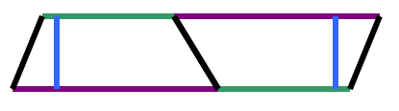

Instructing Concepts: (Zoildal Sand, Sand, Everywhere?)

Area of Polygons

There are two types of polygons concave and convex. Convex polygons have all interior angles less than 180 degrees. Concave polygons have one or more interior angles greater than 180 degrees. To find the area of a concave polygon it is necessary to subdivide the polygon into smaller convex polygons. Since finding the area of concave polygons involve using convex polygons this instructional component will focus on basic convex polygons.

 | Triangle  A 3-sided figure | Area = | b is the base and h is the height at a right angle to the base
 | Parallelogram  A 4-sided figure with both pair of opposite sides parallel | Area = | b is the base and h is the height of the parallelogram at a right angle to the base
 | Rectangle  A parallelogram with at least  1 right angle | Area = | b is the base and h is the height of the rectangle
 | Rhombus  A parallelogram in which at least  2 consecutive sides are congruent | Area = | d₁ and d₂ are the diagonals of the rhombus
 | Kite  A 4-sided figure in which the  2 disjoint pairs of consecutive sides are congruent | Area = | d₁ and d₂ are the diagonals of the kite
 | Square  A rectangle with 4 congruent sides | Area = | b is the base and h is the height of the square
 |  | Area = | d₁ and d₂ are diagonals of the square
 |  | Area = | s is the side length of the square
 | Trapezoid  A 4-sided figure with exactly  1 pair of parallel sides | Area = | b₁and b₂ are the parallel sides and h is the height at a right angle to the base
 | Regular polygon  A polygon with all sides and interior angles congruent | Area = | a is the apothem (distance from the center perpendicular to a side) and p is the perimeter

If the polygon doesn’t fit into one of the above classifications you can find the area by subdividing it into polygons that do fit into one of these types. The easiest method is to subdivide it into triangles and then add up the area of all the small triangles to find the area of the polygon.

Although a circle is not a polygon the area formula is an extension of a regular polygon where the side length approaches zero.Area circle = where r is the radius of the circle.

The volume of a right prism with a regular polygon as a base is found using
Volume of right prism = (Base Area) * (Height)
Organizing Learning: (Zoildal Sand, Sand, Everywhere?)

Summary: Students will explore process of de-silting and how it is accomplished and create a formula to find the volume of the Loup de-silting canal.

Outline:
- Students will watch a virtual tour of the Loup Power Canal System
- Class will have a discussion about the whole process of the Loup Power Canal System with specific attention to the Loup de-silting canal
- Students will determine the variables regarding the size, shape and volume of the Loup de-silting canal
- Students will derive a formula for calculating the trapezoidal prism or shape of the Loup Power Canal

Activity: Students will watch a virtual tour of the Loup Power Canal System (link below). The class will have a discussion about the reason for de-silting and factors that affect the amount of silt/sand that is taken from the canal. The students will determine the shape that best matches the technical drawing (M101_SHINE_Zoildal_Sand_Sand_Everywhere_O_Canal.gif) of the de-silting canal and create the formula that would best generate the volume of the canal. Student discussion would center on the fact that the volume of the canal is consisted of both silt/sand and water. Further discussion could focus on the variables affecting the amount of silt/sand that could be processed from the total volume of material in the canal. After the discussion students will work together in groups of two or three to:
- Derive the formula for the volume of a trapezoidal prism through discussion of the relationship between area and volume of prisms.
- Determine the volume of the canal using the technical drawing of the Loup Power de-silting canal provided.

Extension Activity:
The sand from the de-silting process must be removed as part of the process. The extension activity has students compute how much sand can fit in railcars to be transported away. See attached file: M101_SHINE_Zoildal_Sand_Sand_Everywhere_O_Extension.doc

Attachments:
Technical drawing of the Loup Power De-Silting Canal:
M101_SHINE_Zoildal_Sand_Sand_Everywhere_O_Canal.gif
M101_SHINE_Zoildal_Sand_Sand_Everywhere_O_Extension.doc
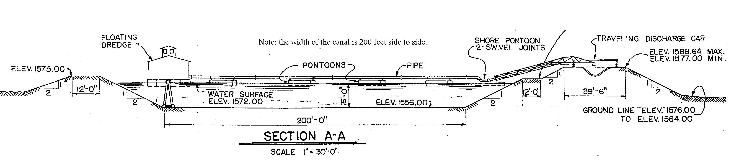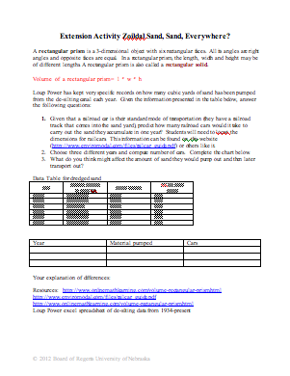

Resources:
Loup Power Website and Virtual Tour: http://www.loup.com/aboutus/virtualTour.asp
Understanding Learning: (Zoildal Sand, Sand, Everywhere?)

Summary: Students will write an explanation of the process used to develop the formula for the area of a trapezoidal prism. Students will solve problems involving volume of a trapezoidal prism.

Outline:
- Formative Assessment on the Area and Volume of Polygons
- Summative Assessment on the Area and Volume of Polygons

Activity: Students will complete written and quiz assessments of area and volume of polygons.

Formative Assessment: As students are engaged in the lesson ask these or similar questions:
- Were students able to transfer their understanding of area and volume of prisms to find the volume of trapezoidal prism?
- Can students explain the process used to develop the formula for volume of a trapezoidal prism?

Summative Assessment: Students can answer the following writing prompt:
1) Explain the method learned to find the volume of a trapezoidal prism and how it relates to the area of trapezoids and the volume of prisms. Be sure to cite any measurements that needed to know to apply the formula.

Students can answer the following quiz question: Using the formula generated, find the volume of the trapezoidal prism.

