SHINE 2.0 Lesson:
Catching the Wind
===============================Lesson Header ==============================
Lesson Title: Catching the Wind
This Teacher was mentored by:

www.nppd.com
In partnership with Project SHINE grant funded through the
National Science Foundation

Draft Date: August 26, 2012
1st Author (Writer): Deb Borgelt
Associated Business: NPPD
Algebra Topic: Rectangular Coordinate System
Grade Level: Pre-Algebra

Content (what is taught):
- Plotting points on a coordinate plane
- Using the coordinate plane to determine quadrants
- Using the coordinate plane to determine locations for wind farms
Context (how it is taught):
- Discover how to plot points on a coordinate plane
- Students will use poker chips or colored candy to plot points on a coordinate plane.
- Talk about the points regarding the quadrants and the axes.
- Students are looking at a map of the state of Nebraska to determine where the best locations would be for wind farms.

Activity Description:
Students will explore the coordinate plane by discussion, labeling and plotting points. They will overlay a coordinate grid on a map of Nebraska with the wind speeds marked on it. Using the information, students will determine the prime wind area and the best locations for wind farms.

Standards:

Math: B1, B3, C1, C4, D1 Science: B2

Technology: A3, A4

Materials List:

- Colored Poker Chips or Candy
- Poster Board
- Coordinate Grid both Paper and Transparency
- Graph Paper
- Wind Power Map (attachment)

Asking Questions: (Catching the Wind)

Summary: Students are shown a coordinate plane and are asked how to represent the ordered pair on the plane.

Outline:
- Demonstrate a coordinate plane
- Show students “locations” and attempt to label them
- What are ordered pairs?

Activity: Start the activity by drawing a coordinate plane on a large piece of poster board with at least 15 to the right of zero vertically and horizontally. Students should be asked how to represent numbers or ordered pairs on a graph. Different numbers (positive, negative, and zero) should be explored with students having to decide how to label their “location”. Finally, the concept of ordered pairs should be introduced. The questions below will help facilitate the discussion.

Questions | Answers
How can we represent the number 12 on a graph? | We could use a number line and travel over 12 units.
How can we represent a set of two numbers together on a graph? | Since we use a number line going right to left (x-axis) for the first number, we could use a number line going up and down (y-axis) for the second number. These two number lines will create the coordinate plane.
On a number line, which way is positive and which way is negative? Why do you think we represent numbers in this way? | We represent positive in the right direction and negative in the left direction because we read from left to right.
How can we do the same thing with two different number lines? | We can do the same thing for the other axis using “up” for positive and “down” for negative. We choose “up” for positive because it shows the increase in value.
What variables should we use to represent the ordered pair? | We could use any two letters but we prefer to use ‘x’ and ‘y’ so that all ordered pairs are represented the same way. Also, using x and y for the ordered pairs relates directly to the x and y axis.
Where do we need to start (zero) when we use the coordinate plane? | We should start where the two number lines intersect (the origin).
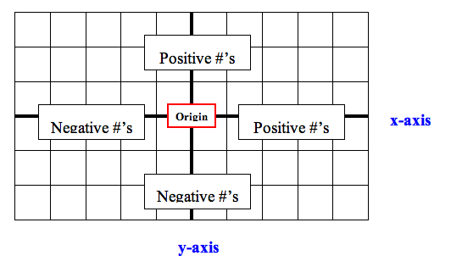
Resources:
- Interactive Plotting Game: http://www.shodor.org/interactivate/activities/GeneralCoordinates/
- “What’s the Point?” http://www.funbrain.com/cgi-bin/co.cgi?A1=s&A2=2&INSTRUCTS=1
Exploring Concepts: (Catching the Wind)

Summary: Students use poker chips or colored candy to plot points on a coordinate plane.

Outline:
- Create and label a coordinate plane
- Plot points on a coordinate plane
- Label points plotted on the coordinate plane

Activity: Students will draw the coordinate plane on a large piece of poster board. It would be a good idea to make the poster board at least 15 unites to the left and right of zero vertically and horizontally. Before getting started ask students how to represent certain numbers or ordered pairs on a graph. Next, they label the quadrant in which each point will be located. There are four different quadrants (I, II, III, and IV) and they will need to label each of these four quadrants.

The students will each be given four or five points that they need to graph and will take turns plotting the points on the coordinate plane that is laid out on the floor or on the table. NOTE: The students need to make sure that they always begin at the origin (0, 0) when they start plotting their points. When the students are given a point such as (6, 5), they need to make sure and plot the ‘6’ first and they need to understand that the ‘6’will be along the horizontal axis (right-left). Also, make sure students understand the positive direction and the negative direction. After the students have plotted all of their points on the plane they will each take a table and record the points of their partners.

To ensure that the students understand these concepts, ask yourself these questions to assess the effectiveness of the lesson:
1. Did the students plot the points in the correct order? (x then y)
2. Did the students know the four different quadrants? (I, II, III, IV)
3. Did the students read the points in the correct order when they were labeling the points (right-left, then up-down).
 | 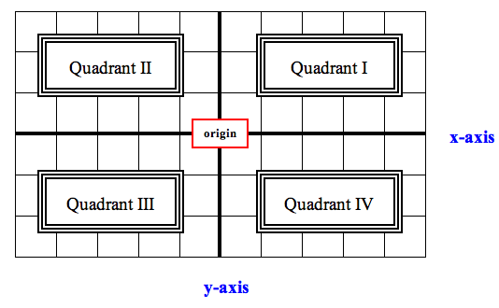
  Name | Ordered Pair

Resources:
- Coordinate Plane Plotting Practice: http://www.learningwave.com/lwonline/algebra_section2/alg_coord.html
- “What’s the Point?” http://www.funbrain.com/cgi-bin/co.cgi?A1=s&A2=2&INSTRUCTS=1
Instructing Concepts: (Catching the Wind)

Putting “Rectangular Coordinate System” in Recognizable Terms: Graphing on a rectangular coordinate system is a method of representing pairs of Real numbers on a flat (plane) surface.

Putting “Rectangular Coordinate System” in Conceptual Terms: Every Rectangular Coordinate System has to start somewhere. Choose any plane on the surface and call it the “origin”, or the starting point. Position a Real number line so that the zero is at your chosen point of origin. Then plane another Real number line at right angles to the first one so that its zero is also at the origin. These two lines are the axes. One line will be the horizontal axis, or abscissa, and the other line will be the vertical axis, or the ordinate. Notice how the intersecting Real number lines have subdivided the plane surface into four sections, or quadrants.

Putting “Rectangular Coordinate System” in Mathematical Terms: Ordered Pairs are necessary to define, or place, any particular point on the grid completely and accurately. An ordered pair is comprised of two real numbers; the first, which represents the position of the point with respect to the abscissa, and the second, which represents the location of the point with respect to the ordinate.

Putting “Rectangular Coordinate System” in Process Terms: Pinpoint the location of any point (ordered pair) by finding the intersection of the first element of the pair of coordinates with that of the second item in the pair. These ordered pairs can be called (x,y) pairs, where the ‘x’ (or first element of the pair) refers to the abscissa location and the ‘y’ (or second element in the pair) refers to the ordinate location.

Putting “Rectangular Coordinate System” in Applicable Terms: As we locate particular points on the coordinate plane it is important that we realize where these points are from the origin. If you were to look at these points as locations on a map, you could think of the origin as your location and the points could be directions from you like north, south, east and west.
Organizing Learning: (Catching the Wind)
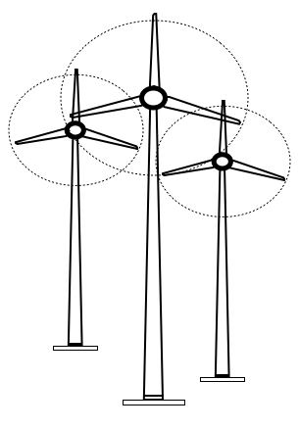
Summary: Students are looking at a map of the state of Nebraska to determine
where the best locations would be for wind farms.

Outline:
- Using the attached map of Nebraska, lay the coordinate grid over the map and
using the information given for prime wind area, determine the best locations
for wind farms.
- Plot points on the coordinate plane overlay
- Analyze points and determine the quadrant without looking at the coordinate
plane.

Activity: Coordinate systems on a map are how you are able to find a specific
location. Map coordinate systems are not all that different from the Cartesian coordinate system. In fact, on flat maps, the Cartesian coordinate system is widely used. As a result, students are going to practice using the coordinate system to determine possible locations of wind power plants in the state of Nebraska.
Students will be given a copy of a map of a Wind Power Map of Nebraska produced by AWS Truewind. This resource map shows estimates of wind power density at 50 m above the ground and depicts the resource that could be used for community-scale wind development using wind turbines at 50-60-m hub heights. The students will use a coordinate system overlay on a transparency to create a coordinate plane in order to mark and label the optimum areas that should be used in the state to develop wind farms. Looking at the map students should agree on a place for the origin to be placed (a suggestion would be Broken Bow). They will use a Vis-A-Vis marker or some sort of marker that marks on transparencies to mark points on the plane that would work for a wind farm. Once they’ve finished they should create a table and record both the points and will try to devise a way to determine the quadrant without looking at the coordinate plane.

Point | Quadrant | Point | Quadrant

Extension Activity: A map of wind farms in Nebraska is attached. Students can compare their coordinate plane and points of Nebraska to the actual map of farms located in Nebraska. Students can see how using the coordinate plane is valuable for planners.

Attachments:
- Wind Energy Map: M107_SHINE_Catching_the_Wind_O_Wind_Energy_Map_Nebraska.pdf
- Extension NE Wind Farms: M107_SHINE_Catching_the_Wind_O_Map_Wind_Farms_Nebraska.pdf

Resources:
http://www.windpoweringamerica.gov/pdfs/wind_maps/ne_50m.pdf
Understanding Learning: (Catching the Wind)

Summary: Students will plot and label points on a coordinate plane. They will also write about the rectangular coordinate plane.

Outline:
- Formative Assessment of the Rectangular Coordinate System
- Summative Assessment of the Rectangular Coordinate System

Activity: Student will complete written, performance, and quiz assessments related to the rectangular coordinate system.

Formative Assessment: As students are engaged in the lesson ask these or similar questions:
- Do students understand how the rectangular coordinate system works?
- Were students able to label the coordinate system and plot points?
- Could students use the coordinate system to locate potential wind farms?

Summative Assessment: Students can answer one of the following writing prompts.
- Explain how the rectangular coordinate system can be used to locate points.
- Given the ordered pair is , explain how you would locate it on the coordinate plane.

Students can complete the following performance assessment: Provide the students with a coordinate plane with 10 points marked and labeled with the letters A – J. Students should write the coordinates for each point on a sheet of paper. NOTE: be sure that the points are spread out over the entire coordinate plane including the axes and origin.

Students can complete the following quiz questions: Given a coordinate plane, plot each ordered pair.
1)
2)
3)
4)
5)
6)

