SHINE 2.0 Lesson:
Negatives and Positives—It’s a Balance!!
==============================Lesson Header===========================
This Teacher was mentored by:

www.katana-summit.com

In partnership with Project SHINE grant funded through the

National Science Foundation

Lesson Title: Negatives and Positives—It’s a Balance!!
Draft Date: September 9, 2012
1st Author (Writer): Deb Borgelt
Associated Business: Katana Summit
Algebra Topic: Integers
Grade Level: 6-9

Content (what is taught):
- Students will learn how to use three different methods to add and subtract positive and negative numbers

Context (how it is taught):
- Students will participate in three different activities to understand the concept of opposites (using flashcards)
- Addition/subtraction of integers using a game board and number cubes
- Keeping track of weight loss using the loss records of patients participating in a weight loss contest
- Additional variations are included with each activity

Standards:
Math: A1, B2 Science: C1

Materials List:
- Wooden cubes from craft store
- Flash Cards with opposite terms on them
- Card stock to create flash cards
- Tokens for game—candy, poker chips, colored chips
- Worksheet containing some integer addition and subtraction problems

Asking Questions: (Negatives and Positives—It’s a Balance!!)

Summary: Students will explore the concept of opposites and how they relate to integers.

Outline:
- Discussion of where integers are found in the world
- Activity relating to opposites
- Opposites make up the integers

Activity: Students should be introduced to the concept of integers before this lesson. The discussion should start by asking where students encounter integers in real life (especially focus on negative numbers since students are more aware of positive numbers and how to add and subtract them.) Next, they will be given flashcards with words on them and instructed to find the card with the opposite of their card. The cards should be created by the teacher before the lesson and have common opposite terms on them. For instance, up and down, day and night, over and under and moving to more abstract ideas like 5 and – 5, etc. This goal of this activity is to allow students to make the connection between the concepts of opposites in everyday ordinary concepts and the opposites that make up the integers.

Questions | Possible Answers
When using a number line, which direction should you go when adding positive numbers together? | When adding you move to the right on the number line.
When using the number line, which direction should you go when adding negative numbers together? | When adding negative numbers you will move to the left.
Where do you begin to add or subtract when using a number line? | You should always start at zero.
If you were to add -3 + 4, what would be your movement on the number line? | You would begin at zero, move to the left 3 places and then turn and move to the right 4 places---ending at positive 1.
If you were to subtract -2 – (-3), what would be your movement on the number line? | You would begin at zero, move to the left 2 places, turn to the right and continue in that direction 3 places to positive 1. Discussion will ensue about double negatives.
If you were to add 5 + -5, what would be your movement on the number line? | You would begin at zero, move to the right 5 places, turn to the left and move 5 places to the left and finally end where you began, at zero.
0
1
2
3
4
5
6
-6
-5
-4
-3
-2
-1

Exploring Concepts: (Negatives and Positives—It’s a Balance!!)

Summary: Students will use number cubes to practice adding and subtracting integers.

Outline:
- Students will roll number cubes with the integers +1 through +6 and – 1 through -6. Whatever numbers the students roll they will add together using the rules of adding and subtracting integers.

Activity: Students will play “Going Up or Down—Riding the Elevator” to add or subtract negative and positive numbers. The Elevator Game should be very helpful to help students learn the rules of positives and negatives. To play this game the game board in the attachment needs to be put on card stock so that students could use it at their desk. Teachers need to create number cubes with both negative and negative numbers 1 to 6 and -1 to -6. The most inexpensive route would be to go to a craft store and purchase plain wooden cubes. Use a sharpie to put numbers on the cubes. To play the game each student places a token on zero (0) and then rolls a die to see who will start. The highest number will begin to play. Game play will be left to right and students will take turns rolling two dice. Once they have rolled the dice they will add them together and move their token up or down the elevator in either a positive or negative direction.

For example: If student A rolls a -5 and 4, she would add them together and the result would be -1, which would result in a negative move. She would move her token down on floor on the elevator 1, which would leave her token at negative 1. Student B rolls 4 and -2. Student B adds 4 and -2 together to get the final positive result of 2. So Student B moves his token in positive direction 2 floors. The game continues with each student taking turns until the student either drops down below -15 or up on the “roof” +15. When that happens, the game is over.

Variations:
- Have students subtract rather than add the number cubes. This variation helps students deal with double negatives.
- Have two negative cubes so that students could work with all negative numbers adding and subtracting

Attachment:
- Elevator Game Board: M108_SHINE_Negatives_And_Positives_Balance_E_Game.doc
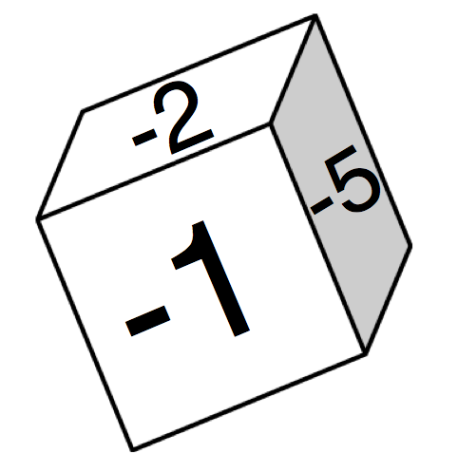
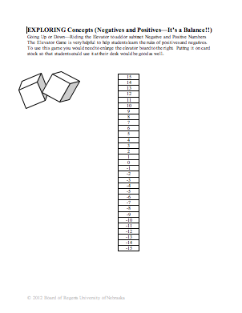

Instructing Concepts: (Negatives and Positives—It’s a Balance!!)

Signed Numbers

Putting “Signed Numbers” in Recognizable Terms: Signed numbers can either be positive or negative with negative being the opposite of positive. Negative numbers are to the left of zero and positive numbers are to the right of zero. Signed numbers describe the position of the number relative to zero.

Putting “Signed Numbers” in Conceptual Terms: Signed numbers can belong to any of these number sets: 1) Integers, 2) Rational, 3) Real, or 4) Complex. Signed numbers including negative are used to represent opposite directions or to distinguish a numbers value relative to zero. With the addition of signed numbers we can mathematically discuss the concept of having less than you started with (a loss), below (as in sea level), opposite direction (as in vectors), or any situation where opposite positions are needed.

Putting “Signed Numbers” in Mathematical Terms: Signed numbers are related to the mathematical concept of absolute value. Absolute value is defined to be the distance from zero. Two numbers that are the same distance from zero (like 5 and – 5) will have opposite signs. From this concept we can extend our understanding of signed numbers to include the idea that every positive number will have an opposite, which will be negative, and both of these “opposite” numbers will have the same absolute value.

Putting “Signed Numbers” in Process Terms: Thus, signed numbers allow us to represent pairs of numbers that have the same distance from zero. They are used in the basic operations of addition, subtraction, multiplication, and division to represent movement to the left on the number line or a change in direction. The process of using signed numbers to represent opposite quantities is critical to our understanding of mathematics, science, economics, and most other academic disciplines.

Putting “Signed Numbers” in Applicable Terms: Signed numbers are essential to represent concepts such as temperature, altitude (above and below sea level), monetary loss, and numerous other situations. They form the basis of the number system that we use to model and gain an understanding of our world.

Organizing Learning: (Negatives and Positives—It’s a Balance!!)

Summary: Students will use records of weight loss and gain of participants in a weight loss contest to compute the negative/positive weight gain or loss, net weight loss and final weight of participants.

Outline:
- Students will use negatives and positives related to weight loss to practice adding and subtracting with negative numbers.

Activity: Students will each receive a table with a list of daily weight loss or gain for a person involved in a “Losers Extraordinary” contest. Using either a horizontal number line or a vertical (thermometer) type number line, they will work with a partner student using the table provided to determine both the final weight of a participant in the Losers Extraordinary contest and the net gain or loss of those participants. Students will begin with the “patient’s” beginning weight and using the table provided add or subtract to determine the final weight of the patient and use the far right column to keep a net gain or loss of weight. Once the students have completed the computation, they will compare their results and determine which participant lost the most weight in net loss.

Resources:
- Number Line on White Board or Paper

Attachment:
- Worksheets with Patient A, B, C, D and a blank worksheet so that the teacher can create more if necessary: M108_SHINE_Negatives_And_Positives_Balance_O_Worksheets.doc
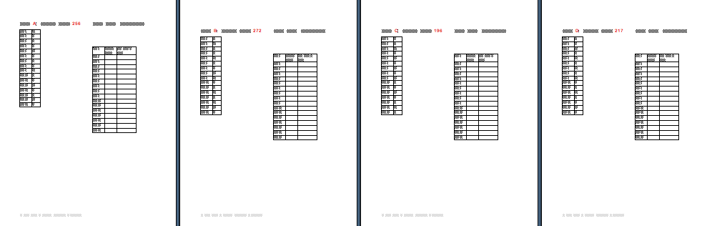

Understanding Learning: (Negatives and Positives—It’s a Balance!!)

Summary: Students will model an addition or subtraction problem using a number line or number cubes. Students will also write an addition or subtraction problem from the given picture.

Outline

Formative Assessment of Signed Numbers

Summative Assessment of Signed Numbers

Activity: Students will complete written and performance assessments related to signed numbers.

Formative Assessment: As students are engaged in the lesson, ask these or similar questions:

Do students understand which way do you move on a number line if you are subtracting? (left) or adding? (right)

Which way do you move on a number line if you are subtracting a negative number (providing you begin at zero)? (right) adding a positive number? (right)

Were students able to complete the weight game by working with signed numbers?

Summative Assessment: Students can answer the following writing prompt.

1) What are the advantages of being able to understand integer addition and subtraction when working with:

Weight loss

Temperature

2) Explain how opposites can help us better understand integers

Students can complete the following performance assessment: Number cubes (with numbers 1-6 on one and -1- - 6 on the other) should be rolled. The result of the roles should be modeled as an addition or subtraction problem using a number line.

