RET Lesson:
Handheld Trigonometry
==========================Lesson Header ==========================
Lesson Title: Handheld Trigonometry
Draft Date: 7/9/13
1st Author (Writer): Scott Burns
2nd Author (Editor/Resource Finder):
Instructional Component Used: Basic Trigonometric Functions
Grade Level: 9-12
Cartoon Illustration Idea: Two android characters examining construction site
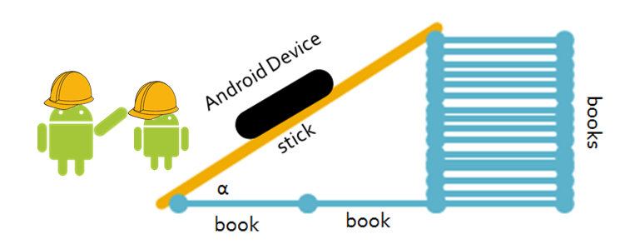
Content (what is taught):
- Understanding of trig ratios (sine, cosine and tangent)
- Application of trig ratios
- Measurement and estimation techniques

Context (how it is taught):
- Students will create triangles using classroom supplies
- The angle measures of the triangles will be measured and explored
- Students will attempt to create a triangle given only one side and one angle
Activity Description:
In this lesson, students will investigate the relationships between angles and side lengths in right triangles with the help of materials found in the classroom and an electronic device. Using all or part of a meter stick or dowel and text books or other supplies, students will build right triangles and measure the angles using a clinometer application on an Android (phone or tablet) or iOS device (iPhone or iPad). Students will then be given the task of creating a triangle with a given side length and one angle. The electronic device will be used to measure the accuracy of their construction.

Standards: (At least one standard each for Math, Science, Engineering and Technology - use standards provided)

Math - MD, MC1, MC4, MD1, MD2

Science - SB1 , SE1
- Technology – TA3, TB1, TD3
- Engineering – EA2, EB1, ED1
- Computer Science - CL:L2 1 , CCP:L2 1 CCP:L2 2

Materials List:
- Yard or meter sticks, or tape measures
- Sticks or dowels of varying lengths and extra textbooks or other stacking objects
- Android (phone or tablet) or iOS (iPhone or iPad) device and free clinometer app
Asking Questions (Handheld Trigonometry)
Summary: Students are asked to make observations about right triangles.

Outline:
- Draw two similar right triangles on a board, mark the right angles on each and mark one set of corresponding acute angles as congruent.
- Ask questions to get students thinking about trigonometry.

Activity: Demonstrate that two right triangles having in common one acute angle measure ensures all other corresponding angles are congruent, which implies the triangles are similar. This creates the foundation for right-triangle trigonometry.

Questions | Answers
What do you notice about the angles of these two triangles? | The corresponding angles are all congruent.
How do you know ALL of the corresponding angles are congruent even though not all are marked as such? | Since all the angles in a Euclidian triangle must sum to 180 degrees, and two corresponding angles are already congruent, an explanation using the transitive property or substitution could be made to show the third angles congruent.
How many parts of a right triangle must we know in order to figure out all of the other parts? | Knowing at least one acute angle and one side will allow for discovery of all other parts of a right triangle.
What does it mean that sin(30 degrees) = ½ | It means ANY right triangle with a 30 degree angle will have a hypotenuse twice as long as the side opposite the 30 degree angle

Image Idea:

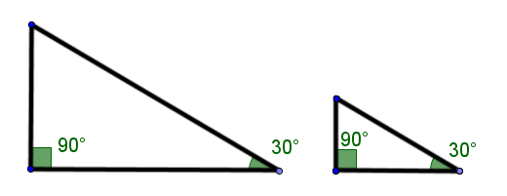

Resources:

Exploring Concepts (Handheld Trigonometry)
Summary: In groups, students will be given a stick of set length (yard stick, meter stick, or cut versions of one of these) and an android or iOS device (iPhone or iPad) with an installed clinometer device installed (see resource below for free app choices). With these tools, and a stack of text books, they should experiment with creating different triangles with their given stick and other common objects (textbooks, rulers, etc.) found in the classroom.

Outline:
- Students are given a stick of set and known length.
- They are also given an Android or iOS device with a clinometer app installed (see resources below).
- Students are given textbooks and other classroom supplies and asked to create right different right triangles using the given stick as the hypotenuse.
- Students explore the relationships between the acute angles and lengths of the legs of a right triangle.

Activity:
Students will be given a stick of fixed length. This can be a yard or meter stick, a dowel, or anything else that is rigid and can be measured. They will also be given a linear measuring device (tape measure, yard or meter stick, etc) and an Android device (phone or tablet) or an iOS device (iPhone or iPad) with a clinometer app installed (see resources below). In their groups, students will construct a right triangle using their stick as hypotenuse and textbooks or other classroom supplies as the two legs (see diagram). They then use their electronic device and clinometer app to measure the angles of the triangle and explore the relationships between the angle measures and the sidle lengths.

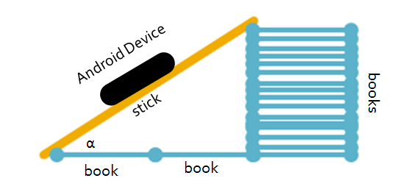
Image Idea:

Resources:
Search for these apps in iTunes or Google Play to find free clinometer apps

iOS Clinometer: Clinometer HD – bubble level and slope finder By plaincode

Android Clinometer: Clinometer (+bubble-level) By plaincode

Basic Trigonometric Functions
Putting “Trig Functions” in Recognizable terms: Trig functions are ratios of the legs and hypotenuse of the right triangles used in the Pythagorean Theorem. The basic trig functions are related to the reference angle (the given angle or its equivalent).

Putting “Trig Functions” in Conceptual terms: If we look at a rectangular coordinate system and place an angle (θ) so that its vertex is located at the origin and the adjacent leg of the angle lies on the abscissa, the basic trigonometric functions of that angle are defined to be:
- Sine – the ratio of the length of the leg opposite the reference angle divided by the length of the hypotenuse.
- Cosine – the ratio of the length of the leg adjacent to the reference angle divided by the length of the hypotenuse.
- Tangent – the ratio of the length of the leg opposite the reference angle divided by the length of the leg adjacent to the reference angle.
Putting “Trig Functions” in Mathematical terms: The basic trig functions for an angle θ positioned as above are defined, then, to be:
- sin θ = y/r
- cos θ = x/r
- tan θ = y/x
where x is the x coordinate of any point on the terminal side of the angle other than the origin, y is the y coordinate of that point, and r is the length of the line segment from the origin to that point. (Remember from the Pythagorean Theorem that x ² + y ² = r ² ).

Putting “Trig Functions” in Process terms: Since the trig functions of an angle are defined to be the ratios above, and those ratios do not change based upon the position of the point (x,y) on the hypotenuse, the sine, cosine, and tangent are related to the angle θ and not the (x,y) point chosen to calculate the ratios.

Putting “Trig Functions” in Applicable terms: Drive the bot along a [straight] line from the origin and stop it at irregular (random) time intervals. Determine the coordinates of the bot’s location and calculate the definition ratios for sine, cosine, and tangent at several different points along the line (the hypotenuse of the right triangle formed by connecting the (x,y) point to the abscissa with a vertical line).

Organizing Learning Handheld Trigonometry
Summary:
Students will be given a stick of fixed length and a stack of textbooks. Their task is to use those tools to construct a right triangle that has a given acute angle. An Android application will be used to verify the correctness of the angel.

Outline:
- Put students in groups of two or three.
- Give each group a stick of fixed length (yard or meter sticks cut to different lengths).
- Provide each group an acute angle measure (0-90 degrees).
- Have students draw rough sketches and use trigonometry to find a right triangle with given hypotenuse and acute angle.
- Have students create a final annotated draft of the triangle they will construct.
- Students build their triangle with the provided stick and textbooks or other objects found in the classroom.
- An Android device (phone or tablet) or iOS device (iPhone or iPad) equipped with a clinometer application (see resources) will be used to check the measure of the angle

Activity:
Working in groups of two or three, students will be given a stick of fixed length (this can be a yard or meter stick, or any stick-like object found in the classroom). This will represent the hypotenuse of a right triangle. If needed, students will need to measure this object and use their recorded length in their calculations. The teacher will also provide them with a target angle. Their objective is to create a triangle that has the stick as its hypotenuse and the given angle as one of the acute angles. They will work on this by first working on rough draft drawings and calculations of their finished product. This can be done with paper and pencil or on white boards. After a firm plan has been developed, students need to create a polished final draft of their proposal for the dimensions of the triangle. This final draft should include brief explanations of numerical results.

Using the final draft as a guide, students will build their triangle using their given stick and textbooks, blocks, desks, or any teacher-approved objects found in the classroom. When each group is ready, the teacher can use one of the electronic devices equipped with a clinometer to measure the angles of the triangle and assess the students’ ability to construct a triangle with the desired dimensions.

Resources:
Search for these apps in iTunes or Google Play to find free clinometer apps

iOS Clinometer: Clinometer HD – bubble level and slope finder By plaincode

Android Clinometer: Clinometer (+bubble-level) By plaincode

Understanding Learning Handheld Trigonometry
Summary: Students will complete assessments related to trigonometry.

Outline:
- Formative assessment of Trig Functions
- Summative assessment of Trig Functions

Activity:
Students will keep a written, step-by-step journal of their processes for constructing their triangle, then create a short video which summarizes the work they did and whether or not they were successful.

Formative Assessment
As students are engaged in constructing the triangle? Ask yourself or your students these types of questions:
- Are the students effectively communicating using trigonometric vocabulary?
- Can students communicate the need for using trigonometry in this situation?
- Can students see the relationship between side lengths and acute angles of a right triangle.
- Is every member of each group playing an effective role in the problem solving process?

Summative Assessment
Students can complete the following performance assessments.

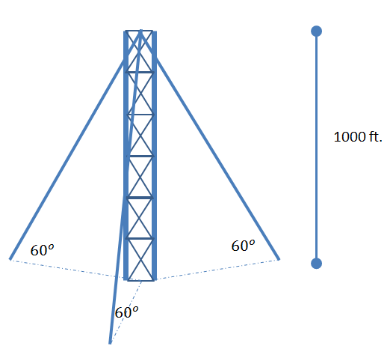
Students will prepare a well-written statement – including all necessary trigonometric equations – to answer the following questions:

A 1000 ft. radio tower is to be supported by three evenly spaced guy wires. Each wire will make a 60 degree angle with the ground (see illustration). Approximately how many feet of cable will be needed to construct the tower? How far will each wire be away from the tower? What is total surface area on the ground needed to build the tower (in other words, what is the area of the triangle formed on the ground by the wire anchors)?

