RET Lesson:
Hook, Line, and CEENBoT
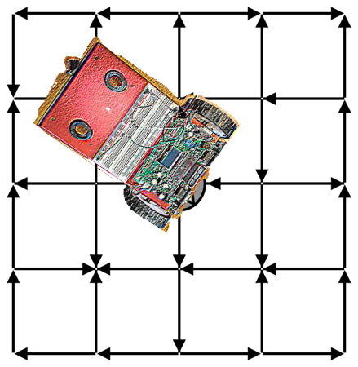
==========================Lesson Header ==========================
Lesson Title: Hook, Line, and CEENBoT
Draft Date: July 15, 2014
1st Author (Writer): Lisa Wheeler
2nd Author (Editor/Resource Finder): Brian Sandall
Instructional Component Used: Parallel and Perpendicular Lines
Grade Level: Geometry, 9-12

Content (what is taught):
- Concepts and applications of parallel and perpendicular lines
- The relationship between slope and determining parallel and
Image source (maze): Wiki Commons
perpendicular lines.
- Basic programming
- Problem solving

Context (how it is taught):
- CEENBoT with TI83 calculator programmed to run parallel and perpendicular lines.
- Making comparisons and calculating slope
- Using predictive and problem solving skills
Activity Description:
Using a CEENBoT with a pen attached and TI83 teacher programmed calculators, the CEENBoT will draw parallel and perpendicular lines. Class will discuss the properties of parallel and perpendicular lines, how slopes determine what lines are indeed parallel and perpendicular. Students will explore how changes in the program affect lines created by the CEENBoT. Will assess based on a maze of parallel and perpendicular lines and the ability of students to edit the program to get the CEENBoT through the maze.

Standards:

Math Science
MA2, MA3, MC1, MC2, MC4 SA1, SE1, SF5

Technology Engineering
TA1, TD1, TD2 EA1, EB1, EB2
Computer Science
CT:L3:MW, CT:L3:CP, CL:L3:MW,CL:L3:CP, CD:L3:MW,CI:L3:MW

Materials List:
- TI83 download
- projector
- tape
- handouts

- CEENBoT
- large paper
- pen attachment for CEENBoT
- marker/pen

- TI83 calculator
- interface cable
- programs

Asking Questions (Hook, Line, and CEENBoT)
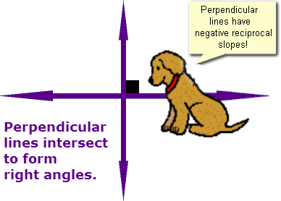
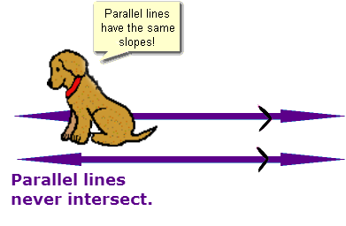
Summary: Discuss the concepts of parallel and perpendicular lines, simple programming concepts, and graphing calculators.
Outline:
- Discuss properties of parallel and perpendicular lines.
- Ask questions about and discuss the basics of how robots perform a task.
- Introduce the graphing calculator and demonstrate the basic uses and then specifically how it can be used for programming a CEENBoT to perform a task.
Activity: A class discussion about parallel and perpendicular will begin the activity. Students will consider what the terms mean and where they might be found in the world. The discussion will then turn to robots and how they perform tasks. Discuss programming and codes. One way is to use a TI-83 graphing calculator. The teacher will introduce the students to programming and the graphing calculator. Demonstrate how the TI83 calculator can be used for programming by running a pre-loaded program. To conclude, the teacher will show students the different commands and what they mean. (see attachment)
Questions | Answers
What are parallel lines? Can anyone point to an example of parallel lines in the room? | Parallel lines are lines that never intersect and their slopes are equal.  Answers will vary.
What are perpendicular lines? Can anyone point to an example of perpendicular lines in the room? | Perpendicular lines intersect to form right angles and their slopes are opposite reciprocals. Answers will vary.
What is the measure of the angle is created by perpendicular lines? | The measure of the angle created is 90°. Since there are 4 angles created in one set of perpendicular lines, they actually create four 90° angles.
How can we prove lines are parallel or perpendicular? | Parallel and perpendicular lines can be proven by calculating the slope of each line. Parallel lines = same slope, perpendicular lines = opposite reciprocal slopes.
What causes any robot to perform a task? How is a robot programmed? What is needed? Can a robot be programmed, without a computer, to perform a task? | A program is needed for a robot to perform a task. This is usually done a computer using different languages, however, for some robots a graphing calculator can be used.
Has anyone had experience with computer programming? Do you know what it is? A different language? What meant by “code?” | Answers will vary. Programming is the process of writing algorithms to perform a task. Yes, there are a variety of different programming languages, each language uses specific instructions called code.
What are the uses for a calculator? Why would we need such a large screen? Can you think of anything else we could do with the calculator? | Answers will vary. A large screen allows us to see graphs and also a larger portion of code used for programming.
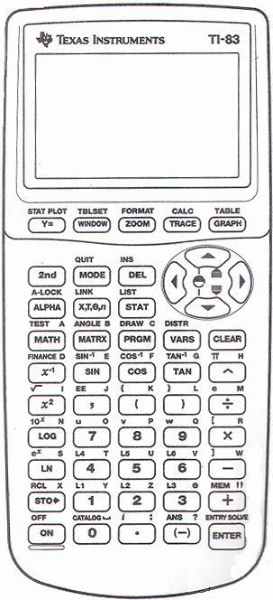
Resources:
TI-83 Graphing calculator
CEENBoT capable of interfacing with a TI-83
Interface cable

Attachments:
M112_RET_Hook_Line_CEENBoT_A_TI_Calculator.doc

Exploring Concepts (Hook, Line, and CEENBoT)

Summary: Run the CEENBoT program with pen attached to create parallel and perpendicular lines and explore the program.

Outline:
- Run drawing line program on CEENBoT.
- Discuss lines and angles drawn
- Investigate TI83 program code

Activity: The activity will begin by hooking up a TI83 calculator to a CEENBoT and showing the students a previously written program. NOTE: The BoT must have a pen attached and be running on a large piece of paper.

What kind of lines were made by the BoT? Were there any angles? If so, estimate the degree.

Next using the projector, the teacher will show students what the TI83 code looks like that created the lines in the first part of the activity. Students will discuss and analyze what in the code made the CEENBoT go forward, back, or rotate.

How did the program cause the CEENBoT to create the lines?

The program will be changed, uploaded to the CEENBoT and run. Students will observe the CEENBoT’s behavior and changes with the lines that are drawn.

Finally, divide up into groups and allow students to discuss and hypothesize how changes to the program will affect the CEENBoT movement. Then pass out calculators, and have students explore the TI83 program and actually make the changes they discussed. NOTE: There is a worksheet that students will need to complete and get approved before they test their hypotheses. (see attached file: Allow students to hook up the calculator and CEENBoT to see if they were correct on their guesstimate. To conclude, each group will share what changes were made and what their results were.
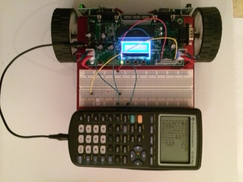

Resources:
TI-83 Graphing calculator(s)
CEENBoT capable of interfacing with a TI-83

Attachments:

Instructing Concepts (Hook, Line, and CEENBoT)

Parallel and Perpendicular lines.
Putting “parallel and perpendicular lines” in recognizable terms: Parallel lines are two or more lines that extend in both directions and never intersect. Perpendicular lines are two or more lines that intersect to make a right angle (90°). When parallel and perpendicular lines are intersected by a transversal, specific relationships between angles are created.

Putting parallel and perpendicular lines in conceptual terms.

Line 1 and Line 2 are parallel. Line 3 and line 4 are perpendicular to line 5.

Putting parallel and perpendicular lines in mathematical terms.

Formula for the slope (m) of a line: m = 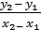 ; slope can also be determined using .
The slopes of parallel lines are equal and the slopes of perpendicular lines are opposite reciprocals.
Parallel lines: = Perpendicular lines: = -

Recall: The slope of a horizontal line is zero (0) and the slope of a vertical line is undefined ( ).

Putting parallel and perpendicular lines in process terms.

For any pair of lines, if slope is calculated or determined then parallel or perpendicular lines can be determined.

Putting parallel and perpendicular lines in applicable terms.

Using the CEENBoT, drive the BoT on paper or some type of impressionable material to look at the lines and/or impressions left by the wheels after going forward some distance. Since the impression that each wheel of the BoT makes will never intersect, the lines created would be parallel lines. Using the same material, and attaching a pen to the BoT, drive the BoT forward some distance and then turn 90°. Drive it forward some distance and then back over the original line. Knowing the BoT turns exactly 90° means that these lines are perpendicular.
Organizing Learning (Hook, Line, and CEENBoT)

Summary: Students will use the CEENBoT and programmed calculator to produce lines parallel and perpendicular to given lines in stations around the classroom. Students will need to calculate slopes to determine if the lines they produced are correct.

Outline:
- Make changes to program to create lines as instructed in each station.
- Calculate slopes to verify correctness.
- Record changes and slope calculations
- Discuss activity

Activity: Students will determine what changes need to be made to a program to create lines that are parallel or perpendicular to a given line as instructed by the teacher. Students will record the program with changes for each station. They will need to calculate slopes to determine if the lines are indeed parallel and perpendicular. The initial lines will be placed around the room by the teacher using masking tape prior to class. To do this project, the teacher will set the CEENBoT on the floor in different positions relative to the marked line and tell the students to make the CEENBoT go either parallel or perpendicular to the line(s). NOTE: For each group, the CEENBoT should be placed in the same orientation. Marking the starting point with masking tape should help with this. By doing this, all groups should get approximately the same solution. As the teacher you can make the problem more difficult if you require rotations that are for each station or increase the number and/or type of lines. To conclude, a discussion of the activity will be conducted to debrief the activity.

Resources:

Educational Robotics: http://educationalrobotics.wikispaces.com/CEENBoT+Commander
STEMbotics: https://sites.google.com/site/stembotics/
TI Connect: http://education.ti.com/en/us/products/computer_software/connectivity-software/ti-connect-software/downloads/download-instructions
Understanding Learning (Hook, Line, and CEENBoT)

Summary: Students define, describe, produce, and prove parallel and perpendicular.

Outline:
- Formative assessment of parallel and perpendicular lines.
- Summative assessment of parallel and perpendicular lines.

Activity: Students will complete written and performance assessments related to parallel and perpendicular lines.

Formative Assessment
As students are engaged in the lesson ask these or similar questions:
- Are students recognizing the difference between parallel and perpendicular lines?
- Do students understand the relationship between the slope and determining parallel and perpendicular?
- Do students understand the type angle created by perpendicular lines?
- Do students understand the number of angles that are congruent created by perpendicular lines?
- Can students apply the properties to create parallel and perpendicular lines?

Summative Assessment
Students can complete the following writing prompts.
- Define parallel and perpendicular. How are the slopes of each related?
- What is the slope of a horizontal line and why?
- What is the slope of a vertical line and why?

Students can complete the following performance assessment.
On a large coordinate plane, you will program the TI83 calculator to drive the BoT to create a perpendicular line. Determine if there are any other angles or rotations of the CEENBoT that would create a right angle when driven and if so, name them. Finally, students will make appropriate changes to the program to drive the CEENBoT through a maze of parallel and perpendicular lines.

