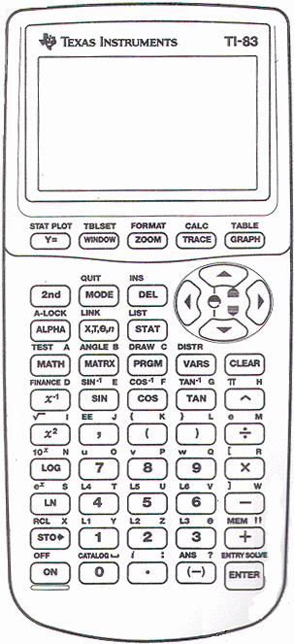
Hook, Line, and CEENBoT
Programming a TI graphing calculator for the CEENBoT

Run a Program
1. Press PRGM
2. Under EXEC, select program
3. Press ENTER twice

Edit a Program
1. Press PRGM
2. Right arrow to EDIT
3. Down arrow to program name, press ENTER
4. Edit the program
5. Use 2nd MODE (QUIT) when finished

Program Editing Commands
In program editor, use keys and menus to enter commands.
CLEAR key - return to programming (if wrong key pressed)
2nd DEL (INS) - turn on insert mode
PRGM key
CTL: If..Then..Else..End
I/O: Disp, Input, Prompt, Get, Send
EXEC: use to call other programs as subroutines
MATH key
NUM: abs, int
PRB: rand
2nd [1] (L1)

Programs
TURNDEMO: Turn a random angle TURNTEST: Forward 750 steps, turn 750 steps, forward again

TURNDEMO TURNTEST
{3,0,0,0,0}->L1 {10,500}->L1:Send(L1):Get(Z)
int(rand*500+100)->L1(3) {2,2,0,750,200,0}->L1:Send(L1):Get(Z)
int(rand*350+50)->L1(4) {3,0,750,200,0}->L1:Send(L1):Get(Z)
Send(L1) {2,2,0,750,200,0}->L1:Send(L1):Get(Z)
Get(Z)

TI Calculator Commands to Control the CEENBoT
Step & Wait {2, <which>,<dir>,<steps>,<speed>,<brk_mode>}
Tank Turn {3, <which_way>,<steps>,<speed>,<brk_mode>}
Delay {10, <delay_ms>}

Which 0 = left motor 1 = right motor 2 = both motors
Dir 0 = forward 1 = reverse
Steps 1 revolution = 200 steps based on the motor design
Speed 0 to 400 in steps/sec
Which Way 0 = left turn 1 = right turn
Brk Mode 0 = off 1 = on

