Teachers rev up robotics knowledge
By Julie Blum jblum@columbustelegram.com
Friday, June 26, 2009 - 09:20:49 am CDT

COLUMBUS - Small robotic cars will be making appearances in the classroom to help students learn about math, science and technology.
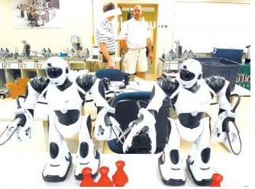
Jeff Korus, right, a math teacher at Humphrey St. Francis High School, speaks with University of Omaha Math Professor Neal Grandgenett about robotics during a two-week Summer Robotics Institute at Central Community College-Columbus. Telegram photo by Blaine McCartney
Several local and area teachers are taking part in a two-week Summer Robotics Institute at Central Community College-Columbus. The 21 teachers built the cars last week and are currently developing lesson activities they will be able to use with their students for the upcoming school year.

"This puts math and science concepts in a realistic context," said Neal Grandgenett.

He is a math professor at the Peter Kiewit Institute, one of the partners along with CCC-Columbus, Columbus Public Schools, the University of Nebraska-Lincoln and the University of Nebraska-Omaha for the workshop.
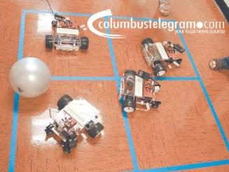
A game of four square is played by Nebraska high school teachers using the radio-controlled robot cars. Telegram photo by Blaine McCartney
A two-year Career Education Partnership Act grant is funding the workshop.

Teachers participating are at the middle school and high school levels teaching in the math, science and technology areas. Each teacher gets to take three robotic cars back to their schools when they complete the workshop.

Shantelle Suiter, a math teacher at Columbus Middle School, said she is looking forward to using the robot in her classroom. Her students, she said, are technologically savvy, so this will be right up their alley.

It will provide a unique way to help students get hands-on lessons in mathematics because every part of the robot, from the circumference of wheels it rolls on to the engineering it takes to develop it, involves numbers and formulas.

"Technology is math. Without the math, you wouldn't have technology," she said.

St. Isidore Elementary School teacher Megan DeWispelare said she was involved in the workshop because she was looking for ways to incorporate more technology into her teaching. She teaches computers, and also math and science to sixth graders.

She plans on using the robots with her computer students. Even the youngest kindergarten students will be able to use them because the cars are controlled with a device that many of them are used to, a PlayStation 2 controller.

Dan Davidchik, Mechatronics Project Coordinator at CCC-Columbus, said the workshop is another way of growing the awareness of technology as a teaching tool. The Mechatronics Education Center at CCC-Columbus emphasizes technical careers. Several workshops open to middle school, high school and college teachers, and industry workers focusing on technology have been offered through the center.

####

http://www.columbustelegram.com/articles/2009/06/27/news/local/doc4a44d11654144160425670.txt

