Summary of Robotics Showcase:
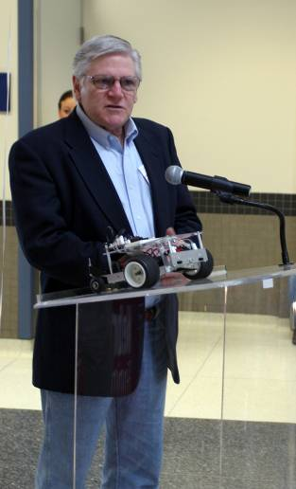
- Over 100 students from grades K-12 attended the event on Saturday, March 28th along with teachers and many parents
- 26 schools participated in the inaugural event
- News coverage by WOWT and the Omaha World Herald
- Sponsors included OPPD, Cox Communications, Lockheed Martin and Union Pacific
Ed Hollingsworth, UP gives a few opening remarks
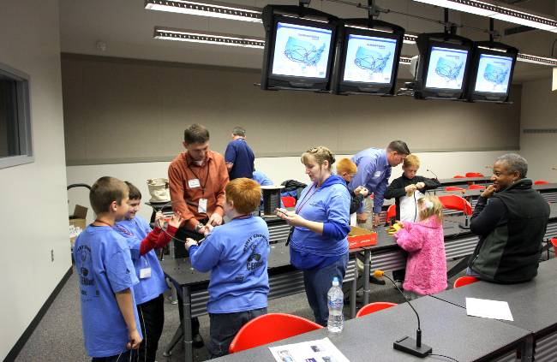
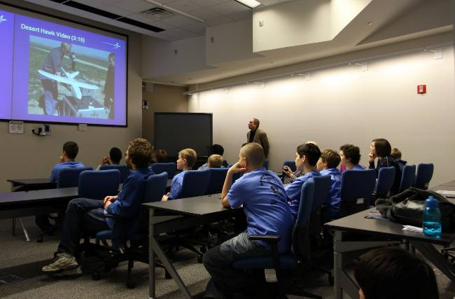
- Presentations were conducted by Cox and Lockheed Martin and proved to be a great success and very popular with students, teachers and parents
Sponsors Cox Communications (left) and Lockheed Martin (right) offered hands-on activities and learning opportunities to participants. Omaha Public Power District and Union Pacific also helped sponsor the 2009 SPIRIT Robotics Showcase.
- IEEE student organization contributed to building road courses and manning the food booth
- All students received t-shirts and a Cricket Robot
- All participating schools received CEENBoTs and/or Electronic Snap Circuit kits, thus infusing their classrooms with new materials related to engineering with the promise of exposure to more K-12 aged students
- When asked if they would like to be engineers someday all the students enthusiastically responded “YES”
- CEEN freshman seminar students served as judges and guides providing them with a service learning experience
- CEEN Laboratories (including the KUKA robot lab) and Computer Science Robotics Laboratory demonstrations were conducted
- All the events were well synchronized and went off without a single hitch thanks to our organizer, Deborah Duran
Plans for next year:
- Due to the success of the inaugural 2009 Robotics Showcase, planning has begun for 2010
- As the CEENBoT adds a microprocessor board with the promise of programming experiences along with new sensors (proximity, video, microphones, light sensing), new events will be added to the Showcase
- Additional schools will be added to the Showcase to expose greater numbers of students to the promise of engineering as a career destination
- Increase the number of corporations providing presentations on their technology as an outreach to the community
- Continue the infusion of engineering tools into more classrooms until there is a continuity of exposure throughout the K-12 period
- Utilize the Showcase as an opportunity for teachers to share their classroom materials related to engineering with one another and to interact with industry sponsors to enhance their understanding of engineering design and philosophy
SPIRIT Robotics Showcase 2009 Photos
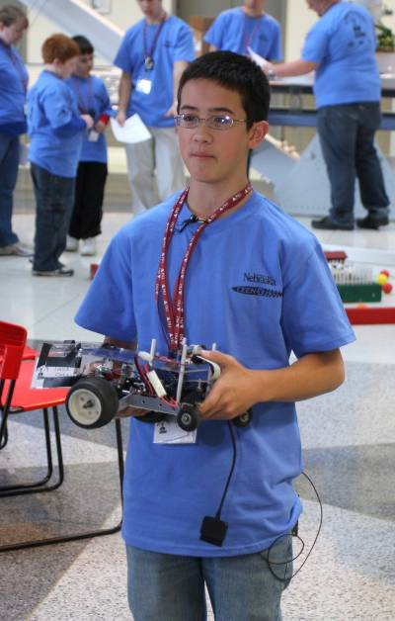
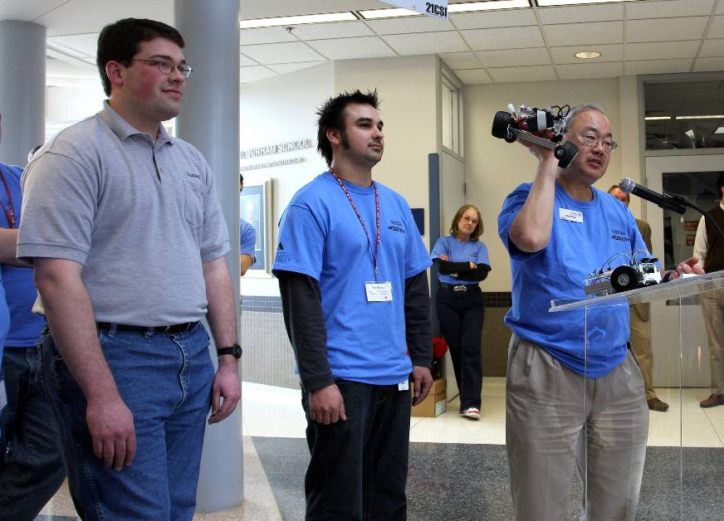
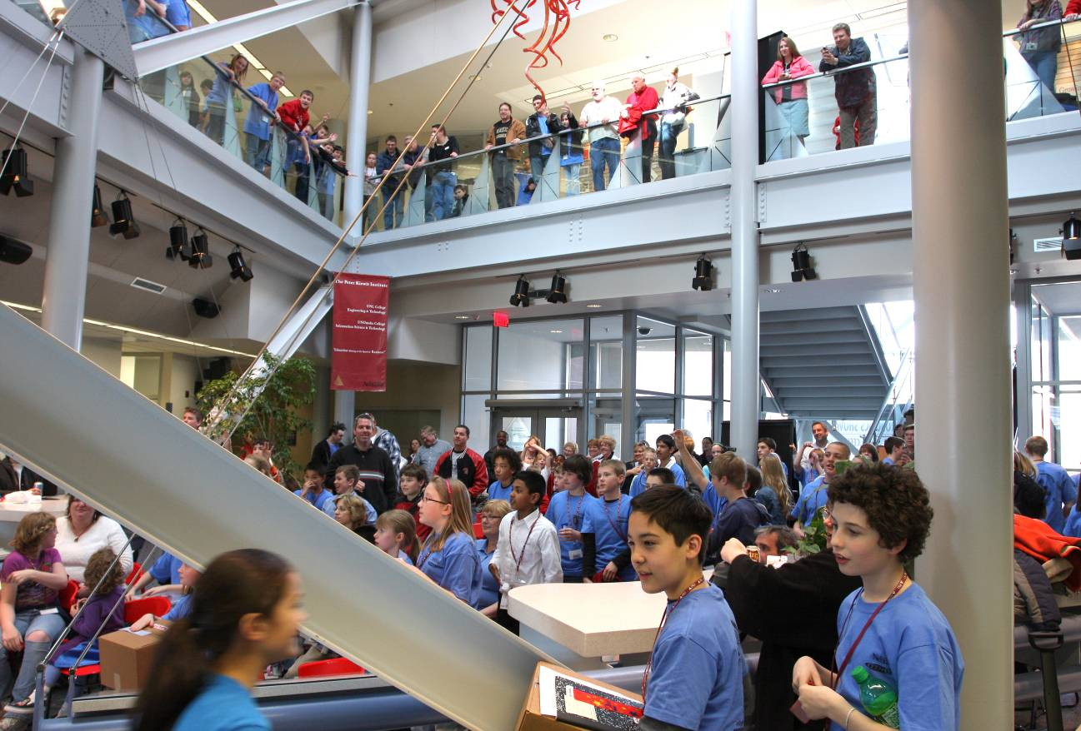
Middle school participant holding his CEENBoT™.
Original CEENBoT™ designers Dan Norman and Ben Barenz with PI Dr. Bing Chen holding the CEENBoT™.
Many middle/high school students, teachers, and parents attended this Saturday event.
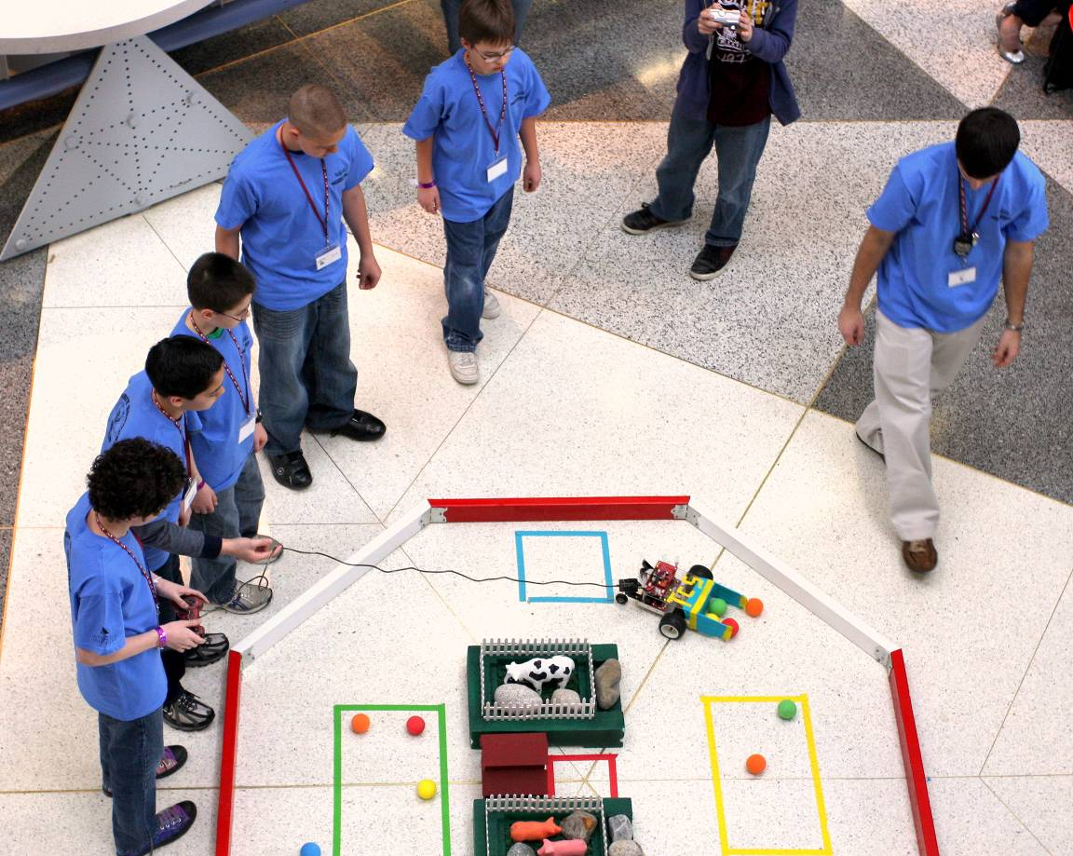
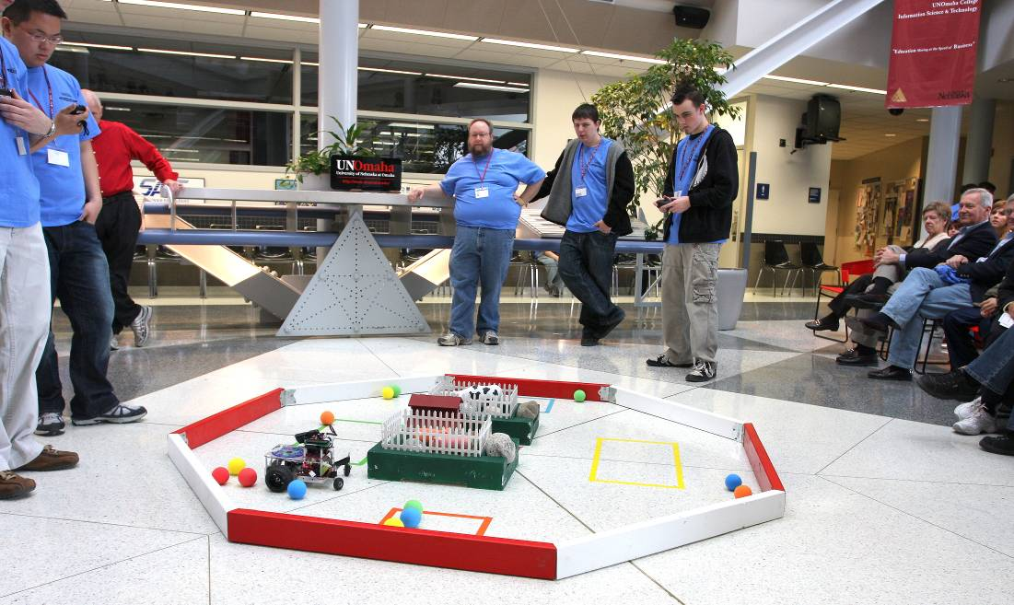
A middle school CEENBoT™ team powers through the ball maze.
The Benson High School CEENBoT™ team pilots the ball maze wirelessly.
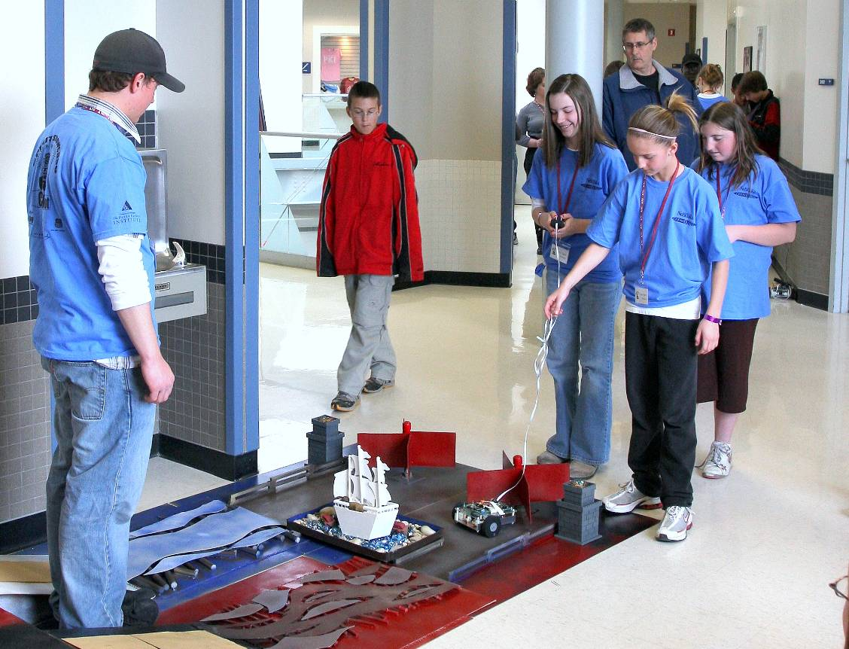
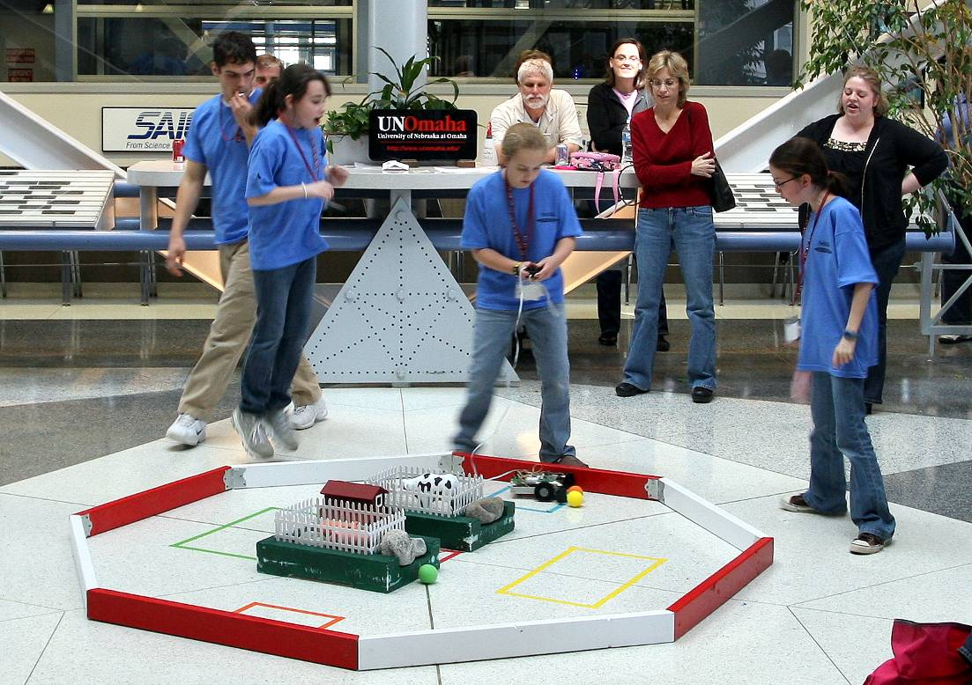
The Tera Heights all-girls TekBot® team navigates the road-obstacle course.
An all-girls middle-school TekBot® team pushes to score in the final seconds.
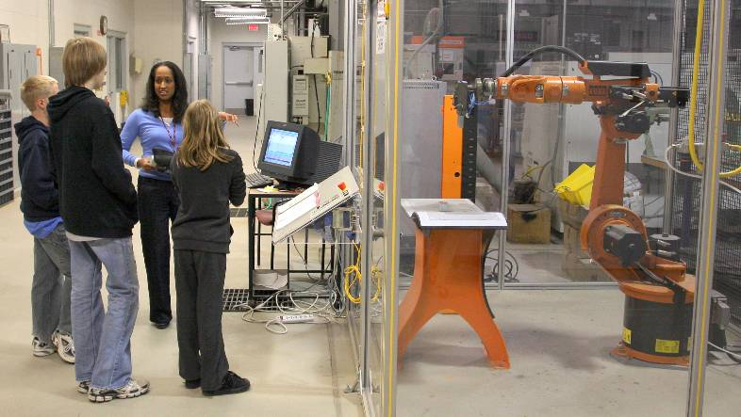
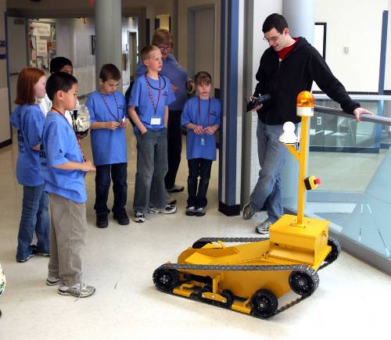
Demonstrations of the KUKA Industrial robot (left) and other CEEN student-built robots (right) were offered to participants and to the public.
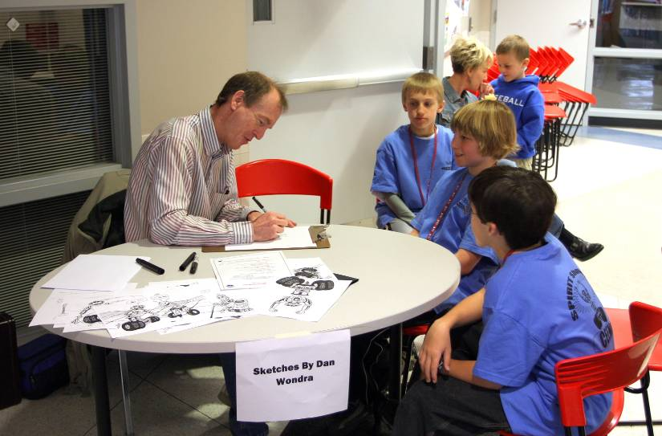
Artist Dan Wondra was on hand to do caricature sketches of participants.

