Westside 5th and 6th Graders Get Into Robotics
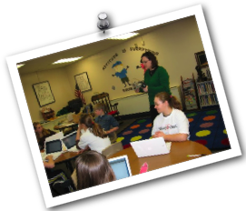
As a starting activity, the 5th and 6th grade students learned about how the TekBot was wired. They switched the motor cords around to see how it changed the wheel movement. They also wired the TekBot with a tethered remote.

Each student had a chance to practice driving the TekBot through a pre-designed course. Other students watched and recorded data (how many golf tees were knocked down, how many times the TekBot touched the tape, and total time). Each obstacle added seconds to the total time and students calculated the final time for each driver.

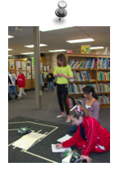

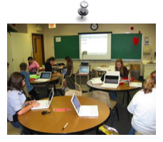

Students typed the obstacle course data into a spreadsheet program and created a graph. Students also calculated the mean, median, and mode of the data.

February and March 2009

Westside 5th and 6th Graders Get Into Robotics
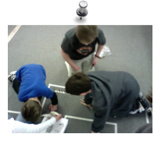
Students were excited to design and build their own obstacle course. They drew out a plan and had group members ask about their specifications. Each group had a chance to drive the TekBot through each course.

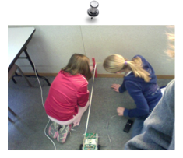

Students were instructed on different types of triangles and how to name them by sides (equilateral, isosceles, scalene) and angles (acute, obtuse, right). Next, students learned about the Pythagorean Theorem and how to find the length of a hypotenuse when given the length of 2 sides of the triangle. The TekBot was used to drive a string and create a right triangle as shown in the pictures. Students measured the legs and used a spreadsheet to calculate the length of the hypotenuse. Afterwards, students measured the sting to find out how close the actual measurement was compared to the calculated measurement from the spreadsheet.

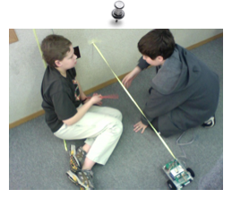

February and March 2009

