Waves I Diagrams
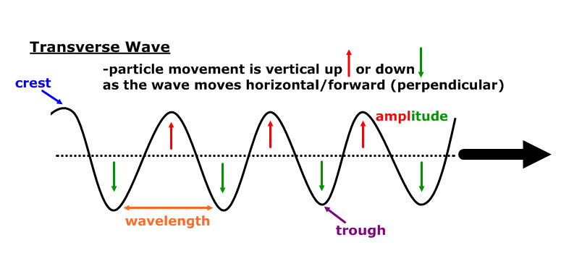
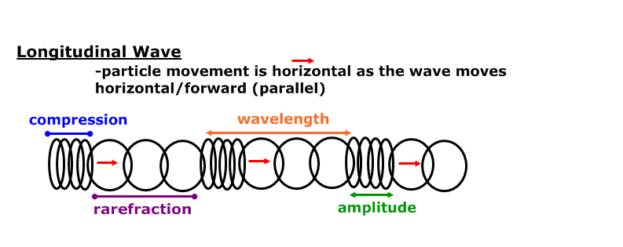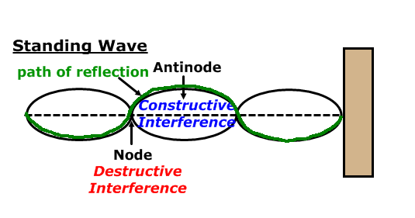
Longitudinal waves are sometimes called compression waves

Equation of Wave Motion in One Dimension
The motion of a single point on the wave can be modeled in one dimension with the formula: $u(t)=a\text{sin}(ωt+φ)$ where the displacement (u) depends on amplitude (a) and the angular frequency ($ω$) at a time (t), with a phase ($φ$). To find angular frequency ($ω$) use one of the equations $ω=2π/T$ or $ω=2π⋅f$ where the period is represented by “T”.

Equation of Wave Motion in Two Dimensions
The motion of a single point on the wave can also be modeled in two dimensions using the formula: $u(x,t)=a\text{sin}(\text{kx}−ωt+φ)$ where the displacement (u) depends on amplitude (a), the wave number (k), the angular frequency ($ω$) at a time (t), with a phase ($φ$). The wave number is the spatial frequency of the wave and is given by $k=2π/λ$where $λ$ is the wavelength. The speed of the wave can be found from $v=f⋅λ=\left(ω/2π\right)\left(2π/k\right)=ω/k$

