Osmosis and Tonicity Explanatory Diagrams
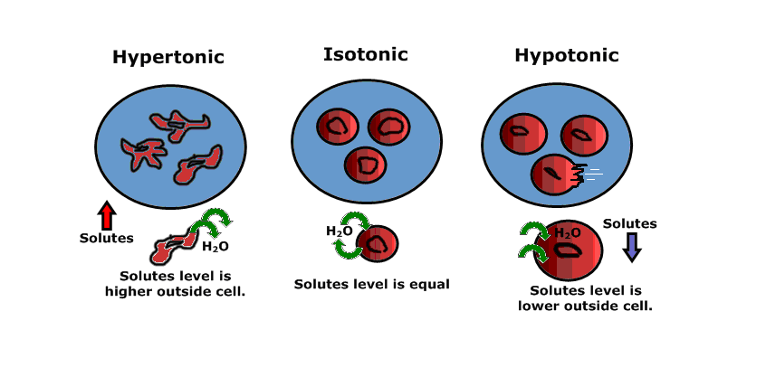
What do red blood cells really look like?
Image A: computer generated image of red blood cells showing a better view of their 3-D concave shape as they travel through a blood vessel
Image B: microscopic image of red blood cells on a glass slide
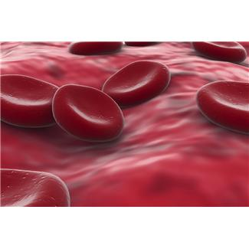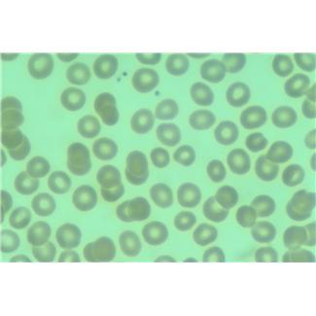
Image A
Image B

