S001: Force
Answers: 1. C, 2. A, 3. C

1) Four students push on a block of wood with the forces shown in the diagram below. Assume friction is negligible. The block slides horizontally. What is the net force acting on the block of wood?
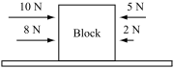

A. | 3 N to the left |  | B. | 8 N to the left
C. | 11 N to the right |  | D. | 25 N to the right

Source: MCAS: T2010, Science and Technology/Engineering – High School
HTUhttp://www.doe.mass.edu/mcas/testitems.htmlUT

2) Which of the following will definitely cause a change in the velocity of a parked car?

A. | The car experiences an unbalanced force. |  | B. | All forces acting on the car increase by 1 N.
C. | All forces acting on the car decrease by 1 N. |  | D. | The forces acting on the car are equal and balanced.

Source: MCAS: T2007, Science and Technology/Engineering – High School
HTUhttp://www.doe.mass.edu/mcas/testitems.htmlUT

3) A hot air balloon exerts a force of 1200 N while lifting a load of 800 N. Which free-body force diagram depicts the forces involved?

A. | 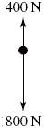 |  | B. | 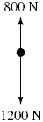
C. | 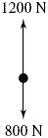 |  | D. | 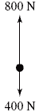

Source: MCAS: T2005, Science and Technology/Engineering – High School
HTUhttp://www.doe.mass.edu/mcas/testitems.htmlUT

