S002: Friction
Answers: 1. C, 2. A, 3. B

1) A car is parked on the side of a hill. Which of the following most likely prevents the car from moving down the hill?

A. | The car has too much mass to move easily. |  | B. | There is friction in the door hinges of the car.
C. | There is friction between the tires of and the road. |  | D. | The weight of the car is mostly on the front wheels.

Source: MCAS: 2007, Science and Technology/Engineering – High School
http://www.doe.mass.edu/mcas/testitems.html

2) A projectile launched at an angle of 45above the horizontal travels through the air. Compared to the projectile’s theoretical path with no air friction, the actual trajectory of the projectile with air friction is:

A. | Lower and shorter |  | B. | Higher and shorter
C. | Lower and longer |  | D. | Higher and longer
Source: University of the State of New York, Regents High School Examination: Physics, June 2008
http://www.nysedregents.org/Physics/20080625exam.pdf

3) The diagram below shows a 4.0-kilogram object accelerating at 10 meters per second² on a rough horizontal surface. What is the magnitude of the frictional force acting on the object?

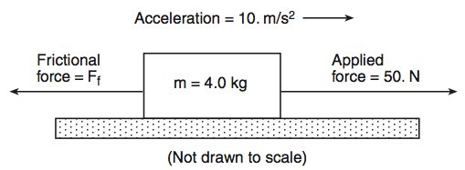

A. | 5.0 N |  | B. | 10 N
C. | 20 N |  | D. | 40 N
Source: University of the State of New York, Regents High School Examination: Physics, January 2007
http://www.nysedregents.org/Physics/20070125exam.pdf

