S003: Hookes Law
Answers: 1. B, 2. A, 3. B

1) An unstretched spring has a length of 10 centimeters. When the spring is stretched by a force of 16 N, its length is increased to 18 centimeters. What is the spring constant of this spring?

A. | 0.89 N/cm |  | B. | 1.6 N/cm
C. | 2.0 N/cm |  | D. | 1.8 N/cm
Source: University of the State of New York, Regents High School Examination: Physics, January 2009
http://www.nysedregents.org/Physics/20090129exam.pdf

2) The diagram below shows a toy cart possessing 16 joules of kinetic energy traveling on a frictionless, horizontal surface toward a horizontal spring. If the cart comes to rest after compressing the spring a distance of 1.0 meter, what is the spring constant of the spring?
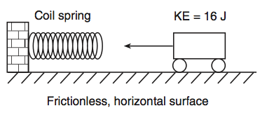
A. | 32 N/m |  | B. | 8.0 N/m
C. | 16 N/m |  | D. | 4.0 N/m
Source: University of the State of New York, Regents High School Examination: Physics, January 2009
http://www.nysedregents.org/Physics/20090129exam.pdf

3) The diagram below represents a spring hanging vertically that stretches 0.075 meter when a 5.0-newton block is attached. The spring-block system is at rest in the position shown. The value of the spring constant is?
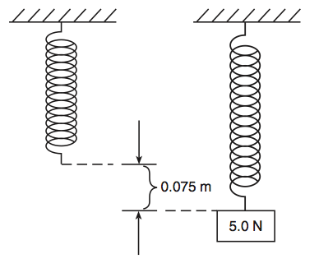
A. | 38 N/m |  | B. | 67 N/m
C. | 130 N/m |  | D. | 650 N/m
Source: University of the State of New York, Regents High School Examination: Physics, June 2007
http://www.nysedregents.org/Physics/20070621exam.pdf

