S004: Magnetism
Answers: 1. D, 2. C, 3. C

1) The picture below shows magnet 2 being pushed toward magnet 1. Which of the following will most likely happen to magnet 1 as magnet 2 is moved closer?
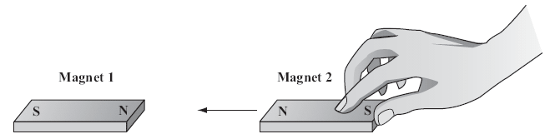

A. | Magnet 1 will move under magnet 2. |  | B. | Magnet 1 will move toward magnet 2.
C. | Magnet 1 will move on top of magnet 2. |  | D. | Magnet 1 will move away from magnet 2.

Source: MCAS: 2008, Science and Technology/Engineering – Grade 5
http://www.doe.mass.edu/mcas/testitems.html

2) In which case would it take the most effort to make points 1 and 2 on the magnets touch each other?

A. |  |  | B.
C. | 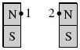 |  | D. | 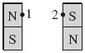

Source: MCAS: 2005, Science and Technology/Engineering – Grade 5
http://www.doe.mass.edu/mcas/testitems.html

3) Which of the following metals will be attracted to a magnet?

A. | copper |  | B. | gold
C. | iron |  | D. | silver

Source: MCAS: 2010, Science and Technology/Engineering – Grade 5
http://www.doe.mass.edu/mcas/testitems.html

