S007: Newton’s 1st Law of Motion
Answers: 1. A, 2. B, 3. D

1) A performer pulls a tablecloth out from under a complete set of dinnerware as shown in the illustration below. Which of the following best explains the performer’s success at leaving all the dinnerware on the table?
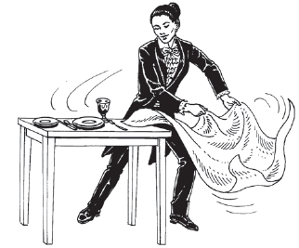
A. | The inertia of the dinnerware |  | B. | The large mass of the tablecloth
C. | The placement of the dinnerware |  | D. | The rough material of the tablecloth
Source: MCAS: 2008, Science and Technology/Engineering – High School
http://www.doe.mass.edu/mcas/testitems.html

2) The tendency of a stationary object to resist being put into motion is known as:

A. | Acceleration |  | B. | Inertia
C. | Weight |  | D. | velocity
Source: MCAS: 2006, Science and Technology/Engineering – High School
http://www.doe.mass.edu/mcas/testitems.html

3) If the sum of all the forces acting on an object is zero, the object will:

A. | Slow down and stop |  | B. | Change the direction of its motion
C. | Accelerate uniformly |  | D. | Continue moving with constant velocity

Source: University of the State of New York, Regents High School Examination: Physics, January 2003
http://www.nysedregents.org/Physics/20030129exam.pdf

