S008: Newton’s 2nd Law of Motion
Answers: 1. A, 2. B, 3. B

1) A 1500 kg car has an applied forward force of 5000 N and experiences an air resistance of 1250 N. What is the car’s acceleration?
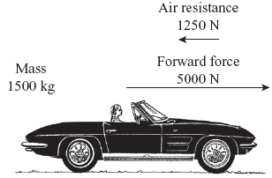
A. | 2.5 m/s² |  | B. | 3.3 m/s²
C. | 4.2 m/s² |  | D. | 9.8 m/s²

Source: MCAS: 2008, Science and Technology/Engineering – High School
http://www.doe.mass.edu/mcas/testitems.html

2) Which value is closest to the mass of an object weighing 63 N on Earth?

A. | 0.1 kg |  | B. | 6.3 kg
C. | 73 kg |  | D. | 617 kg

Source: MCAS: 2007, Science and Technology/Engineering – High School
http://www.doe.mass.edu/mcas/testitems.html

3) A ball has a mass of 0.1 kg and an initial velocity of 20 m/s. The ball is given an acceleration of 30 m/s² for 5 s. What is the net force on the ball during acceleration?

A. | 0 N |  | B. | 3 N
C. | 10 N |  | D. | 15 N

Source: MCAS: 2009, Science and Technology/Engineering – High School
http://www.doe.mass.edu/mcas/testitems.html

