S015: Refraction of Light
Answers: 1. C, 2. C, 3. A
1) The diagram below shows a light ray striking the flat surface of a piece of clear hard plastic at an angle of Light travels faster in air than through plastic. Which of the following diagrams shows how the ray is refracted after it travels through the plastic?
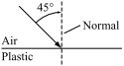

A. | 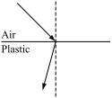 |  | B. | 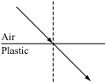
C. | 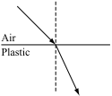 |  | D. | 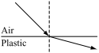
Source: MCAS: 2010, Science and Technology/Engineering – High School
http://www.doe.mass.edu/mcas/testitems.html

2) A light ray traveling in air enters a second medium and its speed slows to meters per second. What is the absolute index of refraction of the second medium?
A. | 1.00 |  | B. | 0.570
C. | 1.75 |  | D. | 1.94
Source: University of the State of New York, Regents High School Examination: Physics, August 2010
http://www.nysedregents.org/Physics/20100622exam.pdf

3) A ray of light () traveling in air is incident at an angle of 40on an air-crown glass interface as shown below. What is the angle of refraction for this light ray?
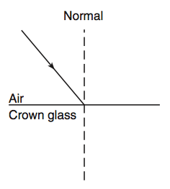
A. | 25 |  | B. | 37
C. | 25 |  | D. | 78
Source: University of the State of New York, Regents High School Examination: Physics, January 2009
http://www.nysedregents.org/Physics/20090129exam.pdf

