S017: Solar System
Answers: 1. B, 2. C, 3. A

1) Which of the following planets is always closer to the Sun than it is to Earth?
A. | Jupiter |  | B. | Mercury
C. | Saturn |  | D. | Uranus
Source: MCAS: 2010, Science and Technology/Engineering – Grade 8
http://www.doe.mass.edu/mcas/testitems.html

2) Which of the following drawings best represents the motion of a planet and its moon around the Sun?
A. | 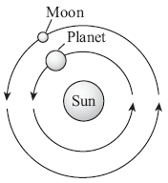 |  | B. | 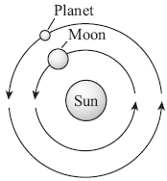
C. | 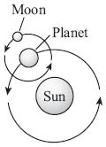 |  | D. | 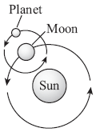
Source: MCAS: 2008, Science and Technology/Engineering – Grade 8
http://www.doe.mass.edu/mcas/testitems.html

3) Compared to the other planets in our solar system, Jupiter, Saturn, and Neptune have:

A. | Shorter periods of rotation |  | B. | Shorter periods of revolution
C. | Greater eccentricities |  | D. | Greater densities

Source: University of the State of New York, Regents High School Examination: Earth Science, August, 2010
http://www.nysedregents.org/EarthScience/20100818examw.pdf

