S018: Electric Current
Answers: 1. B, 2. C, 3. A

1) Which diagram below shows a circuit that will cause the bulb to light?
A. | 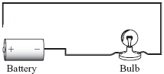 |  | B. | 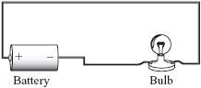
C. | 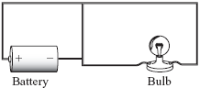 |  | D. | 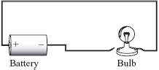

Source: MCAS: 2007, Science and Technology/Engineering – Grade 5
http://www.doe.mass.edu/mcas/testitems.html

2) In which circuit are both bulbs lit?
A. | 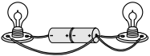 |  | B. | 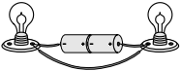
C. | 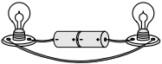 |  | D. | 

Source: MCAS: 2010, Science and Technology/Engineering – Grade 5
http://www.doe.mass.edu/mcas/testitems.html

3) The picture below shows an incomplete electrical circuit. Which of the following objects can be connected to the ends of the two wires to make the circuit complete and light the bulb?
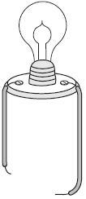

A. | a battery |  | B. | a switch
C. | another bulb |  | D. | another wire

Source: MCAS: 2008, Science and Technology/Engineering – Grade 5
http://www.doe.mass.edu/mcas/testitems.html

