S019: Plane Mirror
Answers: 1. C, 2. A, 3. C
1) The diagram below shows a light ray striking a plane mirror surface at an angle of 40° to the normal. Which of the following diagrams shows the ray that is reflected from the plane mirror surface?
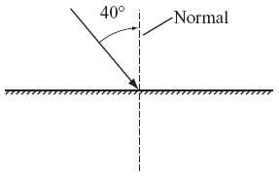
A. | 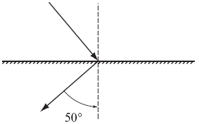 |  | B. | 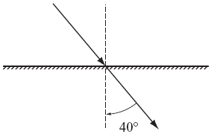
C. | 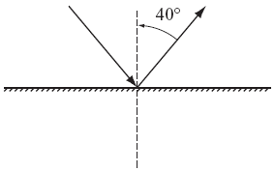 |  | D. | 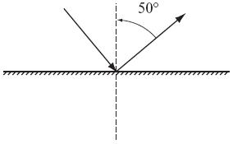
Source: MCAS: 2009, Science and Technology/Engineering – High School
http://www.doe.mass.edu/mcas/testitems.html

2) The diagram below represents a light ray reflecting from a plane mirror. The angle of reflection is:
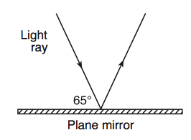
A. | 25 |  | B. | 35
C. | 50 |  | D. | 65
Source: University of the State of New York, Regents High School Examination: Physics, August 2010
http://www.nysedregents.org/Physics/20100622exam.pdf
3) The diagram below represents a light ray striking the boundary between air and glass. What would be the angle between this light ray and it reflected ray?
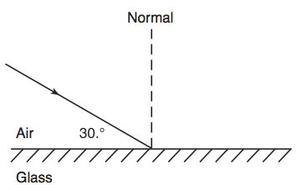
A. | 30 |  | B. | 60
C. | 120 |  | D. | 150
Source: University of the State of New York, Regents High School Examination: Physics, June 2009
http://www.nysedregents.org/Physics/20090624exam.pdf

