S020: Planetary Motion
Answers: 1. C, 2. C, 3. A
1) Approximately how long does Earth take to complete its orbit around the Sun?
A. | One day |  | B. | One month
C. | One year |  | D. | One century
Source: MCAS: 2009, Science and Technology/Engineering – Grade 5
http://www.doe.mass.edu/mcas/testitems.html

2) Which of the following drawings best represents the motion of a planet and its moon around the Sun?
A. | 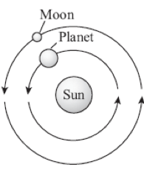 |  | B. | 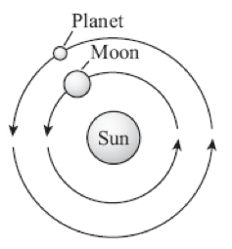
C. | 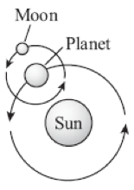 |  | D. | 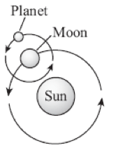
Source: MCAS: 2008, Science and Technology/Engineering – Grade 5
http://www.doe.mass.edu/mcas/testitems.html

3) The following data for the Sun and the four inner planets of the Solar System have been observed. In a simplified model of the Solar System, the planets revolve around the Sun in circular orbits, all in the same plane. Each planet has a different period of revolution. Also, each planet is a sphere that rotates about an axis through its center, but with a different period of rotation. In this model, the axis of rotation of each planet is perpendicular to the plane of the orbit.
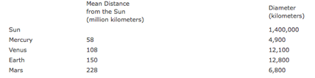
As observed with special instruments from Earth, the Sun appears in the sky to be slightly larger in January than in July. Which of the following accounts for this observation?
A. | The Earth moves in an orbit that is not circular but is closer to the Sun in January than in July. |  | B. | The diameter of the earth is not constant, but bulges slightly at the Equator and contracts slightly during the winter.
C. | The Earth’s orbit is not in the same plane as the orbits of the other planets. |  | D. | The axis of rotation of the Earth is not perpendicular to the plane of its orbit but instead is tilted at an angle.
Source: NEAP, Earth and Space Science, Grade 12
https://www.metacat.net/metacat/app/

