S024: Plate Tectonics
Answers: 1. C, 2. B, 3. C

1) On the map below, dark circles indicate the positions of volcanoes in the "Ring of Fire" in and around the Pacific Ocean. Dark lines indicate tectonic plate boundaries of Earth’s crust.
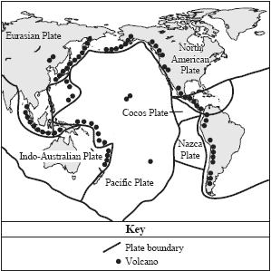
According to this map, which of the following describes where volcanoes are most likely to form in the Ring of Fire?
A. | Volcanoes form in the middle of a tectonic plate. |  | B. | Volcanoes form below the surface of tectonic plates.
C. | Volcanoes form where tectonic plates meet other plates. |  | D. | Volcanoes form where earthquakes are least likely to occur.

Source: MCAS: 2006, Science and Technology/Engineering – Grade 8
http://www.doe.mass.edu/mcas/testitems.html

2) Which of the following statements best explains why earthquakes occur more frequently in California than in Massachusetts?
A. | The rock found in California is igneous, but the rock found in Massachusetts is sedimentary. |  | B. | California is located on the boundary of two crustal plates, but Massachusetts is not.
C. | The rock under California is soft, but the rock under Massachusetts is hard. |  | D. | California is located on a continental plate, but Massachusetts is not.

Source: MCAS: 2007, Science and Technology/Engineering – Grade 8
http://www.doe.mass.edu/mcas/testitems.html

3) Seafloor spreading provides evidence of which of the following Earth processes?

A. | Erosion of coastlines. |  | B. | Weathering of mountains.
C. | Movement of crustal plates. |  | D. | Formation of sedimentary rocks.

Source: MCAS: 2009, Science and Technology/Engineering – Grade 8
http://www.doe.mass.edu/mcas/testitems.html

