S025: Waves
Answers: 1. D, 2. B, 3. A

1) The graphs below give information for waves W and X. Both waves were produced in the same medium and are moving at the same speed. Which of the following statements describes another property of these waves?
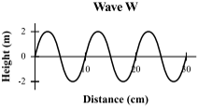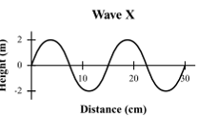

A. | Wave W has a larger period than wave X. |  | B. | Wave W has a lower frequency than wave X.
C. | Wave W has a greater amplitude than wave X. |  | D. | Wave W has a shorter wavelength than wave X.
Source: MCAS: 2010, Science and Technology/Engineering – High School
http://www.doe.mass.edu/mcas/testitems.html

2) A teacher asks a group of students to use a ruler to measure the amplitude of the wave shown below. Between which of the following points should the amplitude be measured?
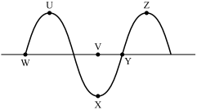
A. | Points U and Z |  | B. | Points V and X
C. | Points W and Y |  | D. | Points X and Z
Source: MCAS: 2010, Science and Technology/Engineering – High School
http://www.doe.mass.edu/mcas/testitems.html

3) The illustration below shows three toy ducks floating on water, moving up and down as a wave travels to the right with a velocity of 3 m/s. Which of the following is the frequency of the wave?
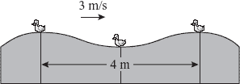

A. | 0.75 Hz |  | B. | 1.33 Hz
C. | 1.5 Hz |  | D. | 6.0 Hz
Source: MCAS: 2006, Science and Technology/Engineering – High School
http://www.doe.mass.edu/mcas/testitems.html

