S028: Friction on an Incline
Answers: 1. B, 2. D, 3. C

1) A block weighing 10.0 newtons is on a ramp inclined at a 30.0to the horizontal. A 3.0-newton force of friction, , acts on the block as it is pulled up the ramp at constant velocity with a force F, which parallel to the ramp, as shown in the diagram below.
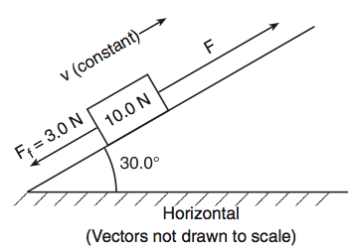
A. | 7.0 N |  | B. | 8.0 N
C. | 10 N |  | D. | 13 N
Source: University of the State of New York, Regents High School Examination: Physics, June 2008
http://www.nysedregents.org/Physics/20080625exam.pdf

2) The diagram below represents a block at rest on an incline. Which diagram best represents the forces acting on the block ( = frictional force, = normal force, and = weight.)
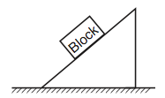
A. | 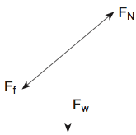 |  | B. | 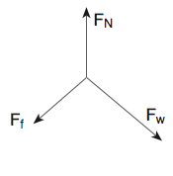
C. | 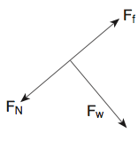 |  | D. | 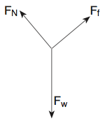
Source: University of the State of New York, Regents High School Examination: Physics, June 2005
http://www.nysedregents.org/Physics/20050622exam.pdf

3) The diagram below shows a block sliding down a plane inclined at angle with the horizontal. As angle is increased, the coefficient of kinetic friction between the bottom of the surface of the block and the surface of the incline will:

A. | Decrease |  | B. | Increase
C. | Remain the same
Source: University of the State of New York, Regents High School Examination: Physics, January 2003
http://www.nysedregents.org/Physics/20030129exam.pdf

