S031: Circular Motion
Answers: 1. D, 2. D, 3. C
1) The diagram below shows a ball moving in a circular path. Which of the following would cause the ball to fly off in a straight-line path?
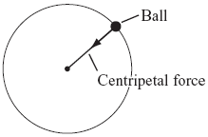
A. | Decreasing the mass of the ball |  | B. | Changing the mass of the ball
C. | Increasing the radius of the ball’s path |  | D. | Removing the centripetal force on the ball
Source: MCAS: 2009, Science and Technology/Engineering – High School
http://www.doe.mass.edu/mcas/testitems.html

2) The illustration below shows an athlete participating in an Olympic hammer throw event. The athlete twirls the hammer (a heavy steel ball attached to a wire) around several times before releasing it. The diagram below shows the path of the ball as it is spun in a circle before its release. Which arrow shows the direction of the centripetal force on the ball before the ball is released?
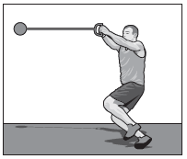 | 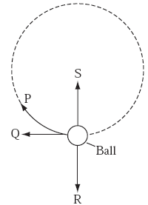

A. | P |  | B. | Q
C. | R |  | D. | S
Source: MCAS: 2008, Science and Technology/Engineering – High School
http://www.doe.mass.edu/mcas/testitems.html

3) The diagram below represents a mass, m, being swung in clockwise at constant speed in a horizontal circle. At the instant shown, the centripetal force acting on mass m is directed toward point?
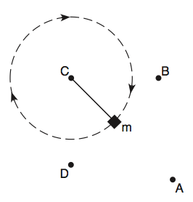
A. | A |  | B. | B
C. | C |  | D. | D
Source: University of the State of New York, Regents High School Examination: Physics, August 2010
http://www.nysedregents.org/Physics/20100622exam.pdf

