S032: Energy and Energy Transfer
Answers: 1. B, 2. C, 3. C

1) Heat, light, and sound are all different forms of

A. | Fuel |  | B. | Energy
C. | Matter |  | D. | Electricity

Source: MCAS: 2009, Science and Technology/Engineering – Grade 5
http://www.doe.mass.edu/mcas/testitems.html

2) The picture below shows a beaker being heated on a hot plate. Which type of energy transfer occurs when a beaker of water is heated on a hot plate?

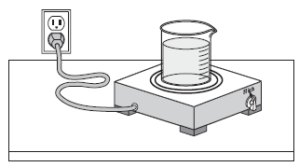

A. | light to heat |  | B. | chemical to heat
C. | electrical to heat |  | D. | magnetic to heat

Source: MCAS: 2008, Science and Technology/Engineering – Grade 5
http://www.doe.mass.edu/mcas/testitems.html

3) When a light bulb is turned on, energy changes from one form to another. Which of the following best describes this change?

A. | sound energy to light energy |  | B. | nuclear energy to light energy
C. | electrical energy to light energy |  | D. | magnetic energy to light energy

Source: MCAS: 2005, Science and Technology/Engineering – Grade 5
http://www.doe.mass.edu/mcas/testitems.html

