S038: Solar Collector Basics
Answers: 1. C, 2. D, 3. X

1) A solar panel is used to collect energy from the Sun and change it into other forms of energy. The picture below shows some solar panels on the roof of a building. Which form of energy is collected by the solar panels?
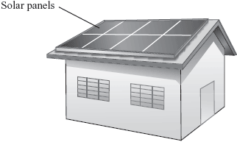
A. | wind |  | B. | sound
C. | magnetic |  | D. | light
Source: MCAS: 2007, Science and Technology/Engineering – Grade 5
http://www.doe.mass.edu/mcas/testitems.html

2) Four different-colored blocks are placed outside in bright sunlight. The blocks are identical except for color. The diagram below shows the amount of light reflected from each block. Which block will increase in temperature most rapidly?
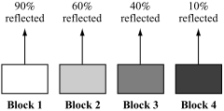

A. | block 1 |  | B. | block 2
C. | block 3 |  | D. | block 4
Source: MCAS: 2010, Science and Technology/Engineering – Grade 8
http://www.doe.mass.edu/mcas/testitems.html

