S039: Terrestrial Seasons
Answers: 1. C, 2. D, 3. B

1) The ocean water near the equator absorbs more heat throughout the year than ocean water near the North Pole. Which of the following best explains this difference?
A. | The equator is closer to the Sun. |  | B. | The equator has higher sea levels.
C. | The equator receives more direct sunlight. |  | D. | The equator rotates more quickly on Earth’s axis.

Source: MCAS: 2007, Science and Technology/Engineering – Grade 8
http://www.doe.mass.edu/mcas/testitems.html

2) The diagram below represents Earth’s orbit around the Sun. About how long does it take Earth to make one complete orbit around the sun?

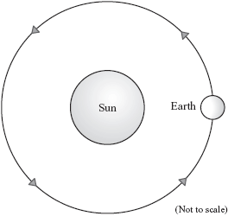

A. | 24 hours |  | B. | 7 days
C. | 1 month |  | D. | 1 year

Source: MCAS: 2007, Science and Technology/Engineering – Grade 8
http://www.doe.mass.edu/mcas/testitems.html

3) Which of the following statements best explains why the tilt of Earth on its axis causes summer to be warmer than winter in the Northern Hemisphere?

A. | The warm ocean currents flow from the tropics to the Northern Hemisphere in the summer. |  | B. | The rays of the Sun strike the Northern Hemisphere more directly in the summer.
C. | The greenhouse effect increases in the Northern Hemisphere in the summer. |  | D. | The Northern Hemisphere is closer to the Sun in the summer.

Source: MCAS: 2008, Science and Technology/Engineering – Grade 8
http://www.doe.mass.edu/mcas/testitems.html

