S045: Density
Answers: 1. B, 2. D, 3. X

1) The diagram below shows what occurred when a can of diet soda and a can of regular soda were dropped into a container of water. The can of regular soda sank to the bottom of the container, but the can of diet soda floated. Which of the following statements best explains this observation?
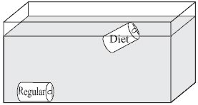
A. | The can of regular soda is less dense than the can of diet soda. |  | B. | The can of regular soda is more dense than the can of diet soda.
C. | The can of regular soda has a larger volume than the can of diet soda. |  | D. | The can of regular soda has a smaller volume than the can of diet soda.
Source: MCAS: 2006, Science and Technology/Engineering – Grade 8
http://www.doe.mass.edu/mcas/testitems.html

2) The data table below shows the mass and volume of three samples of the same mineral. [The density column is provided for student use.] Which graph represents the relationship between the density and the volume of these mineral samples?
Data Table
Sample | Mass (g) | Volume (cm³) | Density (g/cm³)
A | 50 | 25
B | 100 | 50
C | 150 | 75

A. | 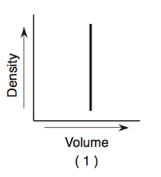 |  | B. | 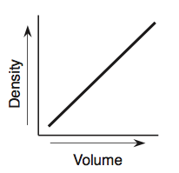
C. | 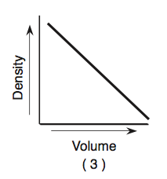 |  | D. | 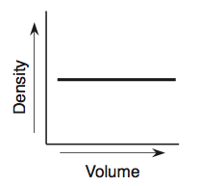
Source: University of the State of New York, Regents High School Examination: Earth Science, June 2007
http://www.nysedregents.org/EarthScience/20070619exam.pdf

