Concave Mirrors
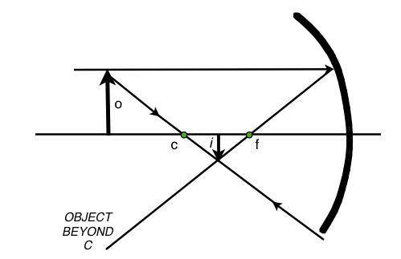
Putting “Concave Mirrors” in Recognizable terms: A spoon is an example of a curved mirror where one side is concave and the other side is convex. The image you receive by looking in a concave mirror depends on the distance you are from the mirror. The image might be upright or inverted and may form in front of the mirror, called a real image, or behind the mirror, called a virtual image. The diagram to the right is sometimes referred to as ‘Case 2’ for a concave mirror where the image is real, inverted, and smaller than the object.

Putting “Concave Mirrors” in Conceptual terms: You can find the terminology for curved mirrors by observing the diagram above: ‘o’ is the object, ‘i’ is the image, ‘f’ is the focal point, and ‘c’ is the center of curvature. The vertex is the point where the center line axis crosses the mirror.

Putting “Concave Mirrors” in Mathematical terms: Relationships for concave mirrors may be found by using the ‘mirror equation’. 1/d_{f} = 1/d_{i} + 1/d_{o} where one over the focal length = one over the image distance plus one over the object distance. In addition,
h_{o} / h_{i} = d_{o} / d_{i} where the height of the object over the height of the image equals the distance of the object from the vertex over the distance of the image from the vertex.

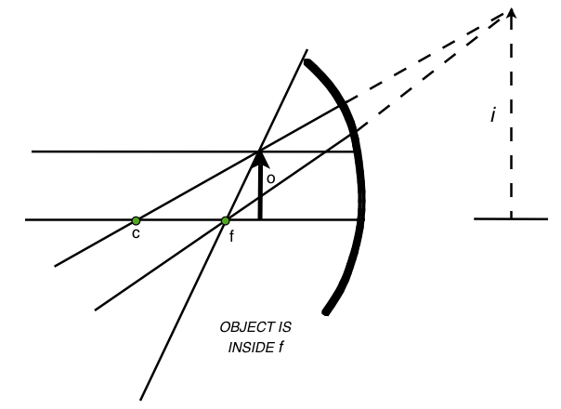
Putting “Concave Mirrors” in Process terms: Use a stationary clear appliance bulb, a concave mirror and a white piece of paper as a screen, move the components around and try to demonstrate the ‘cases’. Is this possible?

Putting “Concave Mirrors” in Applicable terms:
Case 5 - When concave mirrors are used as make-up or shaving mirrors, the object, the person's face, is placed between the focal point and the vertex. The image is enlarged, virtual, and upright.
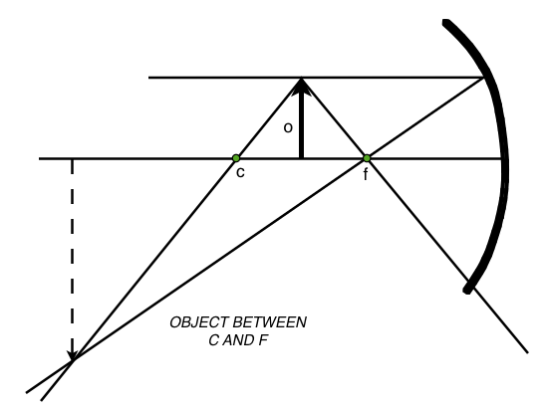

Case 4 - If the object is between the center of curvature and the focal point, the image is enlarged, real, and inverted.

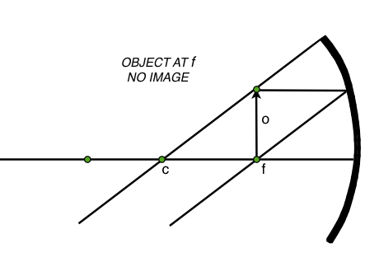

Case 1 - If the object is at the focal point, no image is formed. If the concave mirror has a parabolic shape, the rays will come out parallel and will never converge to form an image.
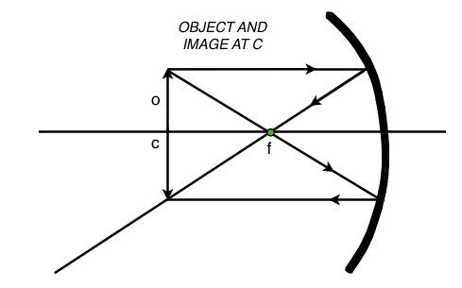
Case 3 - The object is at the center of curvature and the image will be the same size, real, and inverted.

