Titration
Titration Definition: Titration comes from the Latin word titulus meaning “inscription” or “title”. The French developed the word titre, from this origin, meaning “rank”. Titration is now a common laboratory technique used to determine the “rank” or concentration of an unknown solution.
Titration Technique: Titration is performed only with liquid solutions. The volume measurements of these solutions are critical. A controlled addition or volume of a solution with a known concentration (called the titrant or titrator) is required to react completely with a measured amount of a solution with an unknown concentration (called the analyte or titrand). Addition of the titrator to the analyte continues until an endpoint is reached.
Determining the Endpoint: How the endpoint is determined depends on the type of solutions involved. If a strong acid and a strong base are involved the endpoint is determined when the pH reaches 7 or neutral. This is commonly revealed by an indicator which changes color in response to the pH difference or reaction between the solutions. However this is not the only method.
The following is a list of ways to determine the endpoint:
1. pH change,
2. Color change caused by an indicator added to the analyte,
- pH indicator, redox indicator, or secondary chemical (reacts to the titrator once all the
analyte is depleted)
3. Precipitate formed,
or by changes in conductivity, spectrometry, or thermodynamics of the solution.
Equipment Used in Titrations: A buret (also spelled burette) is a tall, thin, cylindrical instruments used in titrations. It is tapered to a fine point at one end, which is designed to slowly release a liquid solution drop by drop while accurately measuring the volumetric amount released.
When using a buret follow these setup instructions:  - Rinse the buret 3 times with the solution intended to be used in the titration. (Ensures contaminates are removed)  - Fill the buret to a point above the 0 mL calibration point.  - Release some of the solution to remove any air bubbles.  - Record the volume to the nearest 0.01 mL. | 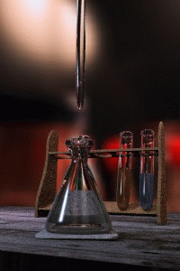  Image compliments of: Wikipedia.com

