Community Ecology
Ecology: is the scientific study of interactions of wild life and their environment.
Levels of Organization for Ecology: Each level is designated by its focus of study from one organism, groups of organisms, or an entire planet’s biological system.
- Species: encompasses only a set of organisms with enough similarities that they are able to breed and produce fertile offspring.
- Population: encompasses several individuals of the same species living in the same location.
- Community: encompasses multiple species populations living simultaneously in a defined location
- Ecosystem: encompasses all the communities or organisms along with the nonliving, environmental components (air, soil, sunlight, water etc.) within a specific area, which affect those organisms
- Biosphere: includes an entire planet’s features relating to living organisms such as air, land, and water
Energy Flow: There are two general kinds of energy organisms: producers and consumers. Producers create their own energy or food supply from a non-living source using either photosynthesis or chemosynthesis. On the contrary, consumers rely on other organisms for their energy or food supply. There are several different types such as: herbivores, carnivores, omnivores, detritivores, and decomposers. Ecologists will often study the interaction between them and develop food chains or food webs based on the trophic structure or feeding relationships.
Community Interactions: There are three primary interactions: competition, predation, and symbiosis. Competition occurs when organisms of the same or different species attempt to use a resource (water, nutrient, food, or space) in the same place at the same time. Predation is when one organism captures and feeds on another organism. This interaction involves a predator, the organism that does the killing and eating, and a prey, the organism consumed by the predator. Symbiosis is any relationship in which two species live closely together. There are three varieties of symbiosis: mutualism, commensalism, and parasitism each differing by how organisms involved benefit.
Ecological Succession: Ecological succession studies the series of predictable changes that occur in a community. These changes maybe as a response to a natural or human disturbance, which may have occurred slowing or rapidly. Often, in either case the older inhabitants gradually die out and are replaced by new inhabitants. There are two kinds of successions: primary and secondary. Primary succession studies the changes that occur to a surface where no soil currently exists such as a land laid bare by volcanic eruptions (covered only in lava rock and volcanic ash). Secondary succession studies changes in an existing community due to a disturbance without soil being removed such as a wild fire. The survival and growth of organisms or ecosystems going through a succession are determined by looking at two main types of factors: biotic and abiotic. Biotic factors are the biological influences on the organism or ecosystem from birds to bacteria. Outside of living organisms there are the nonliving or abiotic factors such as climate (temperature, precipitation, humidity), wind, nutrient availability, sunlight and soil type to consider.
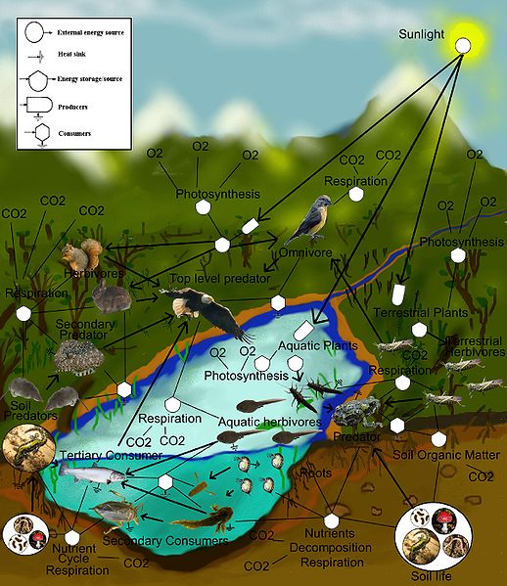
http://commons.wikimedia.org/wiki/File:FoodWeb.jpg

