Population Ecology Diagrams and Calculation

Example of Quadrat Method:
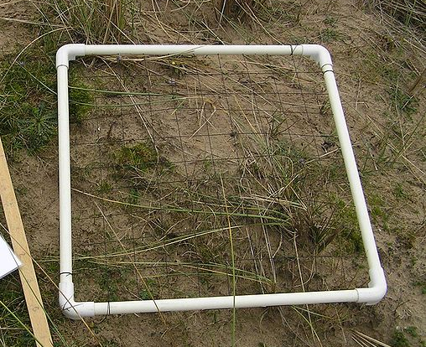  http://commons.wikimedia.org/wiki/File:Quadrat_sample.JPG | 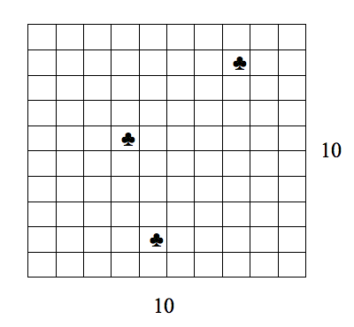

1) Assume the quadrat above represents 10 m x 10 m (100 m²)
2) Three of the quadrats of a smaller size are randomly selected (indicated by ♣) each
representing a 1 m x 1 m (1 m²).

3) Assume the number of moss plants is being counted within each of the three smaller
quadrats.

4) If 8, 11, 14 individuals per each small quadrat are counted, then the average is
calculated by:

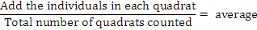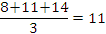

5) The average is then applied to the total area. Assuming there are 1000 m² or 1000
smaller quadrats then the total population size would be estimated as total area
multiplied by the average or 1000 x 11 = 11, 000 moss plants.

6) The process is repeated for other species in the community.

